Starting Your Computer
- Start your computer. Boot to your installation of Windows 7. Log in with your personal account.

Customizing Your Profile
- Desktop Settings: Right-click the desktop and click Personalize. Click "Desktop Background". Select a background you like and click OK.
- Internet Explorer Favorites: Click Start, Internet. Go to my Web page samsclass.info and click Favorites, Add to Favorites, Add. Go to a few more pages you like and add them to your Favorites. Close Internet Explorer.

Saving Your Files and Settings with Windows Easy Transfer
- Close all windows.
- Press the Windows Logo key on the lower left corner of the keyboard
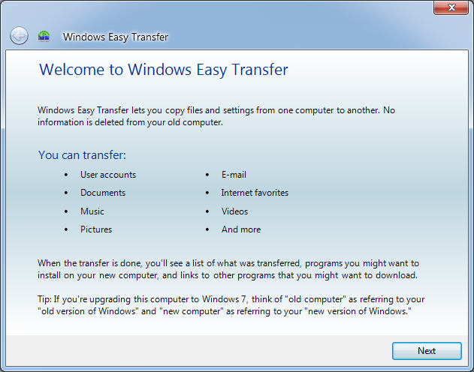
- In the Search bar, type EASY
- "Windows Easy Transfer" appears in the search area at the top of the menu. If necessary, use the up-arrow and down-arrow keys to highlight it.
- Press the Enter key to launch "Windows Easy Transfer".
- The "Welcome to Windows Easy Transfer" screen appears, as shown to the right on this page. Click Next.
- At the "What do you to use to transfer items to your new computer?" screen, click "An external hard disk or USB flash drive".
- At the "Which computer are you using now?" screen, click "This is my old computer".
- The next screen shows two items, one with your name on it, and "Shared items". Clear the "Shared Items" check box, as shown to the right on this page.
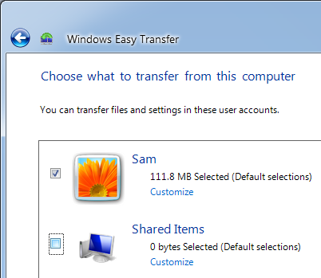

- Notice the size of the item with your name on it. This is the total size of the files in your profile. In the item with your name on it, click the Customize button. This shows a detailed list of how large each of your personal folders are, as shown below on this page.
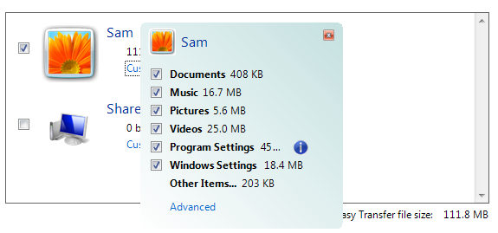

- In the lower right of the "Choose what to transfer from this computer" box, find the "Easy Transfer file size". If it's larger than 500 MB, clear some of the check boxes in the Customize list to make it smaller. Then click Next.
- In the "Save your files and settings for transfer" box, enter a password of P@ssw0rd in both screens. Then click Save.
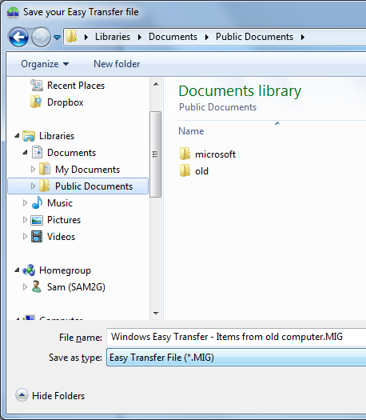
- In the "Save your Easy Transfer file" box, in the left pane, in the Libraries section, click the little triangle next to Documents to expand it. Click the "Public Documents" icon to select it, as shown to the right on this page. Click Save.
- When the save is complete, click Next.
- A box opens saying "Your transfer file is complete". Click Next. Click Close.

Transferring Your Settings to a New Account
- Normally you would move your settings to a different computer. But to make the project simpler, we'll just use a second user account on the same machine.
- Click Start, Documents. Double-click "Windows Easy Transfer – Items from old computer.MIG".
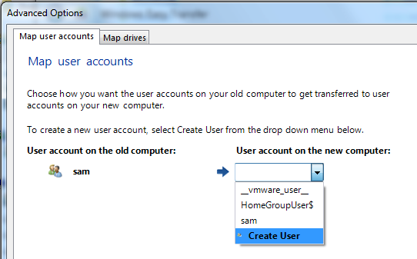
- In the next box, type in P@ssw0rd and click Next.
- In the "Choose what to transfer to this computer" box, in the lower right, click "Advanced Options".
- In the "Map user accounts" box, in the right section, click the drop-down arrow, and then click "Create User", as shown to the right on this page.
- In the "Create New User" box, enter a user name of "Your Name 2". Don't use the literal words Your Name, use your own name. Enter a password of P@ssw0rd in both boxes and click Create. Click Save. Click Transfer.
- In the "Your transfer is complete" window, click "See what was transferred". A "Windows Easy Transfer Reports" box appears, as shown to the right on this page.
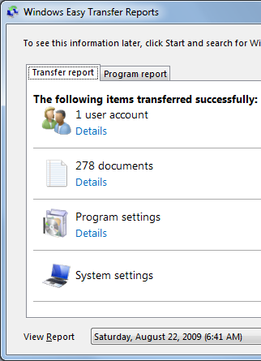

Saving the Screen Image
- Click Start, "All Programs", Accessories, Paint. In the untitled - Paint window, select Edit, Paste from the menu bar. The window image appears in the Paint window.
- In the untitled - Paint window, click File, Save. Save the document with the filename Your Name Proj 3.

Turning in your Project
- Open Internet Explorer, and use it to email the JPEG image to me as attachment to an e-mail message. Send the message to: cnit.345@gmail.com with a subject line of "Proj 3 From Your Name", replacing Your Name with your own first and last name. Send a Cc to yourself.

Observing the New Account
- Click Start, click the arrow next to the "Shut Down" button, and click "Log off". Log on as Your Name 2 with the password P@ssw0rd.
- When the computer starts, you will be asked to "Type the password for your old computer". You need to use the log in password from your old computer, to prove that you are the rightful owner of these transferred files.
- Note that the desktop background is the same one your chose before. Open Internet Explorer and verify that your Favorites were also transferred.
Last Modified: 8-22-09

