What You Need for This Project
- The machine you did Project 6x on, so it has WAIK on it
- The machine must have VMware Workstation installed on it (see below)
- You need a Windows 7 install DVD
- You will need a valid Win 7 product key (any version, see below)
Getting VMware Workstation
- The machines in the S214 lab already have VMware Workstation installed on the main Win 7 partition--the simplest way to do this project is to work in the lab.
- However, if you want to work at home, you are entitled to a free version of VMware Workstation from the college. The instructions are here:
http://samsclass.info/MSDNAA.htm
Getting a Windows 7 Product Key
- You can get a free Windows 7 product key from the college. The instructions are here:
http://samsclass.info/MSDNAA.htm
Configure your Deployment Machine with a Password
- The computer you use for this project must have Windows 7 on it, and at least 15 GB of free space on the C: drive. In addition, the user account you are logged in with must have a password. :
Getting VMware NIC Drivers
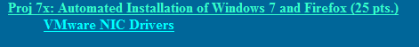
- You will need these drivers for deployment. Open a browser and go to samsclass.info. Click the "CNIT 345" link. Click Projects. Scroll to "Proj 7x" and click the "VMware NIC Drivers" link, , as shown to the right on this page. Save the drivers on your desktop.
- Right-click the downloaded Zip file and extract it on your desktop.
Downloading Microsoft Deployment Toolkit (MDT) 2010
- Open a browser and go to http://tinyurl.com/22cpem
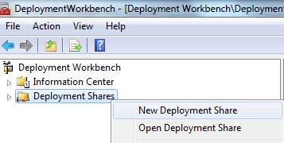
- Scroll to the bottom portion of the page and find the MicrosoftDeploymentToolkit2010_x86.msi line. Click the Download button.
- Run the installer. Install the software with the default options.
Using the Deployment Toolkit to Create a Deployment Share
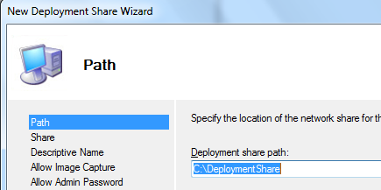
- Click Start, "All Programs", "Microsoft Deployment Toolkit". Right-click "Deployment Workbench" and click "Run as administrator".
- In Deployment Wizard, right-click "Deployment Shares" and click "New Deployment Share".
- Click through the wizard, accepting the default selections.

- In Deployment Wizard, in the left pane, expand "MDT Deployment Share". You will see several folders, , as shown below on this page. These will contain the source files for your automated deployment.
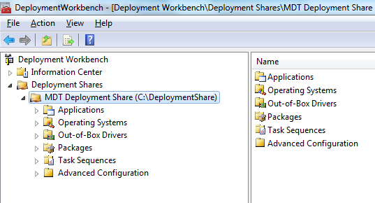

Importing an Operating System
- In the left pane of "DeploymentWorkbench", right-click "Operating Systems" and click "Import Operating System".
- In the first screen, accept the default selection of "Full set of source files" and click Next.
- Insert your Win 7 install DVD.
- In the next screen, click the Browse button and navigate to the DVD. Click Next.
- In the 'Destination" screen, accept the default selection of "Windows 7 x86" and click Next.
- In the "Summary" screen, click Next. Wait for the import to complete-it took me ten minutes to import from a USB drive.
- When the process completes, click Finish. You should see various versions of Windows 7 available, as shown below on this page.
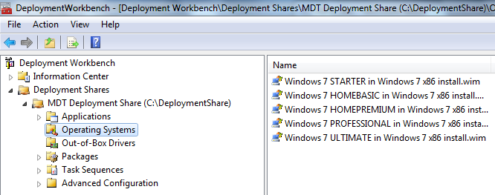

Importing Drivers
- In the left pane of "DeploymentWorkbench", right-click "Out-of-Box Drivers" and click "Import Drivers".
- In the "Specify Directory" screen, click the Browse button and navigate to the VMware drivers you downloaded and unzipped earlier in this project--they should be on your desktop. Click Next. Click Next. Click Finish. Note: even though the drivers were imported, the "OLut-of-Box Drivers" folder remains empty.
Downloading and Renaming Firefox
- Open a Web browser and go to getfirefox.com
- Dowload the latest version and save it on your desktop. When I did it, it was Firefox Setup 3.6.3.exe.
- On your desktop, right-click the Firefox Setup 3.6.3.exe file and click Rename. Type in a new name of "firefox" and press the Enter key. The final name should be firefox.exe, but your computer may not show the filename extension.
Importing Applications
- In the left pane of "DeploymentWorkbench", right-click "Applications" and click "New Application".
- In the first screen, accept the default selection of "Application with source files" and click Next.
- In the "Details" screen, enter an Application Name of Firefox and click Next.
- In the "Source" screen, click the Browse button and navigate to your desktop. Click Next.
- In the "Destination" screen, click Next.

- In the "Command Details" screen, enter a Command Line of:
Firefox.exe -ms
This is the "quiet" switch for Firefox. The "quiet” switch is needed to prevent the application asking for user input during installation. Each application has its own conventions for that, which makes it necessary to research each application you deploy.
- Click Next. Click Next. Click Finish.
Creating a Task Sequence
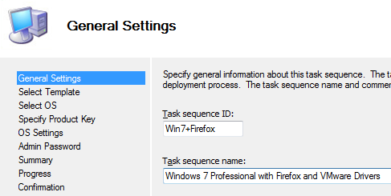
- In the left pane of "DeploymentWorkbench", in the "Deployment Shares" section, in the "MDT Deployment Share (C:\\DeploymentShare)" section, right-click "Task Sequences" and click "New Task Sequence".
- In the "General Settings" page, enter a "Task sequence ID" of Win7+Firefox and a "Task sequence name" of "Windows 7 Professional with Firefox and VMware Drivers", as shown to the right on this page. Click Next.
- In the "Select Template" page, accept the default selection of "Standard Client Task Sequence" and click Next.
- In the "Select OS" page, click "Windows 7 PROFESSIONAL in Windows 7 x86 install.wim" and click Next.
- In the "Specify Product Key" page, click the " Specify the product key for this operating system" button, enter the product key you got from MSDNAA (see step 3 of these instructions), and click Next.
- In the "OS Settings" page, enter an Organization of "CCSF" and click Next.
- In the "Admin Password" page, enter a password of P@ssw0rd in both password fields and click Next.
- In the "Summary" page, click Next. A "Progress" page appears for just a few seconds--this process is very rapid, because all it is doing is preparing a simple text file called an "Unattended Answers" file.
- In the "Confirmation" page, click Finish.
Concealing Unwanted Setup Screens
- We don't want to make the user type in things like the computer name and product key. So we will put them in the Deployment Share Properties.
- In the left pane of "DeploymentWorkbench", in the "Deployment Shares" section, right-click "MDT Deployment Share (C:\\DeploymentShare)" and click Properties.
- In the Properties sheet, click the "Rules" tab. At the lower right, click the "Edit Bootstrap.ini" button.
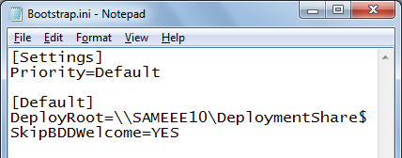
- Add this line to the end of the file, as shown to the right on this page:
SkipBDDWelcome=YES
- Save the file and close Notepad.

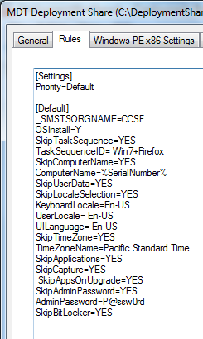
- Open a Web browser and go to samsclass.info. Click on CNIT 345’. Click on Projects. In the "Project X7" section, click on Customsettings.ini.
- Highlight all the text. Copy it.
- In the Properties sheet, highlight all the text, and paste in the copied text. Your properties sheet should now look like the window shown to the right on this page.
- Remove these two lines:
SkipProductKey=YES
ProductKey=11111-22222-33333-44444-55555
- This means you will have to type in the product key during installation, which is not the best procedure, but that's all that I can figure out how to do with single-user product keys. Obviously this automated installation is intended for use with volume-license keys, and no matter what I do, it rejects single-use keys in the Unattend.xml file as invalid.
- Click the OK button.
Updating the Deployment Share
- This is needed to copy all the required files to the shared folder. This process also creates bootable ISO files, so you can boot a Win 7 VM from them.
- In the left pane of "Deployment Workbench", right-click MDT Deployment Share (C;\DeploymentShare)’, and click "Update Deployment Share".
- In the wizard, click Next, Next. Wait for the process to complete--it took me about fifteen minutes. In the Confirmation screen, click Finish.
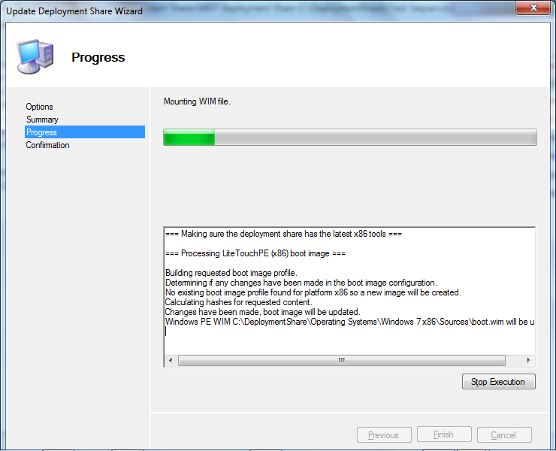

Creating a Virtual Machine
- Launch VMware Workstation.
- From the menu bar, click 'File", "New", "Virtual Machine".
- In the "Welcome to the New Virtual Machine Wizard" screen, accept the default selection of "Typical (rcommended)" and click Next.
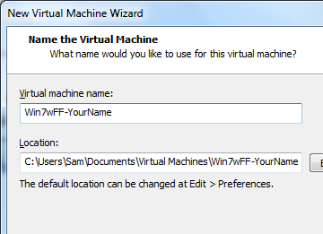
- In the "Guest Operating System Installation" screen, accept the default selection of "I will install the operating system later" and click Next.
- In the "Select a Guest Operating System" screen, accept the default selections of "Microsoft Windows" and "Windows 7" and click Next.
- In the "Name the Virtual Machine" screen, enter a name of "Win7wFF-YourName", replacing YourName with your own name. Accept the default storage location, which will be in your Documents folder, and click Next.
- In the "Specify Hard Disk Capacity" screen, accept the default selection of "40.0" and click Next. Note: the VM will not really use that much space--it will expand only as needed.
- In the "Ready to Create Virtual Machine" screen, click Finish.
Adjusting the RAM
- This creates a VM with 1 GB of RAM. If your host machine has 2 GB or more of RAM, that's fine. But if you are working in the S214 lab, you will need to click "Edit Virtual Machine Settings" and change the RAM to 512 MB, because the host machines only have 1 GB.
Directing the Virtual Machine to the Deployment ISO Image
- In VMware Workstation, click "Edit Virtual Machine Settings".
- In the "Virtual Machine Settings" box, in the left pane, click "CD/DVD (IDE)". In the right pane, click "Use ISO Image File". Click the Browse button and browse to C:\DeploymentShare\Boot\LiteTouchPE_x86.iso, as shown below on this page. Click OK.
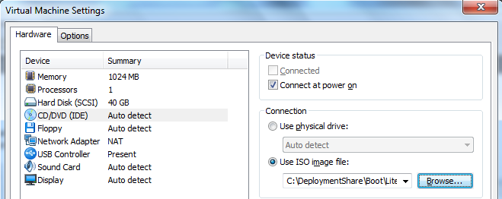

Booting the Virtual Machine from the Deployment ISO Image
- In VMware Workstation, click "Power on this virtual machine".
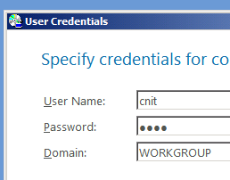
- A black screen with the message "Starting Windows" appears. That's the deployment ISO starting.
- After about a minute, the screen changes to light blue, and a "SOLUTION ACCELERATORS" banner appears at the bottom of the screen.
- In the "User Credentials" box, enter the user name and password of your Windows 7 host system, and a domain of WORKGROUP, , as shown to the right on this page. This information is needed to connect to the deployment share from the virtual machine. Click OK.
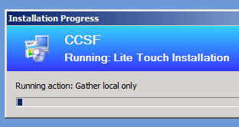
- The next screen asks you to "Join the computer to a domain or workgroup". Accept the default selection of Workgroup and click Next.
- When it asks for a product key, enter your key.
- At the next screen, click Begin. An "Installation Progress" box appears, as shown to the right on this page.

Saving the Screen Image
- Make sure the "Installation Progress" box is visible.
- Click on your host machine's desktop, outside the virtual machine, to make sure your keystrokes are sent to the host machine, not the virtual machine.
- Press the PrintScrn key in the upper-right portion of the keyboard. That will copy the whole desktop to the clipboard.
- Open Paint and paste the image in. Save the image with the filename Your Name Proj 7xa. Select a Save as type of JPEG.

Troubleshooting
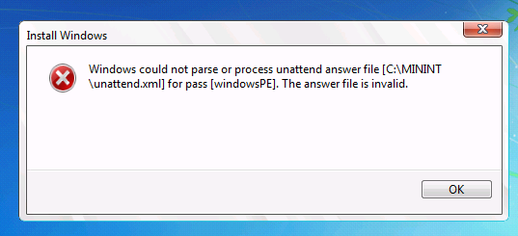
- If the install freezes with the error shown to the right, there is a typographical error in your Deployment Share Properties, which are used to create the Unattend.xml file. Check it. I got that message when I made an error pasting in the product key. If this happens to you, fix the typo, click "Apply", update the deployment share, create a new virtual machine, and boot from the ISO file.
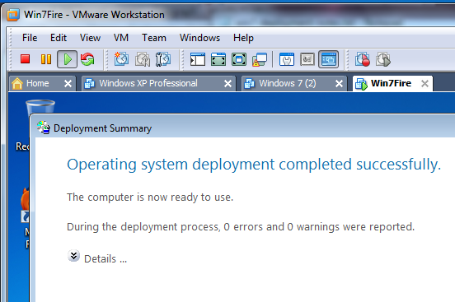
Waiting for the Installation
- If there are no errors, the installation will proceed automatically. It will take a long time--more than one hour on my little Eee netbook. When it completes, you should see this screen, showing "0 errors and 0 warnings".

Saving the Screen Image
- Make sure the Deployment Summary box is visible, showing "0 errors and 0 warnings".
- Click on your host machine's desktop, outside the virtual machine, to make sure your keystrokes are sent to the host machine, not the virtual machine.
- Press the PrintScrn key in the upper-right portion of the keyboard. That will copy the whole desktop to the clipboard.
- Open Paint and paste the image in. Save the image with the filename Your Name Proj 7xb. Select a Save as type of JPEG.
Testing Firefox
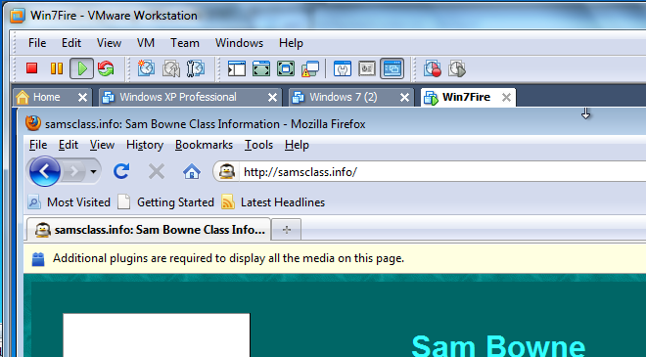
- In your new virtual machine, open Firefox and connect to the Internet. Go to a Web page as shown to the right on this page.

Saving the Screen Image
- Make sure the Firefox window is visible inside your virtual machine, showing a Web page
- Click on your host machine's desktop, outside the virtual machine, to make sure your keystrokes are sent to the host machine, not the virtual machine.
- Press the PrintScrn key in the upper-right portion of the keyboard. That will copy the whole desktop to the clipboard.
- Open Paint and paste the image in. Save the image with the filename Your Name Proj 7xc. Select a Save as type of JPEG.

Turning in your Project
- Open Firefox, and use it to email the JPEG images to me as attachments to a single message. Send the message to: cnit.345@gmail.com with a subject line of "Proj 7x From Your Name", replacing Your Name with your own first and last name. Send a Cc to yourself.
Last Modified: 5-10-10

