What You Need for This Project
- A working Windows 7 machine with at least 5 GB free on the system volume
- A Windows 7 installation DVD.
- A broadband Internet connection: you need to download 2 GB of stuff

Downloading and Installing 7-Zip
- Open a browser and go to 7-zip.com
- Down load the appropriate version for your operating system and install it with the default options.
Downloading and Unzipping WAIK (Windows Automated Installation Kit)
- Open a browser and go to samsclass.info
- Scroll to the bottom of the page and click the "Deploy 1: Download details: Windows® AIK for Windows® 7" link.
- If you are working at home: click the Dowload link and download the KB3AIK_EN.iso file. It will take a long time--it's 1.7 GB in size.
If you are in the S214 lab: Click Start, Computer. Open the VMs drive and open the Install folder. If the KB3AIK_EN.iso file is there, proceed to step 6. If it is not there, get the USB hard drive from the closet and copy the KB3AIK_EN.iso file to the VMs\Install folder.
- In the VMs\Install folder, right-click the KB3AIK_EN.iso file and click 7-Zip, Extract to "KB3AIK_EN.\"
- Wait until 7-Zip finishes extracting the files.
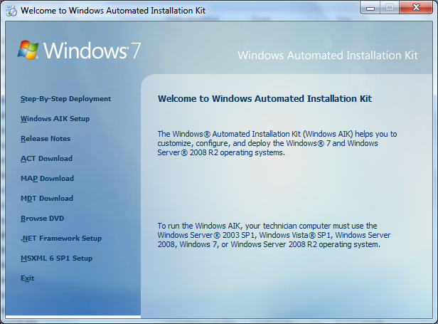
Installing WAIK (Windows Automated Installation Kit)
- Click Start, Computer. Open the VMs drive and open the Install folder. Open the KB3AIK_EN folder. Double-click the StartCD.exe file.
- The "Welcome to Windows Automated Installation Kit" box opens, , as shown to the right on this page.

- On the left side, click "Windows AIK Setup".
- An installer starts. Click through using the default options
Copying the Install.wim File from the Windows 7 Installation DVD
- If you are in the S214 lab: Click Start, Computer. Open the VMs drive and open the Install folder. If the Install.wim file is there, proceed to step 15. If it is not there, do step 13.
- If you are working at home: insert a Windows 7 install DVD. Open the DVD in Windows Explorer and open the Sources folder. Copy the Install.wim file to the VMs\Install folder.
- What's the Install.wim file? This file contains images of every version of Windows 7, in the "Windows Image File" format.
Removing the Read-Only Flag from the Install.wim File
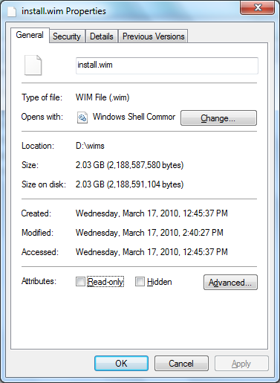
- On the VMs partition, in the Install folder, right-click the Install.wim file and click Properties.
- In the "install.wim Properties" box, clear the "Read-only" check box, , as shown to the right on this page, Click OK.
Using DISM (Deployment Imaging Servicing and Management)
- Point to Start, "All Programs", "Microsoft Windows AIK", "Deployment Tools Command Prompt", right-click it, and "Run as administrator".
- In the command prompt window, enter this command, replacing "D:\wims\install.wim" with the correct path to your install.wim file:
DISM /get-wiminfo /wimfile:d:\wims\install.wim
- This command opens the install.wim file and shows you all the versions of Windows 7 it includes, as shown below on this page.
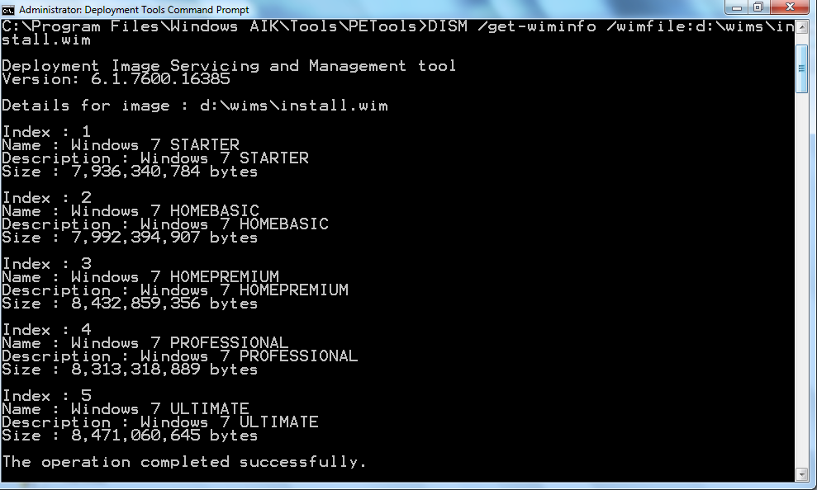

Saving the Screen Image
- Make sure the "Administrator: Deployment Tools Command Prompt" account is visible, showing the many versions of Windows 7, as shown above on this page.
- Press the PrintScrn key in the upper-right portion of the keyboard. That will copy the whole desktop to the clipboard.
- Open Paint and paste the image in. Save the image with the filename Your Name Proj 7x. Select a Save as type of JPEG.

Turning in your Project
- Open Firefox, and use it to email the JPEG image to me as an email attachment. Send the message to: cnit.345@gmail.com with a subject line of "Proj 7x From Your Name", replacing Your Name with your own first and last name. Send a Cc to yourself.
Last Modified: 10-6-11

