Using Local Group Policy Editor to Limit Control Panel Items
- Click Start, type gpedit.msc into the Search box, and press Enter.
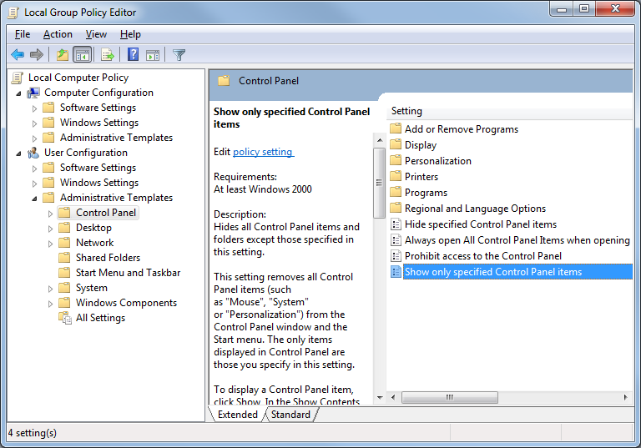
- In "Local Group Policy Editor", in the left pane, in the "User Configuration" section, click the yellow "Administrative Templates" folder. Click the yellow "Control Panel" folder, as shown below on this page.

- In the right pane, double-click "Show only specified Control Panel items".
- In the "Show only specified Control Panel items" box, click the Enabled button. Click the Show button.
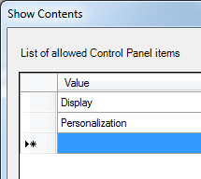
- In the "Show Contents" box, click in the Value field. Type Display and then press the Enter key.
- In the "Show Contents" box, click in the Value field. Type Personalization and then press the Enter key. The box should now show two items, as shown to the right on this page.
- In the "Show Contents" box, click OK.
- In the "Show only specified Control Panel items" box, click OK.

Viewing the Limited Control Panel
- If a "Control Panel" window is open, close it. Click Start, "Control Panel". Switch to "Large icons" view. Only two items should be visible, as shown below on this page.
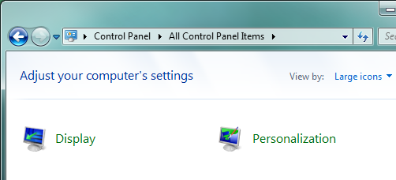

Saving a Screen Image
- Make sure the "All Control Panel Items" box is visible, showing only two items.
- Press PrintScrn to copy the whole desktop to the clipboard.
- Click Start and type in PAINT. Click Paint. In the untitled - Paint window, click Edit, Paste. The image appears in the Paint window.
- In the untitled - Paint window, click File, Save. Save the document with the filename Your Name Proj 8a, using a File Type of PNG or JPG.

Using Local Group Policy Editor to Return Control Panel to Normal
- Click Start, type gpedit.msc into the Search box, and press Enter.
- In "Local Group Policy Editor", in the left pane, in the "User Configuration" section, click the yellow "Administrative Templates" folder. Click the yellow "Control Panel" folder.
- In the right pane, double-click "Show only specified Control Panel items".
- In the "Show only specified Control Panel items" box, click the "Not Configured" button. Click OK.

Viewing the Normal Control Panel
- If a "Control Panel" window is open, close it. Click Start, "Control Panel". Switch to "Large icons" view. Many items should be visible, as shown below on this page.
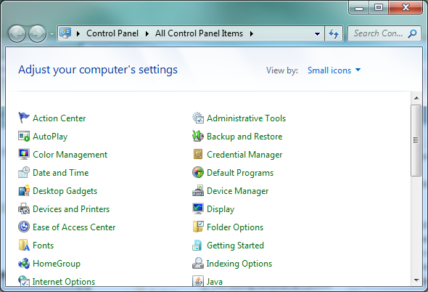

Saving a Screen Image
- Make sure the "All Control Panel Items" box is visible, showing many items.
- Press PrintScrn to copy the whole desktop to the clipboard.
- Click Start and type in PAINT. Click Paint. In the untitled - Paint window, click Edit, Paste. The image appears in the Paint window.
- In the untitled - Paint window, click File, Save. Save the document with the filename Your Name Proj 8b, using a File Type of PNG or JPG.

Turning in your Project
- Email the JPEG images to me as attachments to one e-mail message. Send the message to: cnit.345@gmail.com with a subject line of Proj 8 From Your Name, replacing Your Name with your own first and last name. Send a Cc to yourself.

Last revised 1-13-12

