Launching MMC
- Click Start, type MMC into the Search box, and press Enter. In the "User Account Control" box, click Yes.

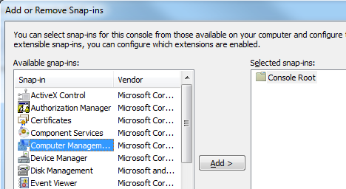
Adding Snap-ins
- In the "Console1- [Console Root]" window, click File, "Add/Remove Snap-in…".
- In the left pane of the "Add or Remove Snap-ins" box, click "Computer Management". Click the Add button.
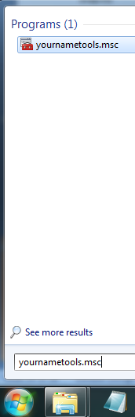
- In the "Computer Management" box, click Finish.
- Use the same procedure to add two more snap-ins of your choice.

Saving the Console
- In the "Console1- [Console Root]" window, click File, "Save As…". Save the file in the C:\Windows\System32 folder with the filename YournameTools. Replace Yourname with your own name. MMC will add a file extension of .msc to the file name.

Finding your Console on the Start Menu
- Click Start, and type the first few letters of your name into the Search box. You may need to type the whole name including the .msc, but you should be able to get the console to appear in the Start menu, as shown to the right on this page.

Saving a Screen Image
- Make sure the YournameTools.msc file is visible in the Start menu.
- Press PrintScrn to copy the whole desktop to the clipboard.
- Click Start and type in PAINT. Click Paint. In the untitled - Paint window, click Edit, Paste. The image appears in the Paint window.
- In the untitled - Paint window, click File, Save. Save the document with the filename Your Name Proj 9a, using a File Type of PNG or JPG.

Using Your Custom Console
- Click Start, and type the first few letters of your name into the Search box. You may need to type the whole name including the .msc, but you should be able to get the console to appear in the Start menu, as shown to the right on this page.
- In the Start menu, click the YournameTools.msc file. In the "User Account Control" box, click Yes.
- Click through the options in your console just to become somewhat familiar with theplug-ins you chose.

Turning in your Project
- Email the JPEG image to me as attachments to one e-mail message. Send the message to: cnit.345@gmail.com with a subject line of Proj 9 From Your Name, replacing Your Name with your own first and last name. Send a Cc to yourself.

Last revised 1-13-12

