What You Need for This Project
- A working Windows 7 machine with at least 5 GB free on the system volume
- A Windows 7 installation DVD (or the Windows ISO file from DreamSpark)
- A broadband Internet connection: you need to download 2 GB of stuff
`
Downloading and Installing 7-Zip
- Open a browser and go to 7-zip.com
- Down load the appropriate version for your operating system and install it with the default options.
Downloading and Unzipping WAIK (Windows Automated Installation Kit)
- Open a browser and go to samsclass.info
- Scroll to the bottom of the page and click the "Deploy 1: Download details: Windows® AIK for Windows® 7" link.
- If you are working at home: click the Dowload link and download the KB3AIK_EN.iso file. It will take a long time--it's 1.7 GB in size.
If you are in the S214 lab: Click Start, Computer. Open the VMs drive and open the Install folder. If the KB3AIK_EN.iso file is there, proceed to step 6. If it is not there, get the USB hard drive from the closet and copy the KB3AIK_EN.iso file to the VMs\Install folder.
- In the VMs\Install folder, right-click the KB3AIK_EN.iso file and click 7-Zip, Extract to "KB3AIK_EN\"
- Wait until 7-Zip finishes extracting the files.
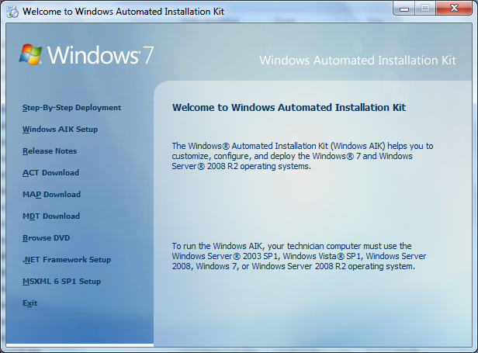
Installing WAIK (Windows Automated Installation Kit)
- Click Start, Computer. Open the VMs drive and open the Install folder. Open the KB3AIK_EN folder. Double-click the StartCD.exe file.
- The "Welcome to Windows Automated Installation Kit" box opens, as shown to the right on this page.

- On the left side, click "Windows AIK Setup".
- An installer starts. Click through using the default options
Copying the Install.wim File from the Windows 7 Installation DVD
- If you are in the S214 lab: Click Start, Computer. Open the VMs drive and open the Install folder. If the Install.wim file is there, proceed to step 15. If it is not there, do step 13.
- If you are working at home with a DVD: insert a Windows 7 install DVD. Open the DVD in Windows Explorer and open the Sources folder. Copy the Install.wim file to the VMs\Install folder.
- If you are working at home with an ISO file: Right-click the en_windows_7_professional_with_sp1_x86_dvd_u_677056.iso file and click 7-Zip, Extract to "en_windows_7_professional_with_sp1_x86_dvd_u_677056\". Open the en_windows_7_professional_with_sp1_x86_dvd_u_677056 folder. Open the Sources folder. The Install.wim file you need is there.
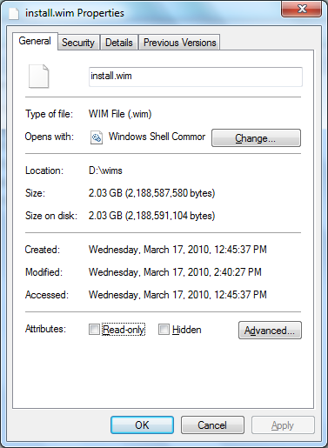
- insert a Windows 7 install DVD. Open the DVD in Windows Explorer and open the Sources folder. Copy the Install.wim file to the VMs\Install folder.
- What's the Install.wim file? This file contains images of every version of Windows 7, in the "Windows Image File" format.
Removing the Read-Only Flag from the Install.wim File
- On the VMs-S214 partition, in the Install folder, right-click the Install.wim file and click Properties.
- In the "install.wim Properties" box, make sure the "Read-only" check box is clear, as shown to the right on this page. Click OK.
Using Windows System Image Manager
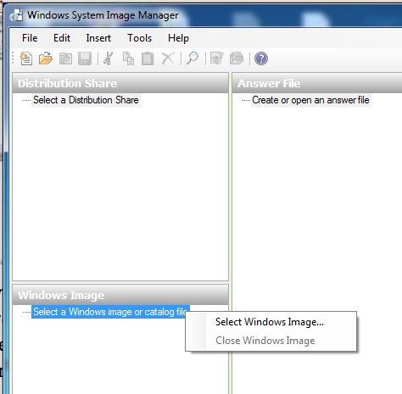
- Point to Start, "All Programs", "Microsoft Windows AIK", "Windows System Image Manager". A "Windows System Image Manager" window opens.
- In the lower left pane of the "Windows System Image Manager" window, in the "Windows Image" section, right-click "Select a Windows image or catalog file", as shown to the right on this page. Navigate to your install.wim file and double-click it--if you are working in S214, it should be on the VMs-S214 partition, in the Install folder.
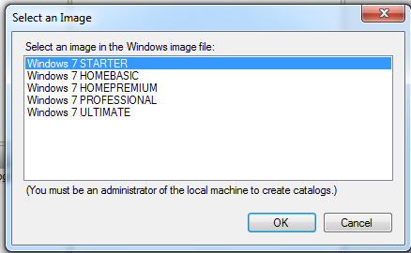
- In the "Select an image" box, click "Windows 7 PROFESSIONAL" and click OK.

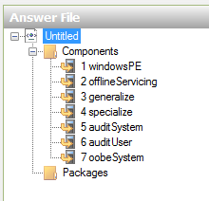
- In the "Windows System Image Manager" window, click File, "New Answer File". An "Untitled" answer file appears in the 'Answer File" pane, as shown to the right on this page.

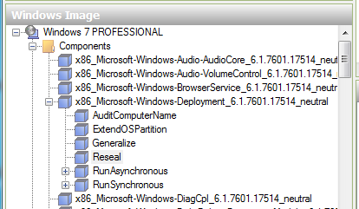

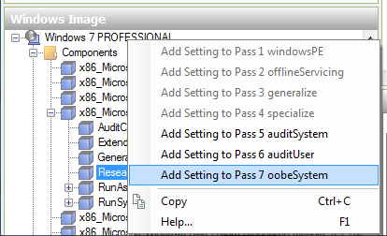
- In the lower left pane of the "Windows System Image Manager" window, in the "Windows Image" pane, expand the Components node, as shown to the right on this page.
- Expand the x86_Microsoft-Windows-Deployment_6.7601.17514_neutral component.
- Right-click Reseal and click "Add Setting to Pass 7 oobeSystem", as shown to the right on this page.
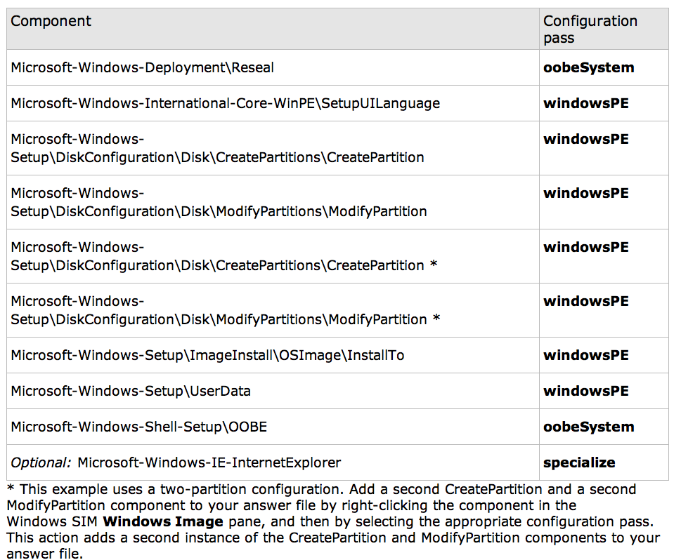
- Continue adding components, following the chart below. The starred items must be added twice.

- Your "Answer File" section should show many items now.
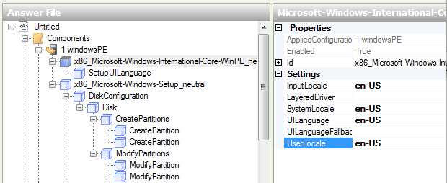
- In the "1 windowsPE" section, click "Microsoft-Windows-International-Core-WinPE" , as shown below on this page.

- On the right, a list of Properties and Settings appears. Type en-US into the four settings as shown.

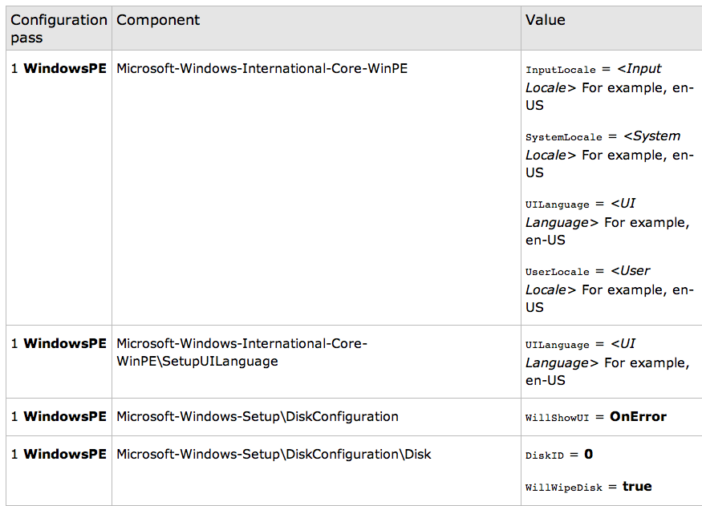
- Continue in the same manner, adding the settings shown below on this page and the next two pages.

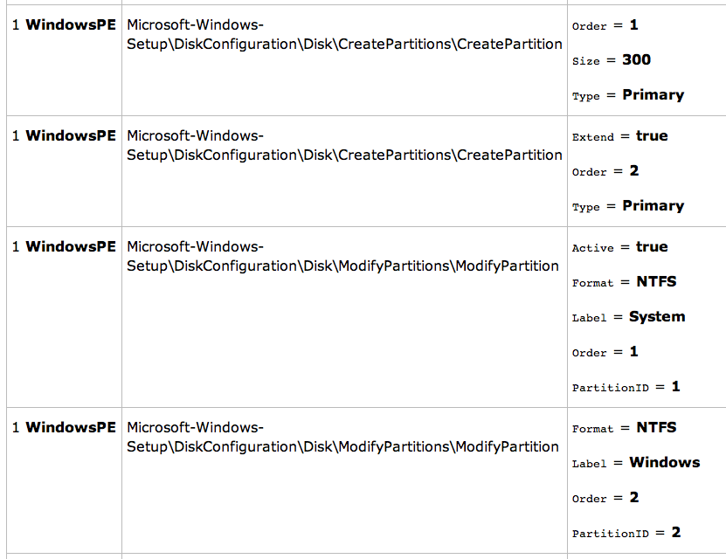
1

- The fourth item below asks for a product key. Just use the dummy value AAAAA-BBBBB-CCCCC-DDDDD-EEEEE.
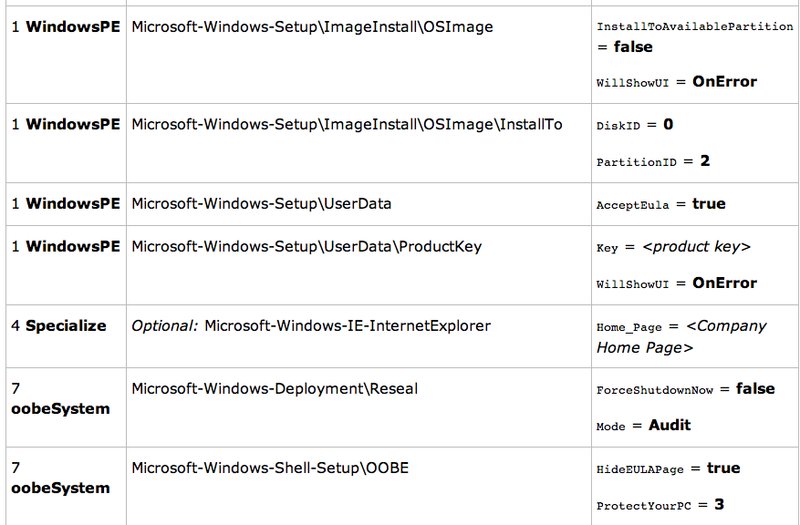
- The fifth item sets the Internet Explorer home page. Set it to www.ccsf.edu

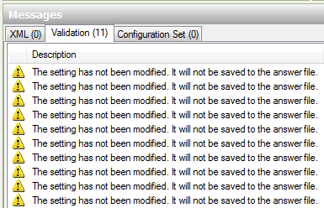
Validate Settings
- In Windows SIM, click Tools, and then click "Validate Answer File".
- You may see some Warnings" at the bottom, but no errors, as shown to the right on this page.

Saving the Screen Image
- Make sure the "Validation" section is visible, showing warnings but no errors, as shown on the previous page.
- Press the PrintScrn key in the upper-right portion of the keyboard. That will copy the whole desktop to the clipboard.
- Open Paint and paste the image in. Save the image with the filename Your Name Proj 11x.

Saving the Answer File
- On the File menu, click Save Answer File. Save the answer file as Autounattend.xml.

Turning in your Project
- Email the image to me as an attachment. Send the message to: cnit.345@gmail.com with a subject line of "Proj 11x From Your Name", replacing Your Name with your own first and last name. Send a Cc to yourself.

Sources
http://technet.microsoft.com/en-us/library/dd349348(v=WS.10).aspx#BKMK_1
http://technet.microsoft.com/en-us/windows/ff657745
Last Modified: 12-13-12

