Installing Windows Live Software
- You should have already have installed the Windows Live tools in a previous project. If you haven't done that, do project 11 first.
Starting Windows Family Safety
- Press the Windows logo key. Type FAM into the search box.
- "Windows Live Family Safety" should appear in the Programs list. If it's not already highlighted, press the down-arrow as needed to highlight it. Then press the Enter key.
- Log in with your Windows Live account. If you don't have one, click the "Sign up" link to get one.
- The "Windows Live Family Safety Filter" box appears, titled "Select the Windows accounts you want to monitor"as shown below on this page. Click "Create a new standard Windows user account".
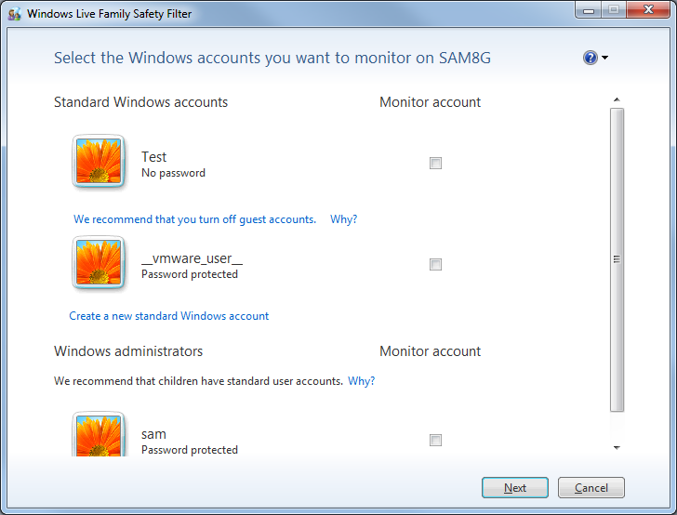
Monitoring the Child Account
- In the "Windows Live Family Safety Filter" box, type a name for the child account. I recommend ChildYourname replacing Yourname with your own name. Click "Create account".
- The new account appears in the "Windows Live Family Safety Filter" box with the "Monitor account" box checked. Click Next.
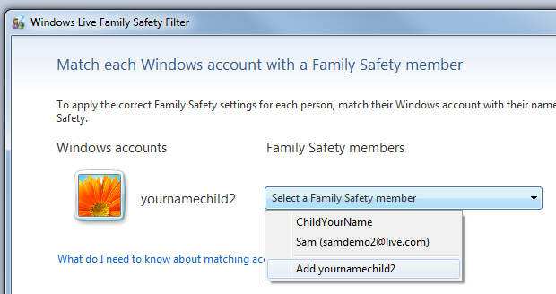
- The next page asks you to "Match each Windows account with a Family Safety member". Click the drop-down arrow and choose the last option to add your new account to the list, as shown below on this page. Click Save.

- The next screen warns you that some accounts don't have passwords. Click Next.
- The next screen says that "Family Safety is now monitoring these Windows accounts". Click Close.
Signing in with the Child Account
- Click Start. Click the right-arrow next to the "Shut down" button. Click "Switch user".
- Sign in with the Child account.
Browsing the Web
- Open Internet Explorer and go to msn.com. Then go to Yahoo.com.
- Open Firefox and go to kittenwar.com. Then go to Slashdot.org.
- Click Start. Click the right-arrow next to the "Shut down" button. Click "Log off".
Viewing an Activity Report
- Log in with your usual account.
- In the "Windows Live Family Safety Filter" box, click familysafety.live.com.
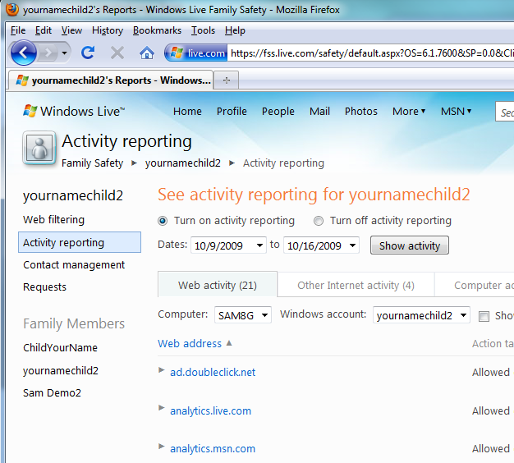
- In the Family Safety webpage, in the line showing your child account, click "View activity report".
- The "Activity reporting" page opens, showing the Web addresses used by the Child, as shown to the right on this page. Notice that it detects all the Web sites visited, even the ones viewed with Firefox.

Saving the Screen Image
- Press PrintScrn. Paste the screen into Paint. Save the image as a PNG or JPG file with the filename Your Name Proj 12.

Turning in your Project
- Send the image as an Email attachment to: cnit.345@gmail.com with a subject line of "Proj 12 From Your Name", replacing Your Name with your own first and last name. Send a Cc to yourself.

Removing Family Safety
- Unless you are actually sharing this machine with children, you probably want to remove Family Safety, with the steps below.
- Click Start, "Control Panel", "Programs and Features". In the list of programs, click "Windows Live Essentials". Click "Uninstall/change".
- In the "Uninstall or repair your Windows Live programs" box, accept the default selection of Uninstall and click Continue.
- In the "Select the programs you want to uninstall" box, check "Family Safety" and click Continue. In the "Done" box, click Close.

Last Modified 10-16-09

