What You Need for This Project
- A working Windows 7 machine with WAIK installed, and an answer file, as you did in the previous project
- A Windows 7 installation DVD (or the Windows ISO file from DreamSpark)
`
Set up a Windows PE build environment
- Click Start, point to All Programs, scroll down and click Microsoft Windows AIK. Right-click Deployment Tools Command Prompt, and then click Run as administrator. In the User Account Control box, click Yes. The menu shortcut opens a command-prompt window and automatically sets environment variables to point to all the necessary tools, as shown below on this page.

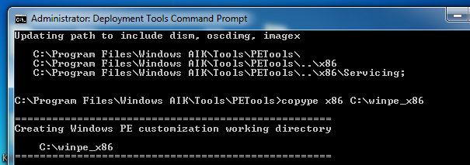

- In the Deployment Tools Command Prompt, enter these commands, pressing Enter after each one:
copype x86 C:\winpe_x86
copy "C:\Program Files\Windows AIK\Tools\x86\imagex.exe" C:\winpe_x86\iso
copy c:\winpe_x86\winpe.wim c:\winpe_x86\ISO\sources\boot.wim
Add Boot Support
- In this step, you will add boot files to your Windows PE image. Before you can add files to the image, you must expand the image by using the DISM /Mount-Wim command.
- In the Deployment Tools Command Prompt, enter these commands, pressing Enter after each one:
Dism /Mount-Wim /Wimfile:c:\winpe_x86\ISO\sources\boot.wim /index:1 /MountDir:C:\winpe_x86\mount
copy c:\winpe_x86\ISO\bootmgr c:\winpe_x86\mount
mkdir c:\winpe_x86\mount\boot
xcopy /cherky C:\winpe_x86\ISO\boot C:\winpe_x86\mount\boot\
Add ImageX
- In this step, you will add ImageX to your Windows PE image. You will need it to capture an image of your template machine.
- In the Deployment Tools Command Prompt, enter this command, and then press Enter:
copy "c:\program files\Windows AIK\Tools\x86\ImageX.exe" c:\winpe_x86\mount
Configure BCD store
- In this step, you create a new boot-configuration file, called BCD, by using BCDEdit. BCD, which replaces Boot.ini, is a command-line tool designed to manage BCD stores.
- In the Deployment Tools Command Prompt, enter these commands, pressing Enter after each one:
Del c:\winpe_x86\mount\boot\BCD
Bcdedit /createstore c:\winpe_x86\mount\boot\BCD
Bcdedit /store c:\winpe_x86\mount\boot\BCD -create {bootmgr} /d "Boot Manager"
Bcdedit /store c:\winpe_x86\mount\boot\BCD -set {bootmgr} device boot
Bcdedit /store c:\winpe_x86\mount\boot\BCD -create /d "WINPE" -application osloader
The last command returns a GUID value. Substitute this value for <GUID> in the following commands:
Bcdedit /store c:\winpe_x86\mount\boot\BCD -set <GUID> osdevice boot
Bcdedit /store c:\winpe_x86\mount\boot\BCD -set <GUID> device boot
Bcdedit /store c:\winpe_x86\mount\boot\BCD -set <GUID> path \windows\system32\winload.exe
Bcdedit /store c:\winpe_x86\mount\boot\BCD -set <GUID> systemroot \windows
Bcdedit /store c:\winpe_x86\mount\boot\BCD -set <GUID> winpe yes
Bcdedit /store c:\winpe_x86\mount\boot\BCD -displayorder <GUID> -addlast
Commit Changes
- In this step, you commit changes to the image. To commit changes to the original image file, use the Dism /Unmount option together with the /Commit option:
- In the Deployment Tools Command Prompt, enter this command, and then press Enter:
Dism /Unmount-Wim /MountDir:C:\winpe_x86\mount /Commit
Creating a Bootable ISO File
- In the Deployment Tools Command Prompt, enter this command, and then press Enter:
Oscdimg -n -m -o -bC:\winpe_x86\Etfsboot.com C:\winpe_x86\ISO C:\winpe_x86\winpex86.iso
Here's how the oscdimg command works:
Usage: OSCDIMG [options] sourceroot targetfile
-n: long file names
-m: ignore maximum soze limit
-o: Encode duplicate files only once
-b: specifies file that will be written to the boot sector of the disk
Examining the ISO File
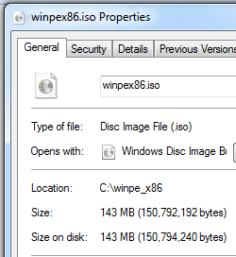
- Click Start, Computer. Open the C: drive and open the Winpe_x86.
- Right-click the winpe_x86.iso file and click Properties.
- The "Type of file" should be "Disc Image File", and the Size should be 143 MB, as shown to the right on this page.

Saving the Screen Image
- Make sure "Disc Image File" and "143 MB" are visible, as shown above on this page.
- Press the PrintScrn key in the upper-right portion of the keyboard. That will copy the whole desktop to the clipboard.
- Open Paint and paste the image in. Save the image with the filename Your Name Proj 12x. Select a Save as type of JPEG.

Turning in your Project
- Open Firefox, and use it to email the JPEG image to me as an email attachment. Send the message to: cnit.345@gmail.com with a subject line of "Proj 12x From Your Name", replacing Your Name with your own first and last name. Send a Cc to yourself.

Sources
http://technet.microsoft.com/en-us/library/dd744537(v=WS.10).aspx
Last Modified: 2-26-12

