Installing Windows Live Software
- Click Start. Type in LIVE MAIL. If "Windows Live Mail" is not found, click "Go online to get Windows Live Essentials".
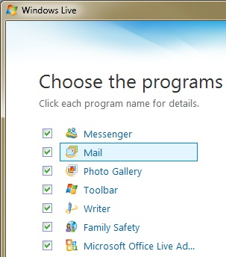
- A browser opens showing the Windows Live Essentials page. Click the Download button.
- Save the wlsetup-web.exe file on your desktop.
- On your desktop, double-click the wlsetup-web.exe file.
- Install the software with the default options. This will add several programs to your Windows 7 machine, as shown to the right on this page.

Creating a Windows Live ID
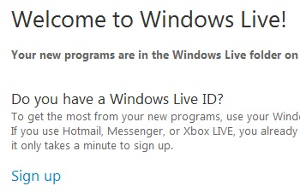
- When the installation is complete, a box will appear announcing "Welcome to Windows Live!", as shown to the right on this page. Click "Sign up".
- A Web page appears with a form to fill out to create a Windows Live ID. Fill it in. Write down your Windows Live ID and password in the box below.

Windows Live ID: ____________________________________
Password: ____________________________________

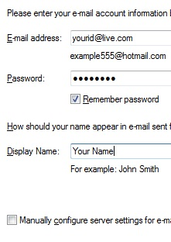
Starting Windows Live Mail
- Click Start. "Windows Live Mail" should appear in the Programs list. If it's not already highlighted, press the down-arrow as needed to highlight it. Then press the Enter key.
- A "Windows Live Mail" window opens. An "Add an E-mail Account" box may open automatically, as shown to the right on this page. If it does not, right-click all the existing email accounts and select "Remove account". Then click "Add e-mail account" on the left side of the window.
- Fill in the "Add an E-mail Account" box with your Windows Live information, as you wrote it in the box on the previous page of these instructions. Then click Next. Click Finish.
- A message appears saying "Windows Live Mail needs to download the folders…". Click Download.
- If an error message appears, saying "There is no hotmail account associated with your Windows Live ID", follow the instructions in that message to solve the problem.
- Your inbox should appear, showing a welcome message, as shown below on this page.
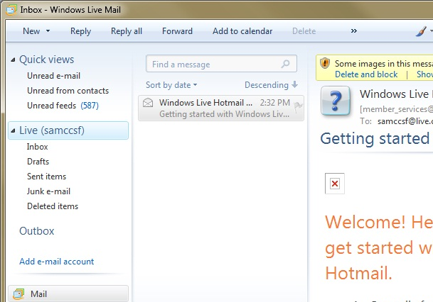

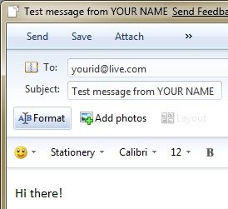
Sending a Message
- In the upper left of the "Windows Live Mail" window, click New.
- Compose a message to yourself, with your name in the subject line, as shown to the right on this page.
- In the upper left corner of the message window, click Send. If a Captcha appears, showing twisted letters, type them in.
- In the upper center of the "Windows Live Mail" window, click Sync.
- Your message should appear in the Inbox, as shown below on this page. If it does not, wait a minute or two and try again.

Capturing an Image of the Received Message
- Make sure that your Inbox contains a message you sent, not just the automatic "Windows Live Hotmail" message.
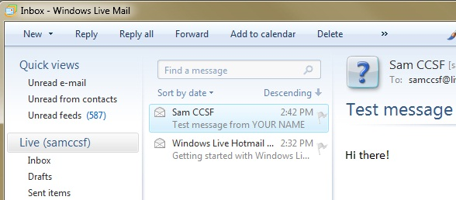

- Press the PrintScrn key in the upper-right portion of the keyboard.
- Press the Windows logo key. Type PAINT into the Search box. When Paint is highlighted in the Search list, press the Enter key.
- Click in the untitled - Paint window. Then press Ctrl+V on the keyboard. The captured screen image appears in the Paint window.
- Click the Save icon in the Paint window (it looks like a tiny blue floppy disk). Save the document with the filename Your Name Proj 13.

Turning in your Project
- Email the image to me as an attachment to an e-mail message. Send the message to: cnit.335@gmail.com with a subject line of CNIT 345 Proj 13 From Your Name, replacing Your Name with your own first and last name. Send a Cc to yourself.
Last modified 10-9-09

