What You Need for This Project
- A WinPE ISO image including ImageX, which you made in the previous project.
- A Windows 7 virtual machine (I used VMware Fusion on a Mac, but you could use any virtual machine type)
`
Creating the G: Capture Volume
- You need a place to store the image. We'll borrow some space from the system volume for that.
- Boot your virtual machine to Windows 7.
- Click Start, right-click Computer, and click Manage.
- In the left pane of Computer Management, click "Disk Management".
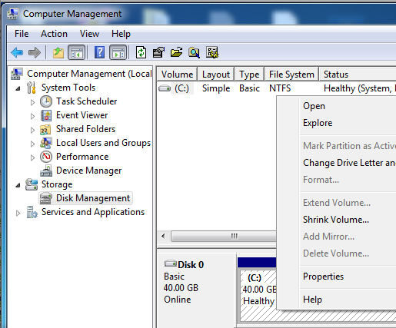
- In the right pane, right-click the C: partition and click "Shrink Volume…", as shown below on this page.

- In the Shrink box, in the "Enter the amount of space to shrink in MB", enter 10000 and click the Shrink button.

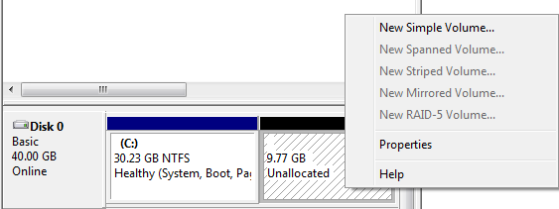
- Right-click the "Unallocated" portion of the disk and click "New Simple Volume", as shown below on this page.

- In the "Welcome to the New Simple Volume Wizard" box, click Next.
- In the "Specify Volume Size" box, click Next.
- In the "Assign the following drive letter" box, select a drive letter of G: and click Next.
- In the "Format Partition" box, click Next.
- In the "Completing the New Simple Volume Wizard" box, click Finish.
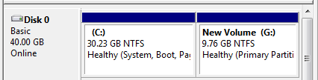
- You should now have a G: volume with approximately 10 GB available, as shown below on this page.

- Click Start, Shut Down to power off your virtual machine.
Connecting the ISO File to the Virtual Machine
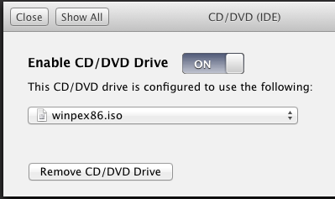
- When your virtual machine has shut down, in the VMware Workstation menu, click Virtual Machine, Settings. Configure the CD/DVD to point to the WinPE ISO file you made in the previous project. The exact steps to accomplish this depend on your virtualization software--the image to the right on this page shows the configuration in VMware Fusion on the Mac.
- Start your virtual machine. If it boots from the ISO file, proceed to the next step. If it still boots from the hard drive, you need to change the BIOS settings. If you are using VMware Workstation on Windows, there is a menu item to reach the BIOS (VM, Power, Power On to BIOS). If you are using VMware Fusion on a Mac, you need to use the procedure described on this page to enter the BIOS:
http://niwos.com/2011/04/17/enter-bios-settings-and-boot-from-cdrom-with-vmware-fusion/
- In the BIOS, configure the CD-ROM to be the first boot device, as shown below on this page.
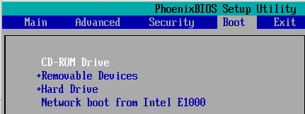

The WinPE Environment
- The WinPE environment has a gray background graphic, and a Command Prompt, as shown below on this page.

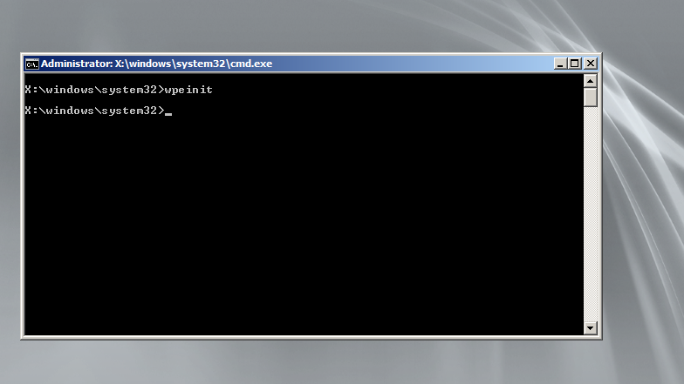

Finding IMAGEX
- In the elevated Command Prompt, enter these commands, pressing Enter after each one:
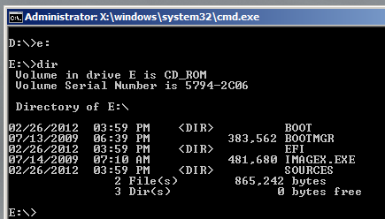
E:
dir
- If your DVD drive is E:, you should see a list of files including IMAGEX.EXE, as shown to the right on this page. If you don't, you will have to try other druve letters till you find IMAGEX.EXE.
Creating an Image of the Reference Computer
- In the elevated Command Prompt, enter these commands, pressing Enter after each one:
E:imagex.exe /capture c: d:\installationimage.wim "YOUR BAME Win7 Install" /compress fast /verify
- The process will take a long time-, but at least it tells you how long it will be. When I did it, it took 20 minutes, as shown below on this page.

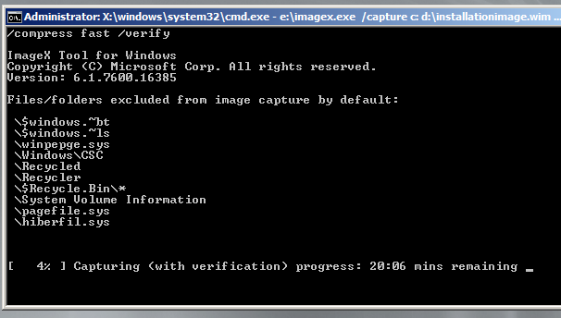
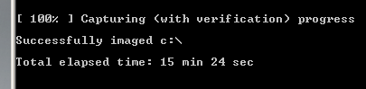

Saving the Screen Image
- Make sure "Successfully imaged c:\" message is visible, as shown above on this page.
- Save the image with the filename Your Name Proj 13x.

Turning in your Project
- Email the image to me as an email attachment. Send the message to: cnit.345@gmail.com with a subject line of "Proj 13x From Your Name", replacing Your Name with your own first and last name. Send a Cc to yourself.
Last Modified: 2-26-12

