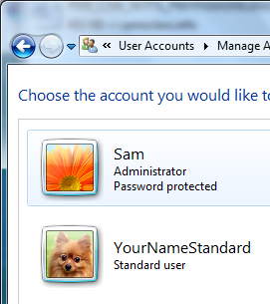
This project can be done on any Windows 7 machine.

Creating a Standard User Account
- You should have already done this in the previous project. If you did not, do these steps:
  - Click Start. Type USER and click "User Accounts".
  - In the "User Accounts" box, click "Manage another account".
  - In the "Manage Accounts" box, click "Create a new account".
  - In the "Create New Account" box, enter a name of YournameStandard, replacing Yourname with your own name. Accept the default selection of "Standard User" and click "Create account". You should see the new account, as shown to the right on this page.

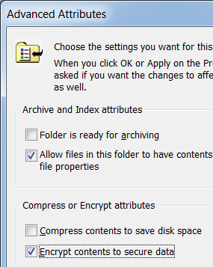
Creating the YourNameEFS Folder
- Click Start, Documents. In the left pane of Windows Explorer, expand the Documents library. Click "Public Documents". In the right pane, right-click an empty spot and select New, Folder to create a new folder. Name the folder YourNameEFS, replacing Yourname with your own name.

Encrypting the Folder
- Right-click the YourNameEFS folder and select Properties. On the General tab, click the Advanced button.
- In the Advanced Attributes window, check Encrypt contents to secure data box, as shown to the right on this page. Click OK.
- Click OK to close the "YourNameEFS Properties" box. Notice that the name of the folder is green – that’s the color Windows uses to denote encrypted files and folders.
- A message may appear saying "Back up your file encryption key". If it does, just let the message fade away.

Creating the Secret.txt File
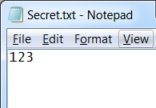
- Double-click the YourNameEFS folder to open it. Right-click an empty portion of the YourNameEFS window and select New, Text Document to create a new document. Name the document Secret (the .txt file extension may or may not be visible, depending on your Folder Options settings).
- Double-click the Secret.txt file to open it in Notepad. Type in some text, as shown to the right on this page. Save the file and close Notepad.
- Click on an empty portion of the window to deselect the Secret.txt file. Notice that the file is green, because it is encrypted. Any file created in an encrypted folder is automatically encrypted.

Switching User to the YourNameStandard Account
- Click Start. Click the right-arrow next to the "Shut down" button and click "Switch User".
- Log in as YourNameStandard.

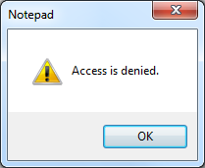
Attempting to Open the Secret.txt File
- Click Start, Documents. In the left pane of Windows Explorer, expand the Documents library. Click "Public Documents".
- Double-click the YourNameEFS folder. The folder opens, showing the Secret.txt file inside.
- Double-click the Secret.txt file. A box appears, saying that "Access is denied", as shown to the right on this page. Click the OK button.

Creating an Encryption Key for the YourNameStandard Account
- On your desktop, right-click and click New, Folder.
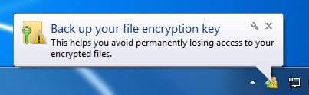
- Right-click the New Folder and select Properties. On the General tab, click the Advanced button. In the Advanced Attributes window, check Encrypt contents to secure data box. Click OK. Click OK.
- A message appears saying "Back up your file encryption key", as shown to the right on this page. This indicates that Windows has just created a new encryption key.

Returning to Your Normal Account
- Click Start. Click the right-arrow next to the "Shut down" button and click "Switch User". Log in with your normal account.

Granting YourNameStandard Access to the Secret.txt File
- Click Start, Documents. In the left pane of Windows Explorer, expand the Documents library. Click "Public Documents". Double-click the YourNameEFS folder.
- Right-click the Secret.txt file and select Properties. On the General tab, click the Advanced button.
- In the "Advanced Attributes" window, in the Compress or Encrypt attributes section, click the Details button.
- The "User Access to Secret.txt: box opens, showing that only your account can access this file. Click the Add… button. A box pops up showing accounts on this machine with certificates. Click YourNameStandard and click OK.

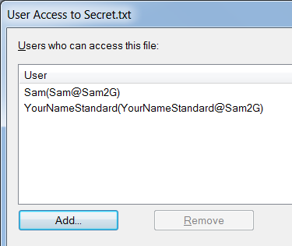
- The "User Access to Secret.txt" box should now show two users, as shown to the right on this page.

Saving the Screen Image
- Make sure that the "User Access to Secret.txt" box shows two users.
- Press PrintScrn. Paste the screen into Paint. Save the image as a PNG or JPG file with the filename Your Name Proj 14a.

Completing the Process of Granting Access to the Secret.txt File
- In the "User Access to Secret.txt" box, click OK.
- In the "Advanced Attributes" window, click OK.
- In the "Secret.txt Properties" window, click OK.

Switching Users to the YourNameStandard Account
- Click Start. Click the right-arrow next to the "Shut down" button and click "Switch User".
- Log in as YourNameStandard.

Opening the Secret.txt File
- Click Start, Documents. In the left pane of Windows Explorer, expand the Documents library. Click "Public Documents".
- Double-click the YourNameEFS folder. The folder opens, showing the Secret.txt file inside.
- Double-click the Secret.txt file. It opens and shows you the text it contains.

Returning to Your Normal Account
- Click Start. Click the right-arrow next to the "Shut down" button and click "Log Off". Log in with your normal account.

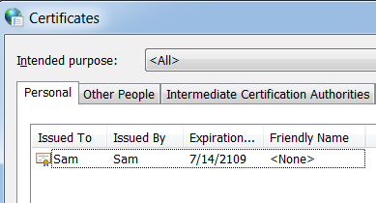
Exporting Your EFS Certificate
- Click Start and type INTER
- Click "Internet Options". Click the Content tab. Click the Certificates button. You should see a certificate with your login name on it as shown to the right on this page.
- Click the certificate with your login name on it to highlight it. Click the Export button.
- In the "Welcome to the Certificate Export Wizard" screen, click Next.
- At the "Export Private Key screen", select "Yes, export the private key" and click Next.
- At the "Export File Format" screen, accept the default selection of "Personal Information Exchange - PKCS #12 (.PFX)" and click Next.
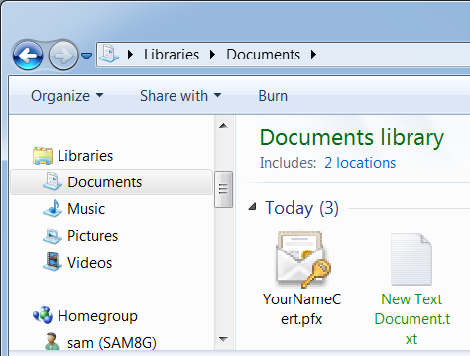
- At the Password screen, enter P@ssw0rd in both boxes and click Next.
- At the File to Export screen, click the Browse button. Browse to your Documents folder, enter a filename of YourNameCert, and then and click Save. Click Next.
- In the "Completing the Certificate Export Wizard" screen, click Finish.
- A "Certificate Export Wizard" box opens saying "The export was successful". Click OK.
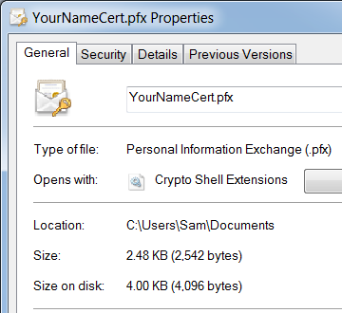
- Click Start, Documents. You should see the YourNameCert.pfx file, as shown to the right on this page.
- Right-click the YourNameCert.pfx file and click Properties. The Properties sheet opens, as shown to the right on this page.

Saving the Screen Image
- Make sure that the Properties sheet shows a file type of "Personal Information Exchange", as shown to the right on this page.
- Press PrintScrn. Paste the screen into Paint. Save the image as a PNG or JPG file with the filename Your Name Proj 14b.

Turning in your Project
- Switch users back to your normal account.
- Send the images attached to an email. Send it to: cnit.345@gmail.com with a subject line of "Proj 14 From Your Name", replacing Your Name with your own first and last name. Send a Cc to yourself.

Last modified 1-13-12

