What You Need for This Project
- A Windows 7 computer (real or virtual)
`
Creating a VHD in Disk Management
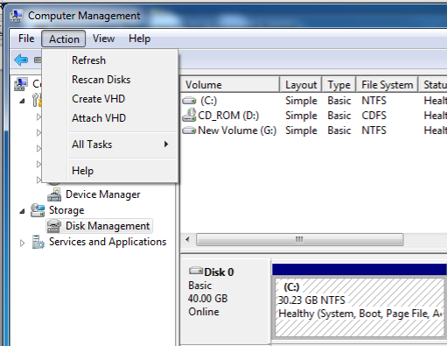
- Click Start. Right-click Computer. Click Manage.
- In "Computer Management", on the left side, click "Disk Management".
- From the "Disk Management" menu bar, click Action, "Create VHD", as shown to the right on this page.
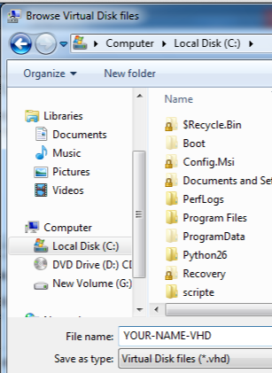
- In the "Create and Attach Virtual Hard Disk" box, click the Browse button.
- In th left pane of the "Browse Virtual Disk files" box, click "Local Disk(C:)". Enter a filename of YOUR-NAME-VHD (using your own name instead of the literal words "YOUR" and "NAME") as shown to the right on this page. Click the Save button.

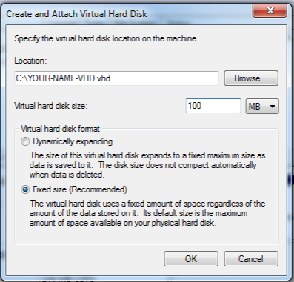
- Enter a "Virtual hard disk size" of 100 MB, as shown to the right on this page. Click the OK button.

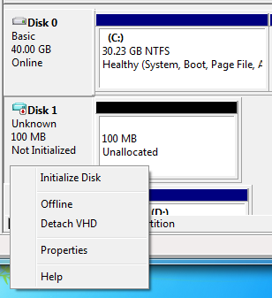
- A new disk appears in the lower portion of Disk Management, as shown to the right on this page. The leftmost block of the new disk entry says "Disk 1" and "Uninitialized". Right-click that block and click "Initialize Disk".
- In the "Initialize Disk" box, accept the default selection of "MBR" and click the OK button.
- Right-click the "Unallocated" space of your new disk and click "New Simple Volume".
- In the " Simple Volume Wizard", click Next four times and then click Finish.
- The process is slow--it took about 2 minutes when I did it.

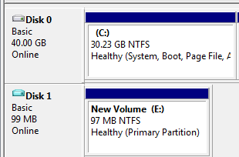
- When the process is complete, you will see a volume named "New Volume" that is approximately 97 MB in size, and "Healthy" as shown to the right on this page:

Saving the Screen Image
- Make sure the volume shows a status of "Healthy" and a size of approximately 97 MB, as shown above on this page.
- Save the image with the filename Your Name Proj 14x.

Turning in your Project
- Email the image to me as an email attachment. Send the message to: cnit.345@gmail.com with a subject line of "Proj 14x From Your Name", replacing Your Name with your own first and last name. Send a Cc to yourself.
Last Modified: 3-5-12 2 pm

