This project requires only one Windows 7 machine.
NTFS Permissions Facts
- These powerful file and folder security features are not available on FAT or FAT32 partitions, but only on NTFS ones.
- The owner of a file or folder, and users with Full Control permission, can assign permissions to it
- The NTFS Folder Permissions are
  - Read, Write, List Folder Contents, Read and Execute, Modify, Full Control
- The NTFS File Permissions are
  - Read, Write, Read and Execute, Modify, Full Control
Multiple NTFS Permissions
- This can happen because a user may belong to groups, so the same user may have 2 or more different permissions applicable to the same file or folder
- Allow Permissions are Cumulative
  - Example: If a user has Read permission, and is in a group with Write permission, that user has both Read and Write permission.
- File Permissions are Separate From Folder Permissions
  - NTFS file permissions take priority over NTFS folder permissions
  - Example: A user with Modify permission for a file will be able to change it even if that user has only Read permissions for the folder containing the file
- Deny Overrides Other Permissions
  - If a user has Full Control permission, and is in a group with Write permission set to Deny, that user can not Write
Permissions Inheritance
- By default, permissions from the parent folder are inherited by all objects within that folder
- Inherited permissions appear grayed-out in the properties box
- To prevent permission inheritance, clear the Allow inheritable permissions from parent to propagate to this object check box in the Security tab of the object’s Properties
  - You must choose to Copy inherited permissions from the parent folder or Remove the inherited permissions

Creating a Standard User Account
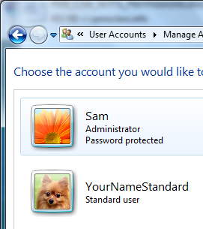
- Click Start. Type USER and click "User Accounts".
- In the "User Accounts" box, click "Manage another account".
- In the "Manage Accounts" box, click "Create a new account".
- In the "Create New Account" box, enter a name of YournameStandard, replacing Yourname with your own name. Accept the default selection of "Standard User" and click "Create account". You should see the new account, as shown to the right on this page.

Creating the YourNameNTFS Folder
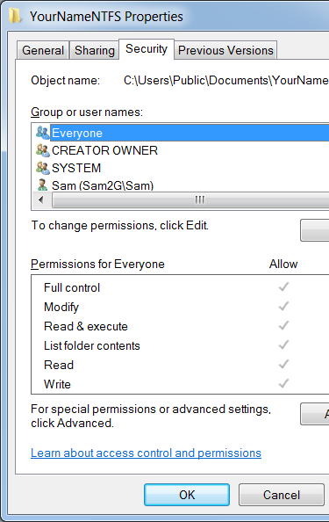
- Click Start, Documents. In the left pane of Windows Explorer, expand the Documents library. Click "Public Documents". In the right pane, right-click an empty spot and select New, Folder to create a new folder. Name the folder YourNameNTFS, replacing Yourname with your own name.

Observing NTFS Permissions
- Right-click the YourNameNTFS folder and click on Properties. In the "YourNameNTFS Properties" box, click the Security tab. This displays the Access Control List, also known as NTFS Permissions. Note that Everyone has Full Control, as shown to the right on this page. Full Control means that all permissions are allowed, so all the Allow boxes are checked. The gray check boxes indicate that these are inherited permissions.

Adding Permissions for Users
- In the "YourNameNTFS Properties" box, click Edit.
- In the "Permissions for YourNameNTFS" box, click Add.
- In the "Select Users or Groups" box, in the "Enter the object names to select" field, type Users and then click OK.

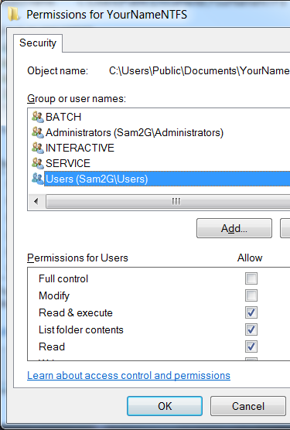
- A new item named Users appears in the "Permissions for YourNameNTFS" box, as shown to the right on this page. Click Users to highlight it. Notice that the Users object has only Read & execute, List folder contents, and Read permissions. Also notice that the check boxes are not grayed out, because these are explicit permissions, not inherited permissions. Click OK.

Advanced Security Settings
- In the "YourNameNTFS Properties" box, on the Security tab, click the Advanced button. An "Advanced Security Settings for YourNameNTFS" window opens as shown below on this page. This page lists all the permissions in a table so you can see them all at once.

Saving the Screen Image
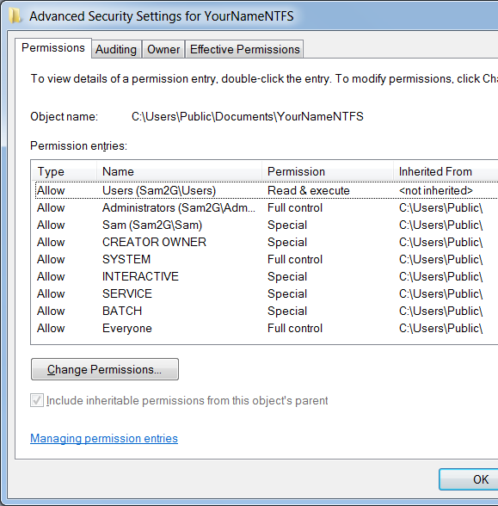
- Make sure that the "Advanced Security Settings for YourNameNTFS" window shows both "<not inherited>" and Inherited permissions (indicated by the path C:\Users\Public), as shown to the right on this page.
- Press PrintScrn. Paste the screen into Paint. Save the image as a PNG or JPG file with the filename Your Name Proj 15a.

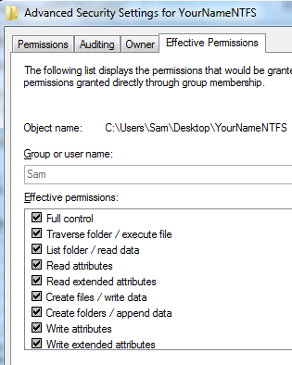
Observing Effective Permissions for Yourself
- In the "Advanced Security Settings for YourNameNTFS" window, click the Effective Permissions tab. Click the Select button. In the "Select User or Group" box, enter your logon name and click OK.
- Now you can see your login name in the Group or User Name box, and the effective permissions you have, as shown to the right on this page. You have all 14 possible permissions for the file – this is also known as Full Control.
- In the "Advanced Security Settings for YourNameNTFS" window, click the OK button.

Removing Inherited Permissions
- In the "YourNameNTFS Properties" box, on the Security tab, click the Edit button.
- In the "Permissions for YourNameNTFS" box, click the Everyone item. Click the Remove button to remove it.
- A "Windows Security" box opens explaining that you must prevent this object from inheriting permissions. Read the message and click OK to close it. You cannot remove inherited permissions without blocking permission inheritance first.
- In the "Permissions for YourNameNTFS" box, click the Cancel button.
- In the "YourNameNTFS Properties" box, click the Advanced button to open the "Advanced Security Settings for YourNameNTFS" window. Click the 'Change Permissions…" button.
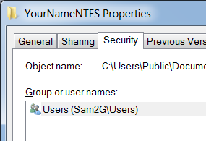
- In the new "Advanced Security Settings for YourNameNTFS" box, clear the "Include inheritable permissions from this object's parent" check box. When a "Windows Security" box opens, select Remove.
- Click OK to close the "Advanced Security Settings for YourNameNTFS" box.
- Click OK to close the other "Advanced Security Settings for YourNameNTFS" box.
- The "YourNameNTFS Properties" box should now have only one item: Users, as shown to the right on this page.

Removing Permissions for the Users Group
- In the "YourNameNTFS Properties" box, on the Security tab, click the Edit button.
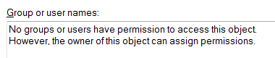
- In the "Permissions for YourNameNTFS" box, the Users item should be highlighted. Click the Remove button to remove it. This removes all permissions. A message appears explaining the situation, , as shown to the right on this page. Click OK.
- In the "Windows Security" box, click Yes.
- In the "YourNameNTFS Properties" box, click OK.

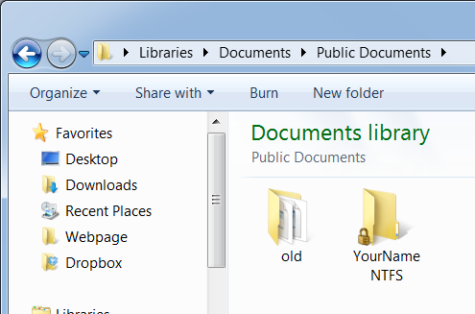
Opening the Folder
- The "YourNameNTFS" folder now appears with a lock icon on it, , as shown to the right on this page. Double-click the "YourNameNTFS" folder.

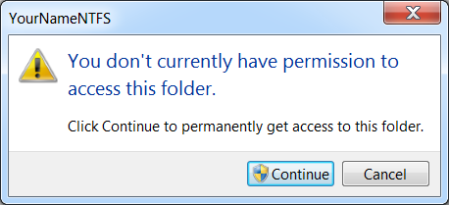
- A "YourNameNTFS" box appears, , as shown to the right on this page. Click Continue.
- In the left pane of Windows Explorer, click "Public Documents".
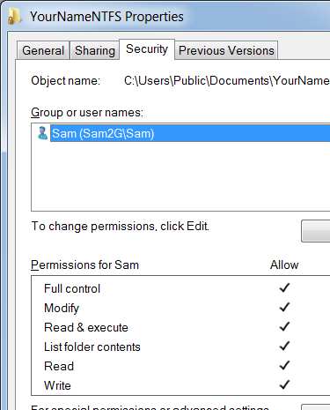
- Right-click the "YourNameNTFS" folder and click Properties. Click the Security tab. Windows 7 has automatically granted you Full Control over this folder, as shown to the right on this page.

Saving the Screen Image
- Make sure that the "YourNameNTFS Properties" window shows only one item with your logon name on it, as shown to the right on this page.
- Press PrintScrn. Paste the screen into Paint. Save the image as a PNG or JPG file with the filename Your Name Proj 15b.

Switching Users to the YourNameStandard Account
- Click Start. Click the right-arrow next to the "Shut down" button and click "Switch User".
- Log in as YourNameStandard.

Attempting to Open the YourNameNTFS Folder
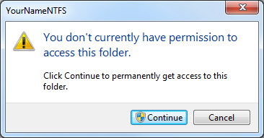
- Click Start, Documents. In the left pane of Windows Explorer, expand the Documents library. Click "Public Documents".
- Double-click the YourNameNTFS folder. A box appears, saying that you don't have permission to open this folder, as shown to the right on this page. Click the Continue button.
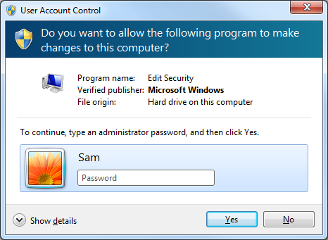
- A "User Account Control" box appears, as shown to the right on this page. This Standard account cannot take ownership of the account and gain permissions--an Administrator password is required. Click No.
- In the left pane of Windows Explorer, click "Public Documents".
- Right-click the YourNameNTFS folder and click Properties. The Properties sheet shows a message explaining why you cannot even view permissions, as shown to the right on this page.

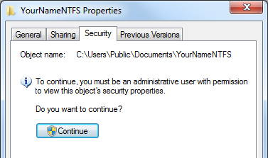
Saving the Screen Image
- Make sure that the "YourNameNTFS Properties" window shows the message shown to the right on this page.
- Press PrintScrn. Paste the screen into Paint. Save the image as a PNG or JPG file with the filename Your Name Proj 15c. Save it in the Public Documents folder so you can find it from your other account.

Turning in your Project
- Switch users back to your normal account.
- Send the images attached to an email. Send it to: cnit.345@gmail.com with a subject line of "Proj 15 From Your Name", replacing Your Name with your own first and last name. Send a Cc to yourself.

Last modified 10-18-09

