This project requires two Windows 7 computers connected to the same network. I call them computer A and computer B below.

Starting Remote Assistance: Do This on Computer A
- Click Start. Type REM. Click "Windows Remote Assistance"
- A "Windows remote Assistance" box opens. Click "Invite someone you trust to help you".
- The next screen asks "How do you want to invite someone to help you?". Click "Save this invitation as a file".
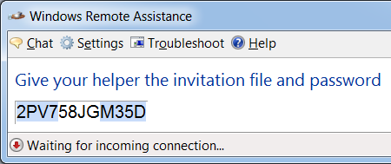
- The next screen says "Save this invitation as a file". Accept the default path and file name, which will create an Invitation.msrcIncident file in your Documents library.
- A box appears saying "Give your helper the invitation file and this password", as shown to the right on this page.

Transferring the Invitation File to Computer B
- Transfer the Invitation file to computer B any way you like. For example, you could copy it to a floppy disk or USB memory stick, or send it by email.

Accepting the Invitation: Do This on Computer B
Double-click the Invitation.msrcincident file. A box pops up asking for the password. Enter the password you saw in step 4 and click OK.
- A large dark window opens. Computer B is waiting for the user on Computer A to approve the connection.

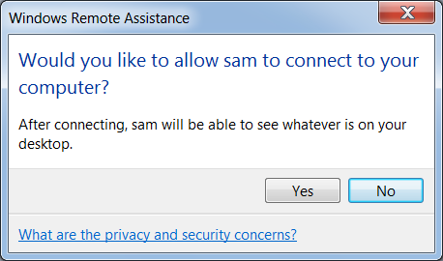
Accepting the Assistance: Do This on Computer A
- A "Windows Remote Assistance" box appears, saying "Would you like to allow Name to connect to your computer?", as shown to the right on this page. Click Yes.
- The background turns to black, and the color scheme is changed to Basic (No Aero).

Using Remote Assistance in View Only Mode: Use Both Computers A and B
- Computer B now shows the desktop of Computer A. Open a window on computer A and move it around, and verify that the things you do are visible on computer B.

Requesting Control: Use Computer B
- On Computer B, in the upper left of the "Windows Remote Assistance" window, click the "Request Control" button.

Allowing Control: Use Computer A
- On Computer A, a box appears asking "Would you like to allow Name to share control of your desktop?". Click Yes.

Sharing Control: Use Both Computers A and B
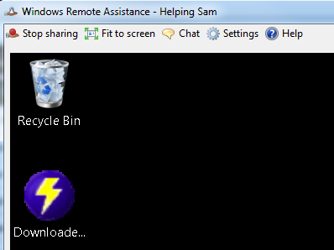
- On computer A, drag a window to the right. On Computer B, drag it up. If you get two people to operate both computers at the same time, both actions take effect and the window moves diagonally. This is Sharing Control.

Capturing an Image of the Remote Assistance Screen: Do this on Computer B
- On computer B, you should see a "Windows Remote Assistance" window with a "Stop Sharing" button in the top left corner, as shown to the right on this page.
- Press the PrintScrn key in the upper-right portion of the keyboard. That will copy the whole desktop to the clipboard.
- Paste the image into Paint as a JPG or PNG file. Save it with the filename Your Name Proj 16.

Turning in your Project
- Email the JPEG image to me as an attachment to an e-mail message. Send the message to: cnit.345@gmail.com with a subject line of Proj 16 From Your Name, replacing Your Name with your own first and last name. If two people worked together on the project, send one email with both names in the subject line. Send a Cc to yourself.

Last modified 1-13-12

