Choosing a Computer to Use
- This project should be safe enough to do on any Windows 7 computer. BadApp will fail in harmless ways, and should do no harm to your machine. But if you are not comfortable using your own machine, or you don't have one, use the lab.
- Log onto any Windows 7 machine with any account that has Administrator privileges.

Downloading BadApp.exe
- Open a browser and go to samsclass.info
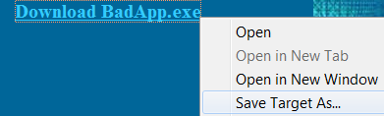
- Click the CNIT 345 link. Click the Projects link. Scroll down to Project 17.
- Right click the "Download BadApp.exe" link and select "Save Target As…", as shown to the right on this page.
- Save the BadApp.exe file on your desktop.

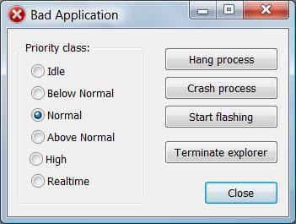
Creating a Hung Process
- On your desktop, double-click BadApp.exe.
- In the "Bad Application" box, accept the default Priority class selection of Normal, as shown to the right on this page. Click the "Hang process" button.
- Try to drag the "Bad Application" box to the side. It won't move, and the title bar changes to "Bad Application *Not Res…" to indicate that the process has hung.

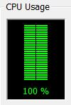
Opening Task Manager
- Press Ctrl+Shift+Esc. Task Manager opens.
- Click the Performance tab—your CPU should be pegged at 100%, as shown to the right on this page. (If you have a dual-core processor, it will be 50%.).
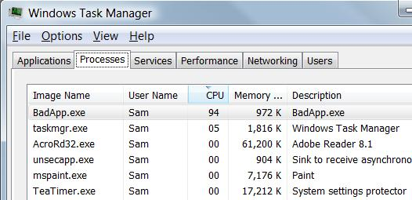
- In Task Manager, click the Processes tab. Click the CPU column header to sort by CPU and put the process with the highest CPU (BadApp.exe) at the top, as shown to the right on this page.

Saving a Screen Image
- Make sure "Windows Task Manager" is the active window.
- Press Alt+PrintScrn to copy the active window to the clipboard.
- Click Start, "All Programs", Accessories, Paint. In the untitled - Paint window, select Edit, Paste from the menu bar. The image appears in the Paint window.
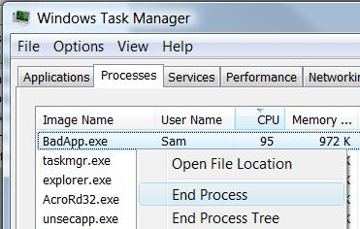
- In the untitled - Paint window, click File, Save. Save the document with the filename Your Name Proj 17a.

Terminating the Hung Process
- In Task Manager, right-click the BadApp.exe process and click End Process, as shown to the right on this page.
- A box pops up asking "Do you want to end this process?" Click the "End process" button.
- Click the Performance tab—your CPU should have returned to some reasonable value below 100%.
- Close Task Manager.

Creating a Crashed Process
- On your desktop, double-click BadApp.exe.
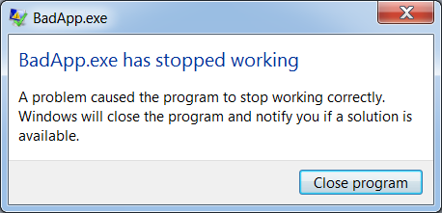
- In the "Bad Application" box, accept the default Priority class selection of Normal. Click the "Crash process" button.
- A box pops up, with a progress bar. When it completes, after a few seconds, it shows the message "BadApp.exe has stopped working", as shown to the right on this page.

Terminating the Crashed Process
- In the "BadApp.exe has stopped working" box, click the "Close Program" button.

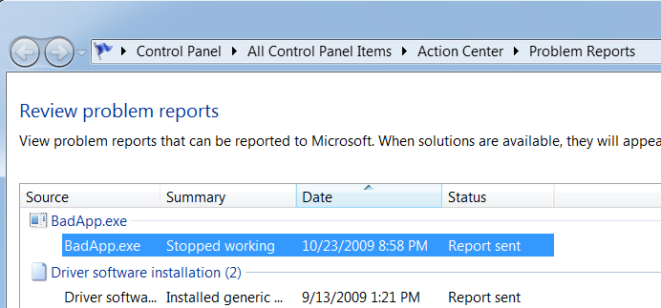
Checking Problem Reports
- Click Start, type in PROB, and click "View all problem reports".
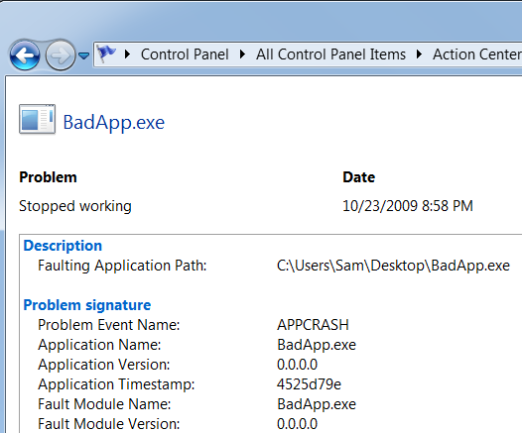
- There should be an entry showing that BadApp.exe "Stopped working", as shown to the right on this page. Double-click the words exe "Stopped working".
- You should see a page showing details about the problem, as shown to the right on this page. It should show a "Problem Event Name" of APPCRASH and an "Application Name" of BadApp.exe.

Saving a Screen Image
- Press PrintScrn to copy the whole desktop to the clipboard.
- Paste the image into Paint. Save the image as a JPG or PNG file with the filename Your Name Proj 17b.

Turning in your Project
- Email the JPEG images to me as attachments to one e-mail message. Send the message to: cnit.345@gmail.com with a subject line of Proj 17 From Your Name, replacing Your Name with your own first and last name. Send a Cc to yourself.

Last modified 10-24-09 7 am

