What You Will Need
- Two computers running Windows (XP or later, and at least one must be a Professional or Ultimate version), both connected to a LAN. They may be real or virtual machines. The instructions below assume you are using Windows 7 Professional in S214.
Selecting Two Machines
- Choose one machone to be the Server. The other one is the Client.
Assigning a Password to Your Account--Do This on the Server
- On the Server machine, think about how you logged in. If you use a password, you don't need to do this section. If you don't have a password now, do this:
  - Click Start and type un USER Click "User Accounts".
  - In "User Accounts" click Manage another account".
  - Click "Create a new account". Create an account with a name of server and a password of server
  - Click the Administrator button. Click the “Create Account” button.
  - Log out and log in with the server account.
Enabling Remote Desktop--Do This on the Server
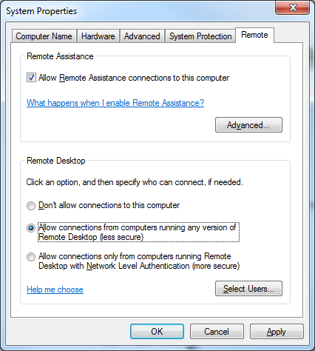
- On the Server, click Start. Right click Computer and click Properties.
- Click "Advanced system settings".
- In "System Propeties", click the Remote tab.
- In the "Remote Desktop" section, click "Allow connections from computers running any version of Remote Desktop (*less secure)", as shown to the right on this page. If a box pops up warning you about sleep or hibernation, click OK.
- In "System Propeties", click OK.

Finding your IP Address—Do This on the Server
- On the Server, click Start, type CMD, and press the Enter key.
- In the Command Prompt window, type the following command, and then press the Enter key:
IPCONFIG
- Scroll up to find your IP Address, as shown below on this page, and write it in the box below on this page. There may be several adapters. In S214, use the one with an IP address starting with 192.168.1.
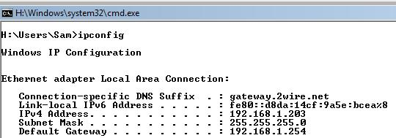

Server IPv4 Address: ____________________________________

Connecting to the Server--Do This on the Client
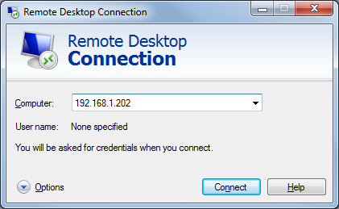
- On the Client machine, click Start and type in REMOTE: Click "Remote Desktop Connection".
- In the "Remote Desktop Connection" box, type in the server's IP address, as shown to the right on this page. Click Connect.
- If a box appears asking "Do you want to connect despite these certificate errors?", click Yes.
- A box may appear on the Server machine's desktop warning you that the user is about to be logged off. If necessary, allow that.

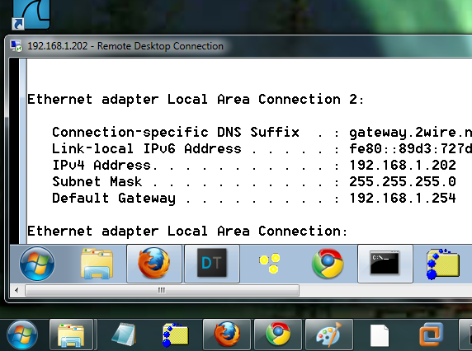
- On the Client, you should see a "Remote Desktop Connection" window with the Server's desktop inside it, as shown to the right on this page.

Capturing the Screen Image
- Make sure that the Server's desktop is visible inside the "Remote Desktop Connection" window.
- Press the PrntScn key to copy whole screen to the clipboard. Open Paint and paste in the image. Save it as a JPEG, with the filename Your Name Proj 21.
Testing Remote Desktop
- Use the Server from the Client a bit. Open a Web page, try moving and resizing windows, etc. See how it feels--the graphics are more primitive and the response is slower, but it should be usable.
Turning in your Project
- Send the image as an email attachment cnit.345@gmail.com with a subject line of Proj 21 From Your Name. Send a Cc to yourself.

Last modified 4-5-10

