Ch 1: The Importance of DNS Security

DNS is Essential

Without DNS, no one can use domain names like ccsf.edu

Almost every Internet communication begins with a DNS resolution

DNS Under Attack

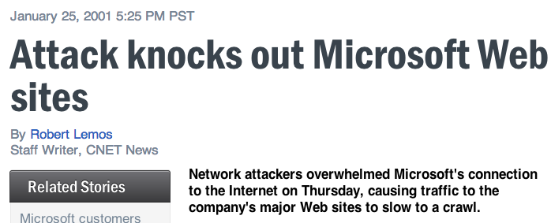
Microsoft (2001)

In 2001, Microsoft's DNS servers were attacked

Link Ch 1a

Single Point of Failure

Microsoft's network went through a single switch at that time

25% of the 1000 largest companies had a centralized DNS architecture at that time

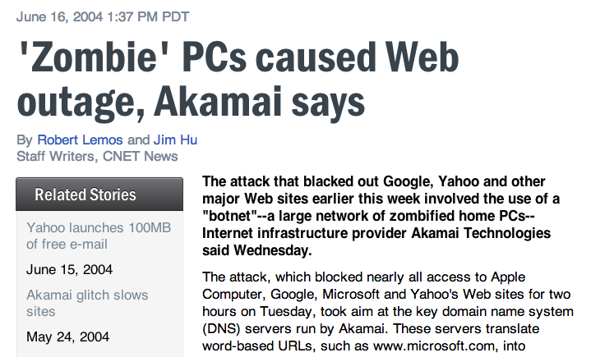
Companies moved to distributed architectures

Botnet defeated distributed architecture

Link Ch 1b

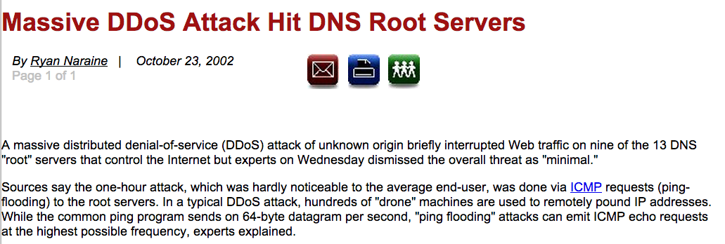
2002 Attack on DNS Root Servers

Attacked all 13 root servers simultaneously

ICMP flood, 900 Mbps

Links Ch 1c, 1d

Defenses in 2002

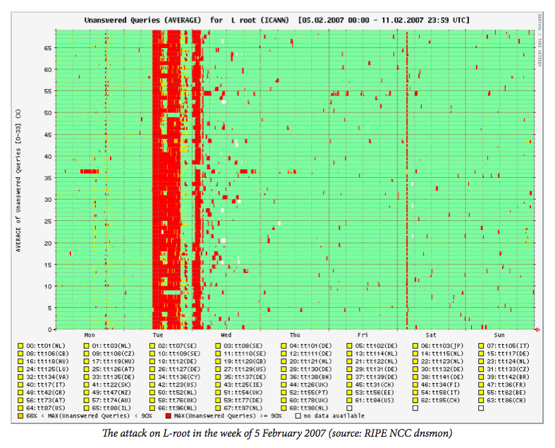
The attack had little effect, because

Root DNS servers are vastly over-provisioned

Attack was short; 1 hour

DNS records were cached in downstream servers

2007 Attack on DNS Root

Six root servers attacked from Asia

Volume 1 Gbps per server, bogus DNS requests

Only two were affected, because they did not yet have Anycast configured

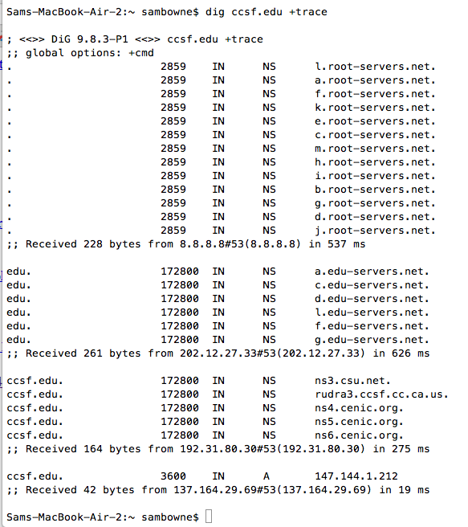
Anycast allows one IP address to be shared by many different servers

Traffic automatically goes to closest working serer via BGP

Link Ch 1e

Recursive DNS Query

DNS Cache Poisoning

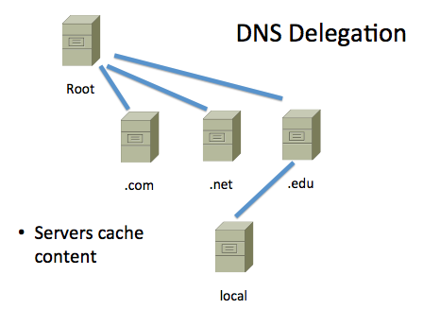
Malicious altering of cache records redirects traffic for users of that server

2005 attack redirected traffic for more than 1000 companies

Link Ch 1g, from 2005

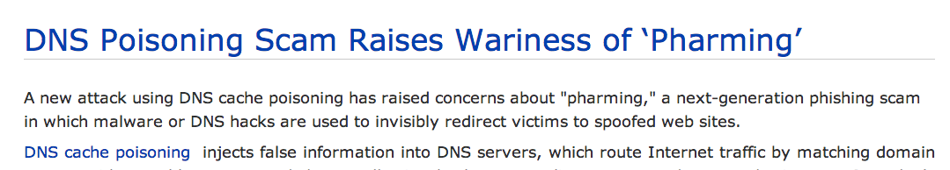

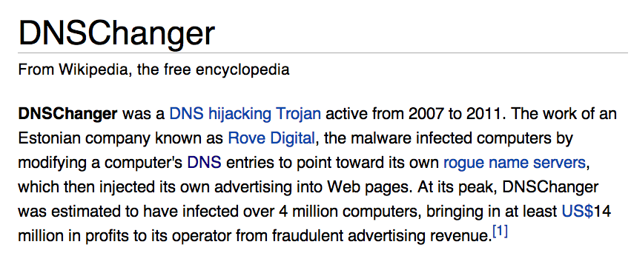

Changed local DNS server address

Link Ch 1h

Kaminsky DNS Vulnerability

Serious vulnerability in 2008

Allowed poisoning caches on many servers

Patched before it was widely exploited

Link Ch 1h
DNS Assisting Attacks

Dynamic DNS (DDNS)

Allows the IP address of a domain name to change quickly

This allows home users to host servers on transient addresses

Abused by botnet operators, phishers, and malware download sites

Change address rapidly to avoid detection and shutdown

Fast Flux DNS

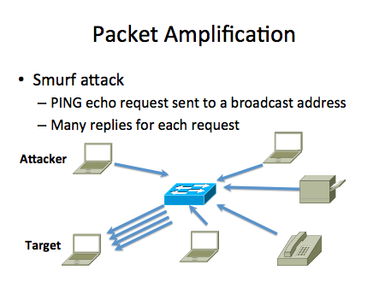
Changes DNS addresses rapidly

Hides servers behind reverse proxies that rapidly change

Makes it difficult to find the central servers

Link Ch 1j

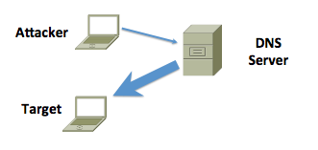

DNS Amplification

Find a domain name that gives a large response

Also called "DRDoS Attack" (Distributed Reflection and Amplification Denial of Service)

Link Ch il

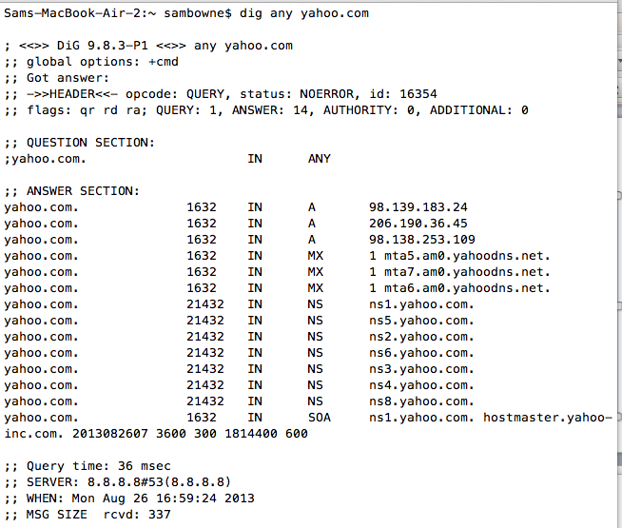

dig any yahoo.com

Request: 69 bytes

Reply: 379 bytes

Amplification: 5.5 x

dig any ietf.org

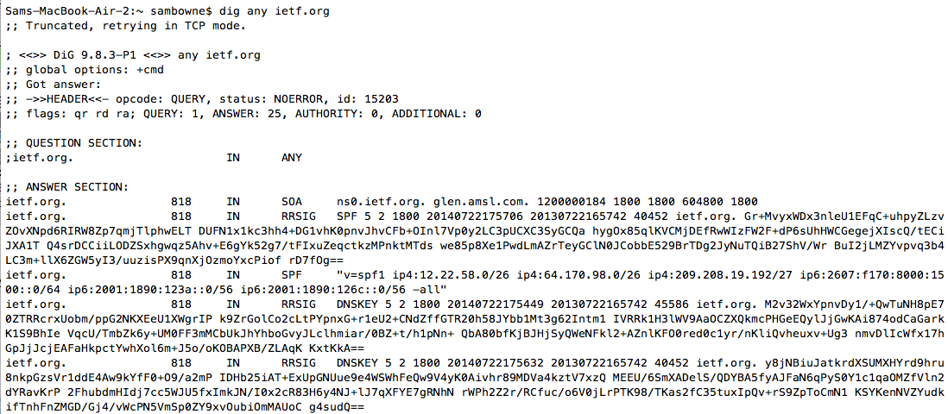
Large DNSSEC signatures

Request: 28 bytes (+66 header)

Reply: 4183 bytes (+ headers)

Amplification: 45 x (but via TCP)

Extension mechanisms for DNS (EDNS)

Allows transmission of larger packets via UDP

Normal max. is 512 bytes

This extends it to larger values, such as 4096

Essential for DNSSEC efficiency, but will make DNS amplification much more powerful

Link Ch 1k

DNS as a Conduit of Attacks

Sinit Trojan (2003)

Used port UDP 53

Allowed by firewalls

Link Ch 1m
DNS Traffic as a Gauge of Malicious Activity

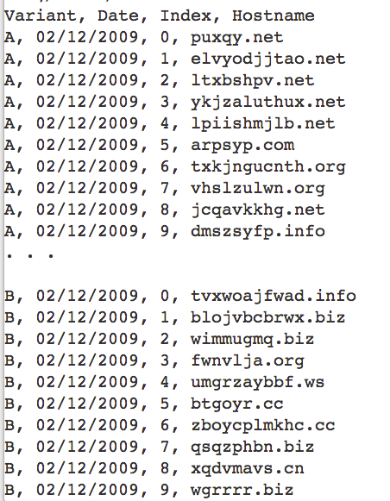
DNS Monitoring

Infected machines often make many DNS queries

Spam relays make DNS requests to find addresses of mail servers

Botnets often make many DNS requests to obscure domains

Conficker Worm Domains

Algorithm made 50,000 new domains per day

Registrars tried to block them all

Links Ch 1u, 1v

Graph from Link Ch 1q
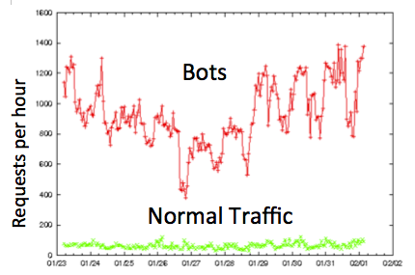

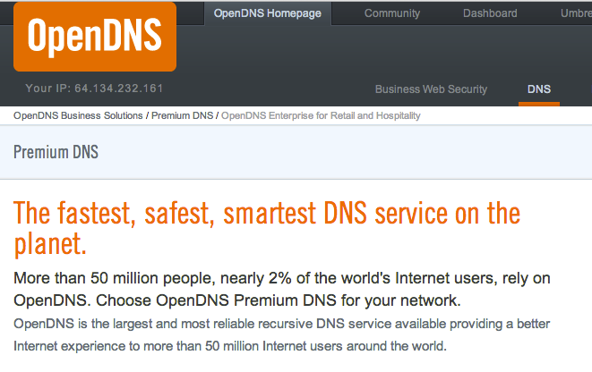
Blocking DNS Resolution for Known Malicious Domains

OpenDNS

Anycast for reliability

Reports of DNS activity for management

Blocks malicious servers

Can enforce other rules like Parental Controls

Storm Worm (2007)

Distributed C&C (Command and Control) via a peer-to-peer system

Fast flux DNS

Mutates every 30 minutes

Link Ch 1s


Microsoft took over the 3322.org domain, with authorization from a court order, in 2012

Controversial process

Only temporary botnet disruption

Takes down C&C servers controlled by other researchers; "collateral damage"

Link Ch 1t
Lack of DNS Authentication and Privacy

Intrinsic Protocol Weakness

DNS requests and responses are not encrypted

No strong authentication

Responses cannot be fully trusted

Responses can be spoofed or intercepted and modified

Altered responses may be cached for a long time

Financial Impacts and Intangible Losses

Availability: DNS outage causes direct loss of revenue

Fraud: Modified DNS services can

Send spam

Drive users to phishing sites

Connect bots to C&C servers

Locate malware download sites

Cyberwar

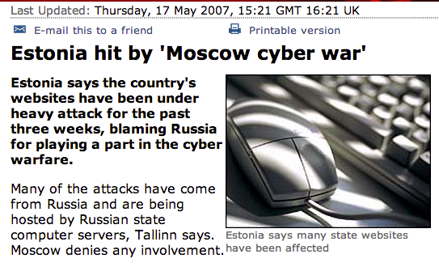

Last modified 8-27-13

