History

On ARPANet, host names were mapped to IP addresses in a hosts.txt file stored on a single master server

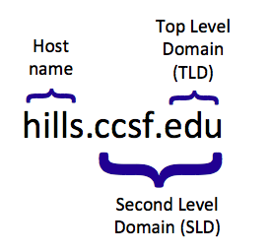
Other machines downloaded copies of hosts.txt periodically

Unix stored this information in /etc/hosts

This technique didn't scale well. DNS started in 1983.

Design Principles

Distributed storage

DNS data split across many servers

Smaller storage requirements for each server

Faster transfer of information

No single point of failure

Hierarchical organization of data

Allows local control of names and avoids name conflicts
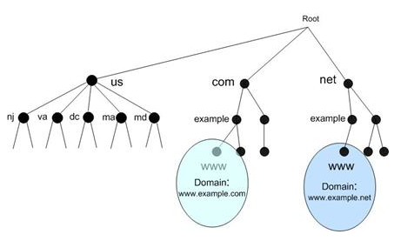
DNS Name Structure

Up to four labels separated by dots form a Fully Qualified Domain Name (FQDN)

Hierarchical DNS Namespace

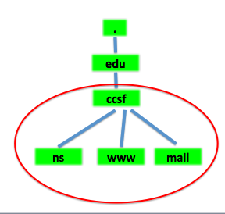

DNS Zones

Data for a domain and all or some of its subdomains is called a zone

All of CCSF could be one zone, containing

ns.ccsf.edu

www.ccsf.edu

mail.ccsf.edu

Domain Delegation

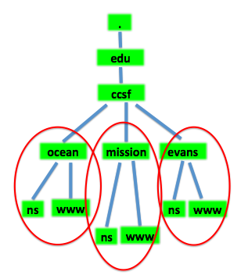
CCSF could have separate nameservers on each campus, each responsible for their own subdomain

The ccsf.edu parent domain would delegate responsibility for a subdomain to each campus, making many zones

URLs would be longer

www.ocean.ccsf.edu

DNS Clients, Servers, and Resolvers

DNS Client

A program like a Web browser using a domain name like www.ccsf.edu

DNS Server

Stores and serves DNS data

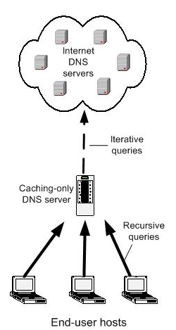
DNS Resolver

Software that accepts a query from a client, queries one or more DNS servers, and replies to the client

DNS Servers

Authoritative servers manage information about a domain

SOA (Start Of Authority)

Caching servers store data they copied from other servers

Not authoritative for any domain

Cache records have a Time To Live (TTL)

Specified by SOA for each record

DNS Queries

Recursive query

Server will find the answer, even if it has to query other servers to get it

Server will not respond with a referral to another server

Iterative query

If server does not have the answer, it will send a referral to another DNS server

Requester has to send another query to hunt for the answer

DNS Forwarder

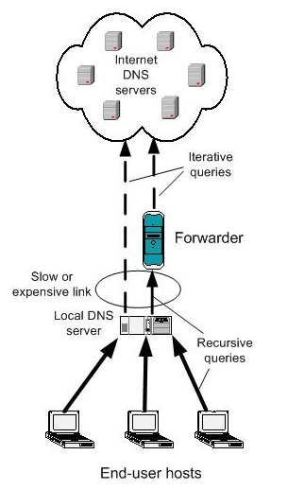
Can reduce traffic through slow or expensive links

DNS Resolvers

Receive requests from client applications

Query DNS servers

Can cache data

Stub resolver

Simplified resolver without caching

Part of the operating system on the end device

Local DNS Server

Provided by Internet Service Provider (ISP)

Configured at the client manually or by DHCP
IPCONFIG /ALL shows it
DNS Replication

Master server contains primary zone files

Slave servers have copies of the zone files

Zone transfer

The process of copying the files
Root Servers

Named .

"dot"

Has pointers to the top-level domains

com, biz, mil, net, and so on

If a DNS server has no data in the cache, e. g. after a reboot

Receives a recursive query

Is not the SOA for that domain

Must query root to find the TLD servers

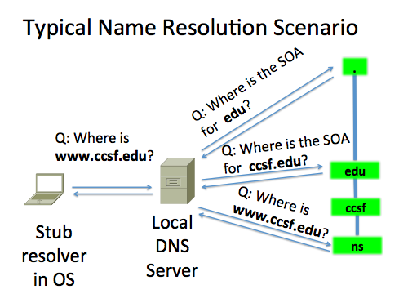
Root Servers

Hundreds of servers

Dispersed around the world

13 domain names

a.root-servers.net

b.root-servers.net

...

m.root-servers.net

DNS Resource Record Types and Classes

Each data element in DNS is called a Resource Record (RR)

Common RR Types

A IPv4 address of host

AAAA I Pv6 address of host

MX Mail exchange

PTR Host name corresponding to IP address

NS Host name of SOA name server

CNAME Canonical Name: alias

SOA Attributes of zone

TXT General information

NAPTR Naming Authority Pointer

SRV Service (for specific applications)

SPF Sender Policy Framework

(used to control spam)

DNSKEY, DS, RRSIG, NSEC for DNSSEC

Reverse DNS Resolutions

Start with IP address and query to find the domain name

Used to block spam email

If IP address of server doesn't have a valid domain name, or the domain name is blacklisted, the email is rejected

PTR Records for RDNS

Reverse the order of the IP address

Add "in-addr.arpa"

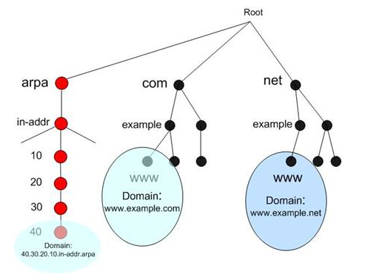
For example, 147.144.1.212 becomes

212.1.144.147.in-addr.arpa.

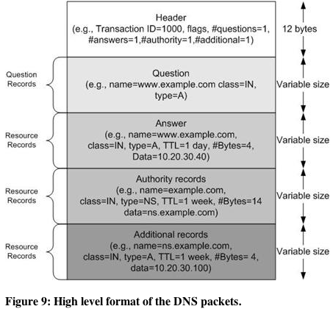

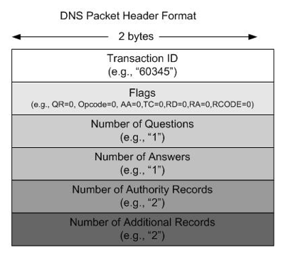

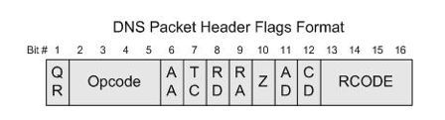
Flags specify:

Query or Response

Forward or Reverse

Recursive or Iterative

Glue Records

If the SOA for ccsf.edu is ns.ccsf.edu the system fails

Q: Where is www.ccsf.edu?

A: Ask ns.ccsf.edu

Q: Where is ns.ccsf.edu?

A: Ask ns.ccsf.edu

To prevent this, each domain has a glue record in their top-level domain zone specifying the IP address of the SOA

Bind Version Query
Common Server Architectures

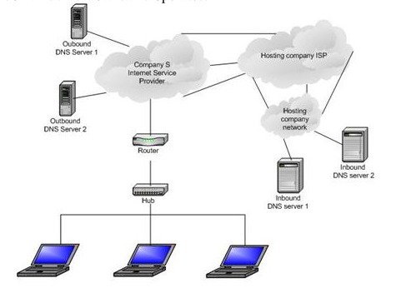
Small Company: Outsource DNS

Medium Company

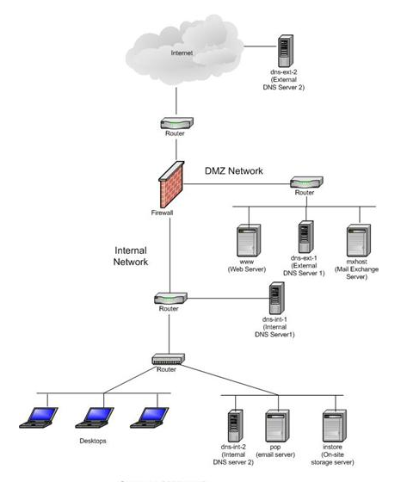
Internal and external DNS servers

Only public servers like www and mx on external DNS servers

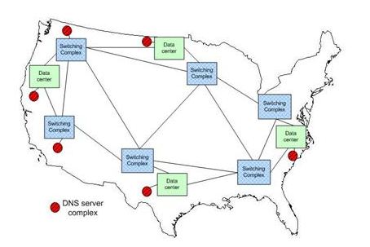

Large Company

Hierarchical Caching Architecture
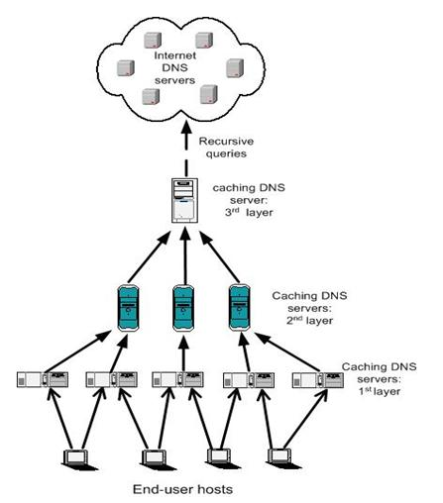

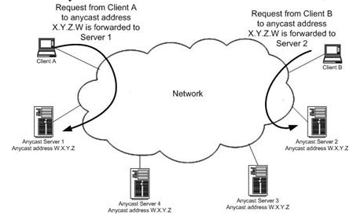

Anycast

Last modified 9-9-13

