Causes of Vulnerabilities

Configuration errors

Architecture mistakes

Vulnerable software implementations

Protocol weaknesses

Failure to use the security extensions in the protocol
DNS Architecture Mistakes

Single Point of Failure

The SOA could be a single server at a single site

If the server crashes, clients would be unable to resolve any of the domains in the zone

Also Internet connection outage, power failure, fire, storm, etc.

If a single server is the recursive resolver for clients in an intranet

They'll all lose DNS service if it goes gown

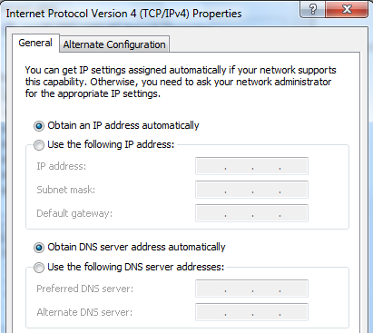
Two Servers

Many hosting providers do not allow delegation of DNS service to a single DNS server name

End devices are typically provisioned with two DNS server addresses

Router or Link
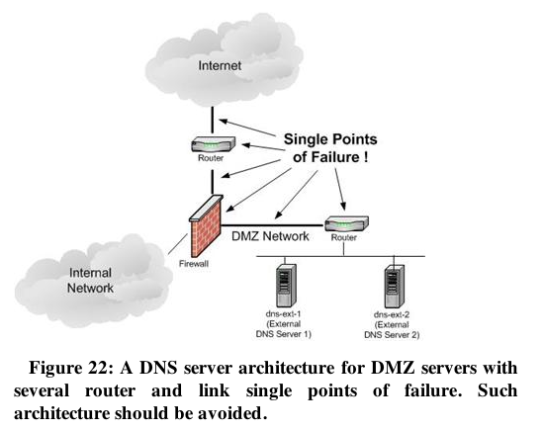

Data Center or Single Site

If all DNS servers are at a single site or data center, a regional event could take them all down

Earthquake

Power failure

The more critical the DNS service is, the more distributed servers should be

Geographically and topologically

Like the 13 root servers

Common Configuration Errors

Exposure of Internal Information

Only public Web-facing servers should be in the external DNS zone files

Your DNS server is a target of attack and may be compromised
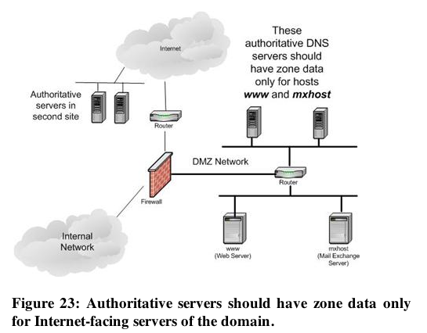

Leakage of Internal Queries to the Internet

Some Windows DHCP clients leak dynamic DNS updates to the Internet

Link Ch 3a
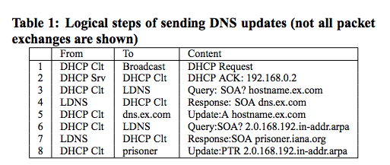

Windows Versions

These packets were sent from Windows 2000, Windows XP, and Server 2003

When tested in 2006

To prevent this, configure local DNS servers not to refer internal machines to external name servers

And block DNS requests directly to the Internet

Unnecessary Recursiveness

Not all name servers need to be recursive

Authoritative servers don't need to

Recursion is complex and burdens servers

Added function means more potential vulnerabilities

Recursion may be on by default

Thousands of open recursive resolvers on the Internet

Failure to Restrict Access

Recursive DNS servers should only accept queries from your own clients

Block outside addresses with access control lists

Open Resolver Project

Link Ch 3b

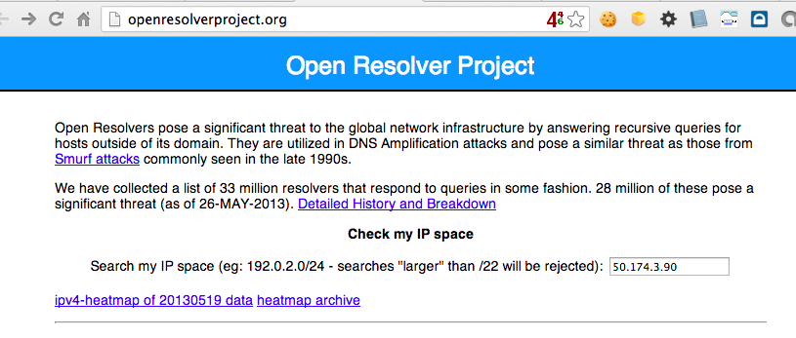

Testing CCSF's DNS Servers

dig ns ccsf.edu shows 6 servers

ns5.cenic.org 137.164.29.69 CLOSED

ns4.cenic.org 137.164.29.67 CLOSED

rudra3.ccsf.cc.ca.us 147.144.3.238 CLOSED

ns6.cenic.org 198.188.255.193 CLOSED

ns1.csu.net 130.150.102.100 OPEN

ns3.csu.net 137.145.204.10 OPEN

Unprotected Zone Transfers

Data transfers from a master to a slave authoritative server

Update the zone files on the slave

Can be requested by any other host

Reveals information about all hosts in the zone

Information disclosure vulnerability

Running Server in Privileged Mode

root on Unix/Linux

Administrator on Windows

Makes any security flaws more dangerous

Attacker who owns DNS then owns the server

Weakness in Software Implementations

DNS servers have bugs and vulnerabilities

Buffer overflows

Other errors

Search CVE List for "ISC Bind"

Severe 2008 Bind Vulnerability

Attack used an IP address like

1.2.3.4.xxxxxxxx-exploit-code-here-xxxx

Another list of DNS vulns at link Ch 3d
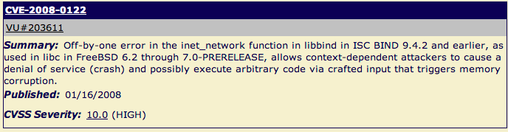

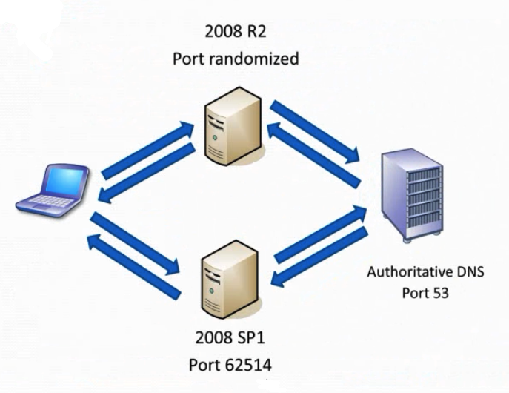
Source Port Randomization

Good video

Link Ch 3e

Randomness of Transaction ID

Each DNS query and response has a TXID field

16 bits long (65,536 possible values)

Should be random

Bind 8 & 9 used predictable transaction IDs

So only ten guesses were needed to spoof the reply

Tricking a Target into Using Your DNS Server

Run a domain evil.com with a SOA you control ns1.evil.com

Send the target an email with a link to server.evil.com and hope someone clicks it

Send email from joe@evil.com to target email address

The server will automatically perform a reverse lookup to detect spam

Tricking a Target into Making Multiple DNS Queries

CNAME Chaining

www.evil.com is a CNAME for www1.evil.com

www1.evil.com is a CNAME for www2.evil.com

www2.evil.com is a CNAME for www3.evil.com

etc.

NS Referral Chaining and NS Chains

a.a.a.a.evil.com has SOA ns.evil.com

ns.evil.com delegates to ns.a.evil.com

ns.a.evil.com delegates to ns.a.a.evil.com

etc.
Protocol Design Weaknesses

Weak Authentication

DNS uses these elements to match a request and a response

Transaction ID (16 bits)

Question

Source and destination IP

Source and destination ports

But request destination port is known (53)

Client accepts the first response that meets these criteria, and caches the result

DNS Cache Poisoning

A false response that tricks the client puts a false entry into its cache
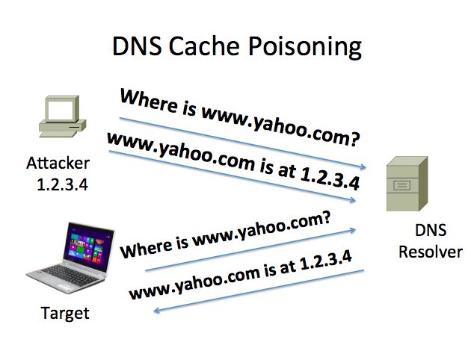

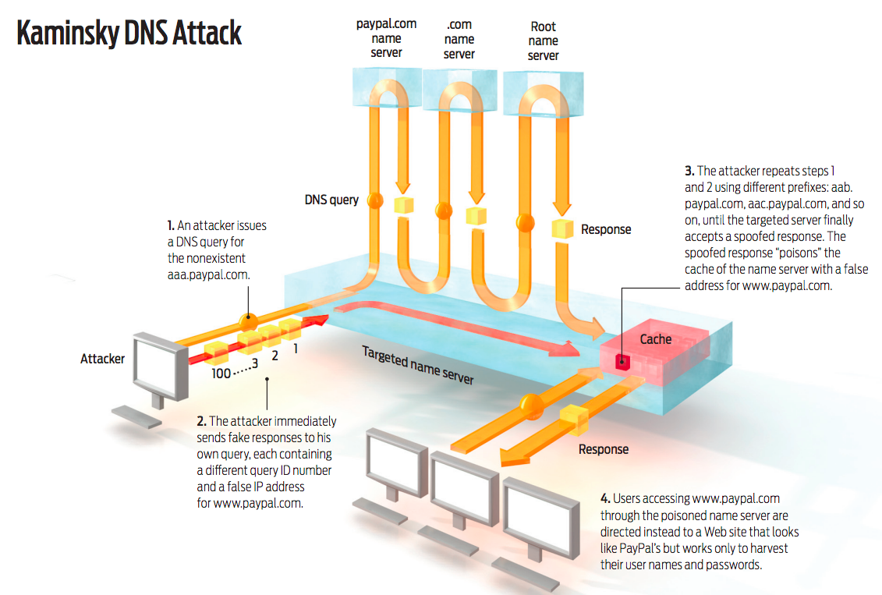
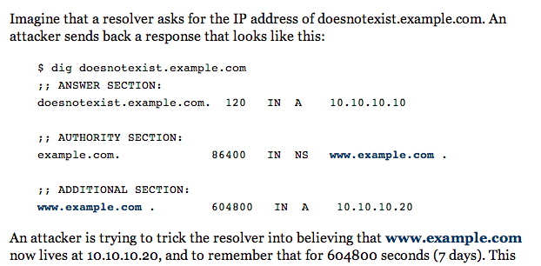
Link Ch 3f

Link Ch 3g

Consequences of the Kaminsky Attack

Attack can be placed in a Web page

Many img tags

<img src=aaaa.paypal.com>

<img src=aaab.paypal.com>

<img src=aaac.paypal.com>

<img src=aaad.paypal.com>

etc.

If one Comcast customer views that page, all other Comcast customers will be sent to the fake paypal.com

Poisoning can take as few as 10 seconds

Man-in-the-Middle Attacks

Attacker in the middle has enough info to perfectly forge responses

Unless DNSSEC is used
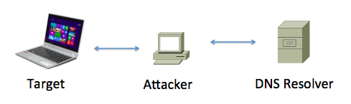

DNS as a DoS Amplifier

Small requests lead to large responses

UDP allows spoofing the source IP address
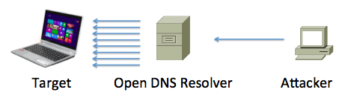

Last modified 10-6-13

