Monitoring

Four useful types of data

Log data

Network flow data

Packet data

Application level metadata
Log data

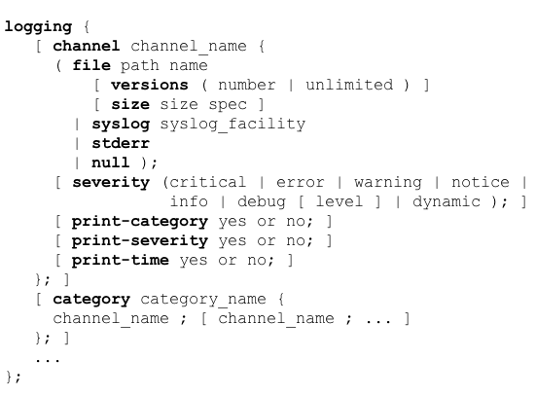
Types of Log Data

Format errors in queries

Lame delegations

Referral from a parent zone to an invalid name server for the child zone

Queries for nonexistent domains

BIND's Logging in named.conf

Clauses

Channel

Defines output medium, such as files, syslog, stderr, or null to eliminate output

Versions

Max. number of files that can be used

Files are rolled when "size" is reached

Severity

"critical" logs only critical events

"info" stores much more

Print

print-time, print-severity, print-category

Controls what is printed (link Ch 4a)

Categories

queries

Logs client IP & port, question name, type and class of query

Useful to record which hosts are querying for what domains

+ indicates recirsive query

S indicates signed query

E indicates Extended DNS (EDNS)
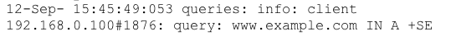

security

Requests that were denied

Rejected by access control lists (ACLS) that define which hosts are allowed to send queries, zone transfers, etc.

ACLs are set using these options statements

allow-query

allow-recursion

allow-transfer

update-security

Denied requests to update DNS zone data dynamically, because of ACLs or policies

ACLs and policies defined with

allow-update

allow-update-forwarding

update-policy

BIND tool "nsupdate" generates dynamic updates

dnssec

Only works if DNS server supports DNSSEC and is configured to perform record validation

DNSSEC statements

dnssec-enable

dnssec-validation

DNSSEC Example

Every line prefixed with

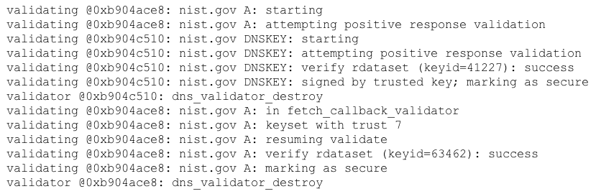
Date dnssec: debug 3:
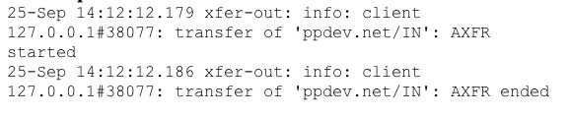

xfer-in

xfer-out

Report zone transfers

Packet data

SPAN Port

Capture packets with tcpdump or Wireshark

From a SPAN port on a router or switch

Provides a copy of every packet

Or use an optical or electronic splitter

Or a hub

Data sent to a server that captures and stores all the packets

Usually uses libpcap or WinPcap with standard pcap format
Network flow data

Flow Data

Summarized record of a network traffic session

Packets with common characteristics

Source and destination IP, Port, and Protocol

Each flow typically goes in only one direction

NetFlow

Originally developed by Cisco

Standardized by IETF as IP Flow Information Export (IPFIX)

Packet Grouping

TCP sessions

Export flow as soon as session ends with FIN or RST

UDP traffic

Must guess when flow ends

Activity timer expiration exports after a period of time, even if flow is still in progress

Inactivity times generates a flow record when there is inactivity for a period of time

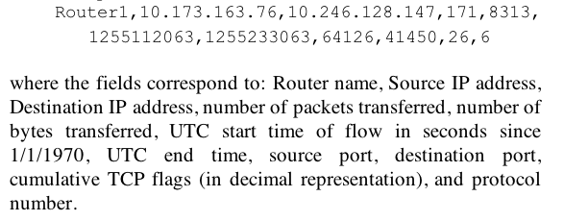
Flow Records

Don't contain a complete summary of a session between two hosts

Very long sessions, or sessions with periods of inactivity, may appear in multiple flow records

Application level metadata

Flow records provide very little information

Packet data are overwhelming, containing too much data

Also raise privacy concerns

Application layer metadata

Keeps some packet fields from application and other layers

Detection

Cache Poisoning Attack Detection

Brute force attempts to guess Transaction ID and Source Port

Of a query from a recursive DNS server to an authoritative server

First attacker makes a request for a record that is not cached

Then blasts server with spoofed responses with many Transaction ID and Source Port values

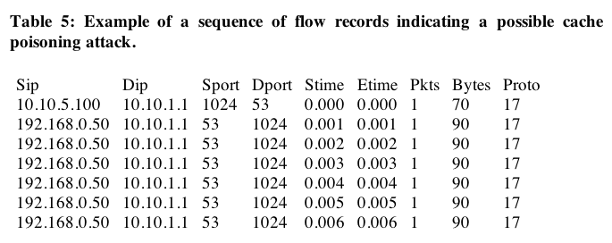
Flow Records

Keep flows with source or destination port 53 (TCP or UDP) and source or destination IP of the DNS server

Limitations of Flow Records

No Layer 7 data

Such as the DNS request

Cannot pinpoint the domains being targeted

Or the addresses being injected

Selecting Relevant Data

DNS requests are irrelevant

Poisoning is performed by replies

Data needed

Source & destination IP

Domain name in the question section

Answer, authority, and additional sections

Transaction ID

Timestamp

Only include authoritative replies (AA set)

Transient Domains

Resolve to a small number of IP addresses

Change over hours or days

IP addresses are not owned by the same autonomous system (AS)

Typically they are botnet controllers, malware downloads, or file drop sites

Could be an innocent software bug, or a security research site

Identifying Transient Domains

Collect DNS traffic with

Small TTLs

Collect at peering links to other AS networks

Record

Domain that was queried

Answer given

Timestamp

Exclude client IP address for privacy

Fast Fluxing Domains

TTLs set to a few seconds

IP changes rapidly

Example from Conficker

Answer at time 0

www.refaourma.info. 60 IN A 65.54.40.75

www.refaourma.info. 60 IN A 65.118.223.203

www.refaourma.info. 60 IN A 65.130.228.46

Answer 28 sec. later

www.refaourma.info. 32 IN A 65.130.228.46

www.refaourma.info. 32 IN A 65.54.40.75

www.refaourma.info. 32 IN A 65.118.223.203

Answer at 56 sec.

www.refaourma.info. 4 IN A 65.118.223.203

www.refaourma.info. 4 IN A 65.130.228.46

www.refaourma.info. 4 IN A 65.54.40.75

Answer at 83 sec.

www.refaourma.info. 32 IN A 209.17.184.203

www.refaourma.info. 32 IN A 209.228.250.75

www.refaourma.info. 32 IN A 209.229.142.35
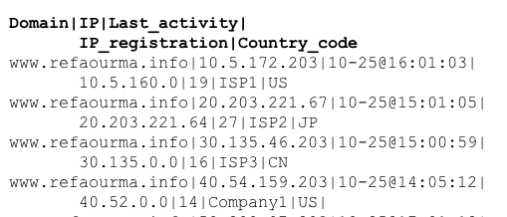

When cache expires, IP addresses are all new

Detecting Fast-Flux Domains

Phantom Domains

Register a domain

Use it for only a few hours or days

Defends malware against sinkholing

Resolving to an address that offers no service

Works best with domain registrars who offer a free trial period

Detecting Phantom Domains

Find domains that have been active recently

Find current addresses

Find domains with no matching historical IP addresses

Find records with very different IP addresses for the same domain

Corrupted Local DNS Server Settings (DNS Changer)

Redirect victims to evil DNS server

Most resolutions are correct

Some lead to fake websites

Such as banking sites, antivirus sites, etc.

Detecting DNS Changers

Recursive DNS requests to suspicious remote addresses

Not in ISP's address range

Not a known public DNS server

Are in an IP address blacklist

Associated with transient, fast-flux, phantom, sinkholed or blacklisted domain

Located more than 1000 miles away

Have no forward DNS domains

Tunneling

Firewalls allow port 53 through

Malware can phone home via port 53

Covert channels via DNS traffic

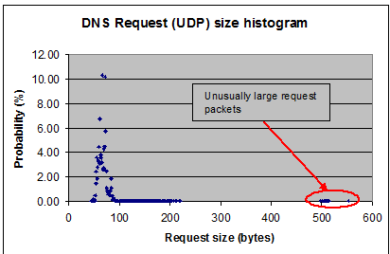
Even embedded in fields of legitimate-looking DNS packets, such as DNSSEC keys or signatures

Detecting Tunneling

Large UDP Request packets (>300bytes)

DoS Attacks

Attacks against the DNS server

TCP or UDP flood

SYN flood

Spoofed source addresses or botnets

DoS Attack Detection

Watch for these to be different from baseline

Incoming bits/sec and outgoing bits/sec

Imbalance indicates an attack

DNS requests/sec (TCP and UDP)

TCP SYN/sec

Incoming TCP and UDP packets/sec

ICMP incoming and outgoing packets/sec and bits/sec

Last modified 10-27-13

