Guest Speakers

Thu Nov 21, 6 PM MUB 180, Matthew Prince, CEO & Co-Founder of CloudFlare

Thu Dec 5, 6 PM MUB 180, Lee Holloway, Co-Founder & Lead Engineer at CloudFlare
Prevention of DNS Service Disruption

Architecture to Resist DoS

Authoritative servers typicallty need to accept queries from every device on the Internet

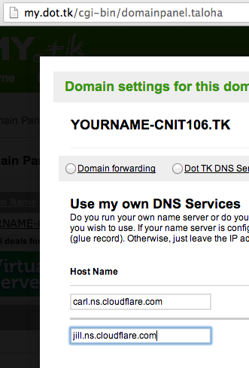
A network distributed system places authoritative servers in multiple networks

Small scale: different subnets with different gateways

Large scale: different Autonomous Systems (AS)

Geographically distributed systems are in different regions or countries

Types of DoS Protection

Host authoritative DNS servers at an ISP or Content Distribution Network (CDN)

Purchase caching acceleration service and delegate DNS resolution with a CNAME record

Risky because the authoritative server is still needed to provide the CNAME record

Direct delegation from the TLD to the ISP's or CDN's authoritative servers

Project 6x

Protecting a domain with Cloudflare

Anycast

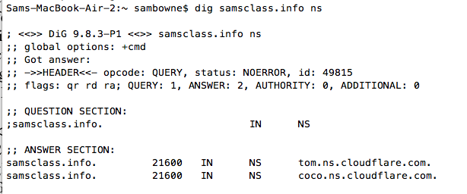
Multiple geographically separated servers use the same IP address

This spreads attacks over the whole network

Used by the root DNS servers and Cloudflare

NS Delegation

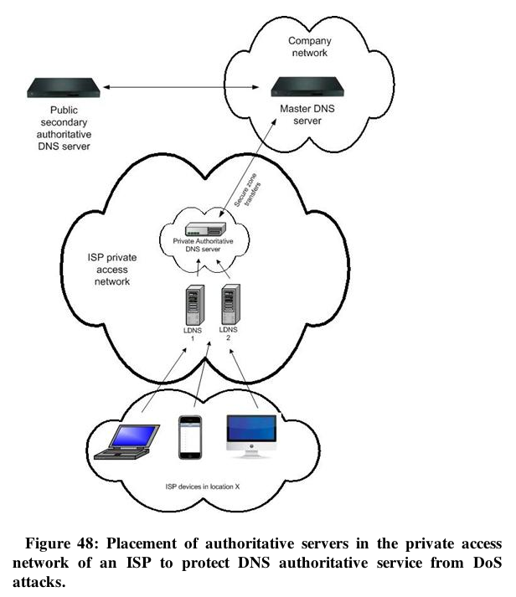

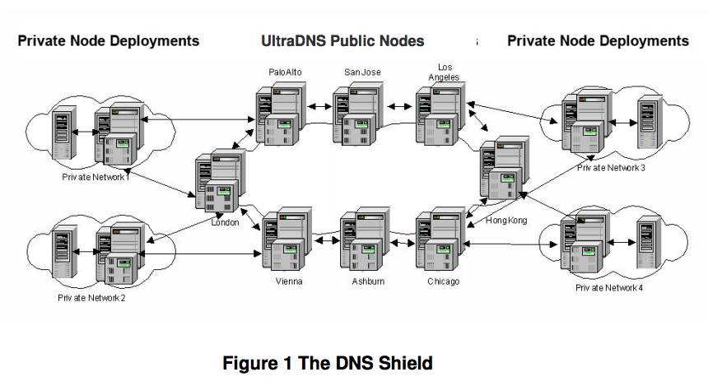
UltraDNS DNS Shield

Link Ch 5a

Software

Whatever you use, keep it updated

Bind

The standard

djbdns

Intended to be more secure than bind, but no longer centrally maintained (links Ch 5b)

There are many others (link Ch 5c)
DNS Security Extensions (DNSSEC)

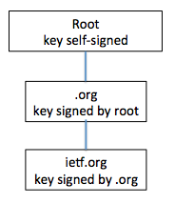
Purpose of DNSSEC

Ensure authenticity of data origin

And integrity of data received by a resolver from an authoritative DNS server

Done by signing Resource Record (RR) sets

With a private key

And including the signature (RRSIG) with the record

Chain of Trust

Resolver can verify the RRSIG with the server's Public Key

Published by the server in its zone file

Vouched for by the parent zone

Vouched for by its parent...

Unbroken chain of trust up to the root zone

Only works if all higher-level zones are signed

DNSSEC Chain of Trust

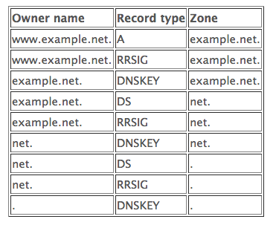
Detailed Chain of Trust

Link Ch 5d

Root Signed in 2010

Link Ch 5e
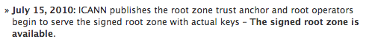

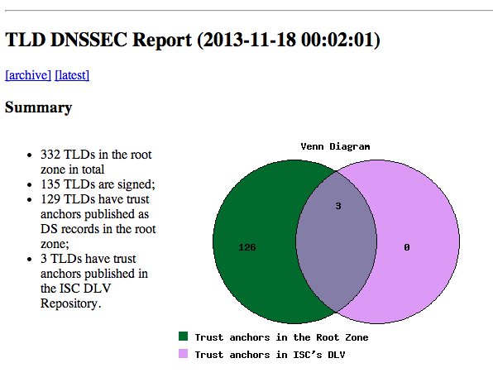
Link Ch 5f

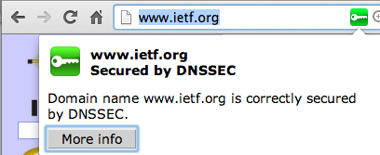

DNSSEC Validator Chrome Extension

DNSSEC Issues

Protocol still changing

Only secures record to resolver, not traffic from resolver to client

Another reason to disallow external DNS servers like 8.8.8.8

To keep all resolver traffic local

Transaction Signatures: TSIG

Maintains integrity of DNS messages between two severs

Cryptographically signs messages with TSIG

Calculates a Message Authentication Code

Encrypts it with a secret key

Key shared by the two end-nodes

Includes the time, to prevent replay attacks

TSIG expires after the "time fudge factor"

You must generate secret key and securely transmit it to the other server

Transaction Signatures: SIG(0)

Alternative signature method using public key cryptography

Public key stored in a KEY record

Transaction Keys (TKEY)

Establishes a shared secret using

Diffie-Hellman key exchange, or

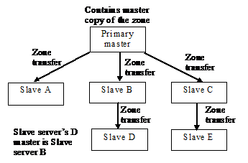
General Security Service API (based on Kerberos)

TKEY record contains the keying material required

Vulnerable to man-in-the-middle attacks

Should be secured with SIG(0) (shared secret)

Software Diversification

Most root servers use Bind

K and H servers use NSD from NLnetlabs

Master-Slave Setup

Changes are made at the master

Replicate to the slaves

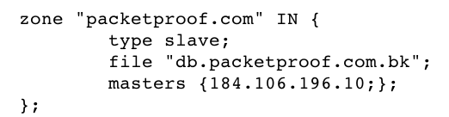
Slaves can be masters of lower-level slaves

Configuring a Slave Server in Bind

Limitation of 512 Bytes

Running many slave servers is good for fault-tolerance

But they all need to be listed as authoritative servers in DNS responses

Limited to 512 bytes in legacy systems

Failover via multiple NS records is slow

Requires several seconds for timeout of a bad server

CCSF.EDU has 6 NS Records
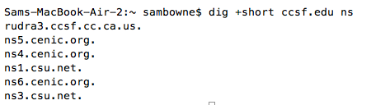

Automatic Failover

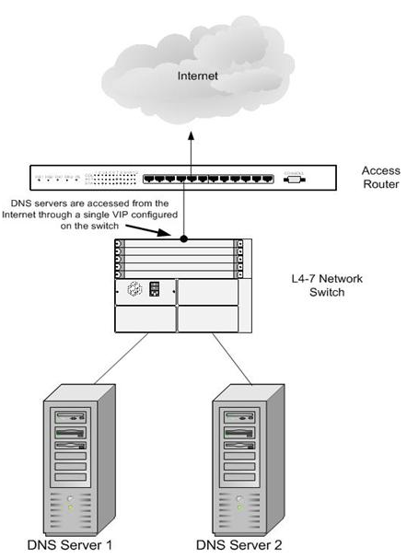
Use a load balancer

Appears to be a single server to external nodes

Protection of DNS Service

Firewalls, IDS/IPS

Run on hardened systems

Port 53 UDP/TCP open

Management ports only open to internal hosts

IDS/IPS blocks known attacks by signatures

Firewalls limit traffic with Access Control Lists (ACLs)

Older firewalls limit DNS packets to 512 bytes

Now obsolete; EDNS0 allows UDP packets up to 4096 bytes (link Ch 5i)

Scrubbers

DDoS attacks look like many legitimate customers

Scrubbers block packets that meet DDoS criteria

Not usually fully automated

When under attack, BGP updates are sent to redirect traffic to the scrubbers
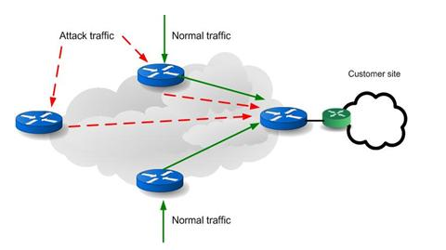

Normal Networking

Using Scrubbers
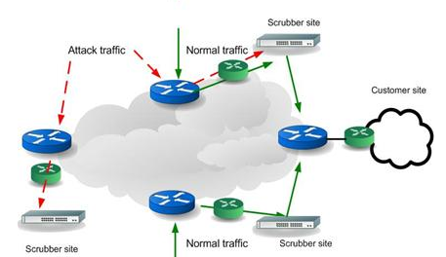

Service Monitoring and Restoration

Monitoring

Send periodic probes from multiple ISPs and geographic regions

Such as DNS requests

Send directly to monitored servers

Verify that responses are accurate

Backups

Regular backups of the DNS servers are essential

Can be full or incremental

Could back up whole OS, or just DNS configuration files

Cloud DNS servers must be backed up too

Using backup tools appropriate for the cloud service

MUST TEST YOUR BACKUPS

Slow DNS Response

If a DNS server is down, it slows responses

Because the dead server must time out before another server is queries

Remove NS and A records for failed server to avoid this

Last modified 11-18-13

