DNSSEC

Objectives of DNSSEC

Data origin authentication

Assurance that the requested data came from the genuine source

Data integrity

Assurance that the data have not been altered

Development of DNSSEC

Record signatures use public-key cryptography to verify authenticity of DNS records

RFC 2065 (1997): SIG and KEY records

RFC 2535 (1999): NXT record – denial of existence of a record

2003: DS (Delegation Signer) record

Allows secure delegation to child zones

SIG, KEY, NXT evolved to RRSIG, DNSKEY, NSEC

Development of DNSSEC

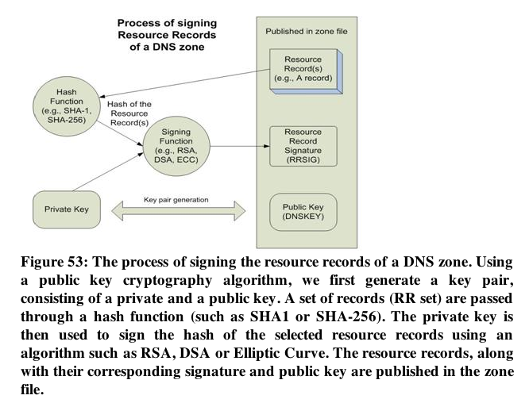
RFC 3757 (2004)

Zone-Signing Key (ZSK)

Key-Signing-Key (KSK)

Secure Entry Point (SEP)

A flag used to identify a KSK

2005

NSEC replaced by NSEC3

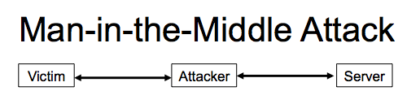
Man-in-the-Middle Attack

Attacker generates two “false” key pairs

Attacker intercepts the genuine keys and send false keys out

Client trusts the Attacker's data

Trusted third party prevents this attack

The root of DNS

Hierarchical Chain of Trust
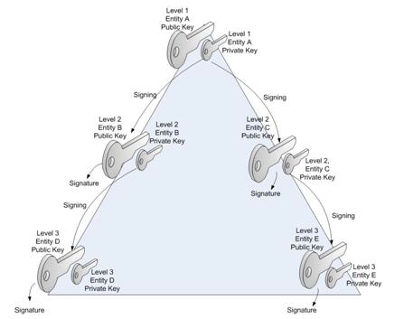

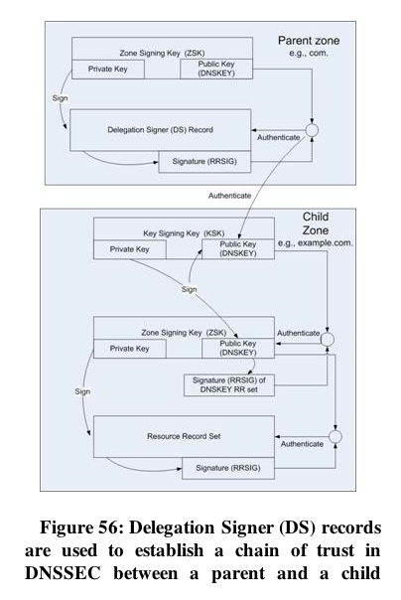

The Delegation Signer (DS) Record

Links in the chain of trust

DS record contains a hash of a zone's public key

To make performance better, the zone key may be separated into

Zone Signing Key (ZSK) and

Key Signing Key (KSK)

Authenticated Denial of Existence
NSEC and NSEC3 Records

Sort all domain names in zone in alphabetical order

a.example.com with A, AAAA, RRSIG

c.example.com

NSEC Record

a.example.com TTL IN NSEC c.example.com A AAAA RRSIG

This record proves there is no b.example.com

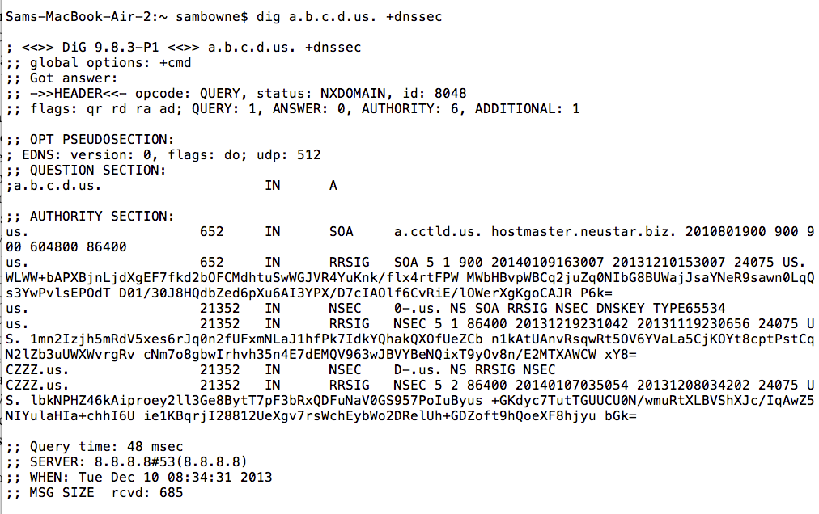
Example

NSEC Information Disclosure

Easy to find all domains in a zone

Like a zone transfer

dig *.se +dnssec

Reveals first valid hostname

Dig for valid hostname* to find next one

NSEC3 fixes this problem
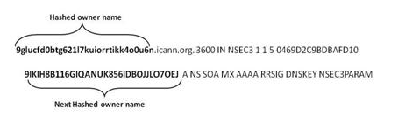

NSEC3 Hostnames are Hashed and Salted

Reply contains algorithm and salt

Making a Validating Resolver

See Proj 7x

Weaknesses of DNSSEC

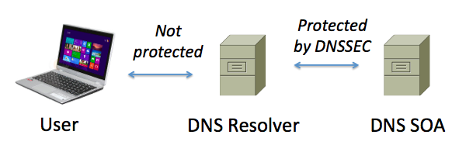
Lack of Protection Between User Devices and Resolvers

Attacker in the middle has enough info to perfectly forge responses

Unless DNSSEC is used

Lack of Protection of Glue Records

DNSSEC only protects Resource Records if they are authoritative in the zone

Glue records are resource records that facilitate a resolution that is delegated from a parent zone to a child zone

They are owned by the child zone but appear in the parent zone

So they are non-authoritative

Not protected by DNSSEC

Key Changes Don't Propagate

Keys can

Roll over

Be Revoked

Signatures can expire

These events do not propagate down the DNS tree

NSEC3 Denial of Service

If a zone is insecurely delegated to another zone

And it includes NSEC3 records

A MITM can block resolution of a domain

Or delegate the resolution to another server and change the A record

Enabling spoofing, cookie-stealing, etc.

Re-Addressing Replay Attack

If a server moves to a new hosting provider

The old IP address can be used until the signatures expire

Because there's no way to push signature expiration from authoritative servers to resolvers

NSEC3 Still Allows Zone Walking

An offline dictionary attack can be used to guess the hashes

It's the same as cracking password hashes

No Protection of DNS or Lower Layer Header Data

The AD flag is part of the DNS header

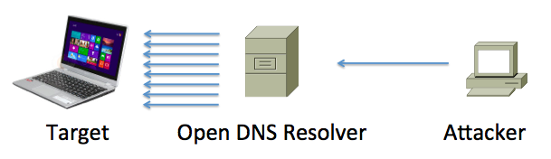
Can be changed by a MITM

DNSSEC won't detect that

DNSSEC Data Inflate Zone Files and DNS Packet Sizes

Small requests lead to large responses

UDP allows spoofing the source IP address

DNSSEC Increases Computational Requirements on Validators and Servers

Verifying signatures

Calculating hashes for NSEC3 records

DNSCurve

Encrypted Packets

Operates at layer 2 (Data Link)

Uses Elliptic Curve Cryptography

Each request and response packet is encrypted in its entirety

DNSSEC doesn't encrypt any data, it just signs it

ECC keys are 256 bits long

Calculation is much faster than RSA

DNSCurve Limitations

Not yet an IETF standard

Does not provide end-to-end security

Just from endpoint to resolver

Name-server names need to be longer to include a Base-32 encoded 53-byte public key

Makes responses even larger

DNS Queries may exceed 255 bytes, which will be dropped by old middleware

Key compromise requires renaming the server

And manual update of NS record in the parent zone

Last modified 12-11-13

