Total Internal Reflection

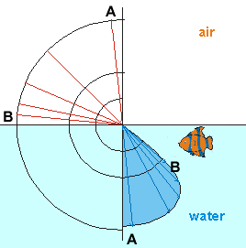
Refraction (Bending) of Light

Sunlight shines down into the water

Ray A comes from straight up into the water and does not bend much

Ray B comes at a shallow angle and bends a lot more

Image from seafriends.org.nz

The View From Underwater

Underwater, the light always shines down steeply, even when the Sun is low in the sky

The whole sky appears in a limited round area called “Snells Window”

Image from seafriends.org.nz
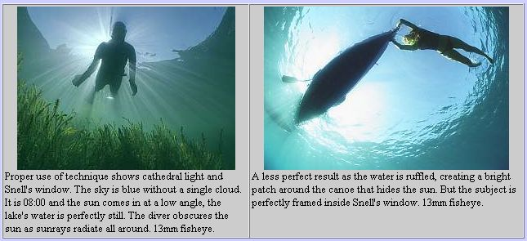

Light is Trapped Underwater

The light ray that comes from the fish to the origin cannot escape the water

Total Internal Reflection
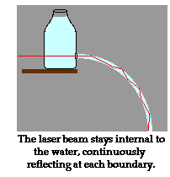

Guiding Light With Water

Light in a stream of water stays inside the water and bends with it

This was first demonstrated in the 1840s

Image from glenbrook.k12.il.us/gbssci


Total Internal Reflection

There is a critical angle at which no light can be refracted at all, so 100% of the light is reflected

Light is trapped in the water and cannot escape into the air

This works with any dense medium, such as plastic or glass, the same way it works with water

Image from glenbrook.k12.il.us

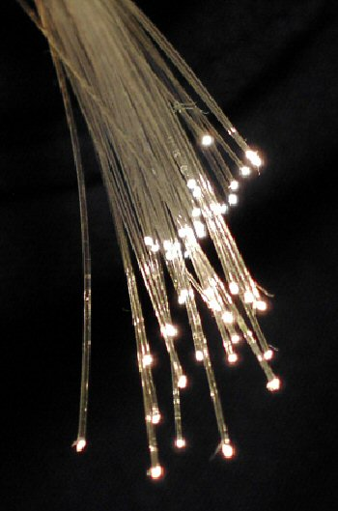
Types of Optical Fiber

Bare Fiber

During 1920-1950, thin, flexible rods of glass or plastic were used to guide light

Such “bare” fibers require air outside each fiber

Fibers degrade rapidly from handling

Image from Wikipedia

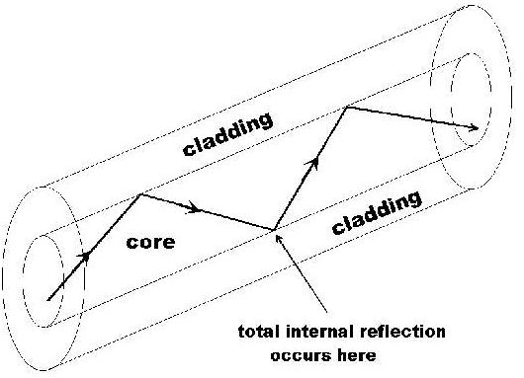

Fiber With Cladding

Developed in 1954 by van Heel, Hopkins & Kapany

Cladding is a glass or plastic cover around the core

Protects the total-reflection surface from contamination

Reduces cross-talk from fibers in bundles

Corning

Corning scientists developed low-attenuation silica glass fibers in 1970

Corning Video: At The Speed of Light

Link Ch 1c on my Web page (samsclass.info, CNIT 211 / ELEC 211)

Singlemode and Multimode Fiber

Singlemode fiber has a core diameter of 8 to 9 microns

Multimode fiber has a core diameter of 50 or 62.5 microns

Both have a cladding diameter of 125 microns

Singlemode Fiber

Singlemode fiber has a core diameter of 8 to 9 microns, which only allows one light path or mode

Images from arcelect.com (Link Ch 2a)

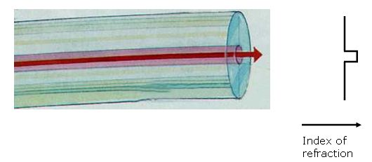

Multimode Step-Index Fiber

Multimode fiber has a core diameter of 50 or 62.5 microns (sometimes even larger)

Allows several light paths or modes

This causes modal dispersion – some modes take longer to pass through the fiber than others because they travel a longer distance

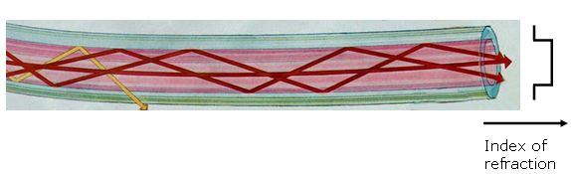
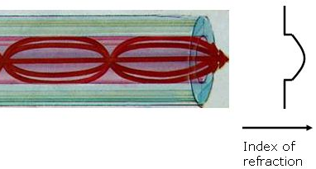

Multimode Graded-Index Fiber

The index of refraction gradually changes across the core

Modes that travel further also move faster

This reduces modal dispersion so the bandwidth is greatly increased

Popular Fiber Types

At first there were only two common types of fiber

62.5 micron multimode, intended for LEDs and 100 Mbps networks

There is a large installed base of 62.5 micron fiber

8 micron single-mode for long distances or high bandwidths, requiring laser sources

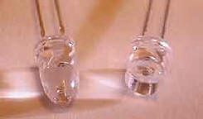
Corning’s SMF-28 fiber is the largest base of installed fiber in the world (links Ch 2j, 2k)

Gigabit Ethernet

62.5 micron multimode fiber did not have enough bandwidth for Gigabit Ethernet (1000 Mbps)

LEDs cannot be used as sources for Gigabit Ethernet – they are too slow
LED

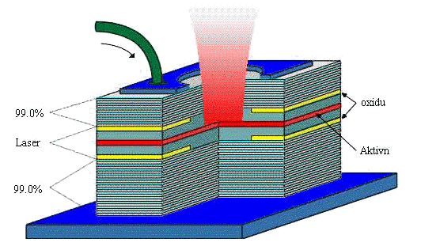
So Gigabit Ethernet used a new, inexpensive source:

Vertical Cavity Surface Emitting Laser (VCSEL)

LEDs and VCSELs

From www.mtmi.vu.lt/pfk/funkc_dariniai/diod/led_laser.htm

Multimode Fiber Designed for VCSELs

First came laser-rated 50 micron multimode

Bandwidth 500 MHz-km at 850 nm

Then came laser-optimized 50 micron multimode

Bandwidth 2000 MHz-km at 850 nm

Distinctive aqua-colored jacket

See links Ch 2g, 2h, 2i
VCSEL
Cable Types

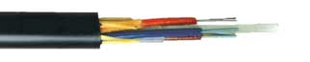
Loose-Tube Cable

1-12 fibers loose in a tube
Strength member outside the tube

Used Outdoor

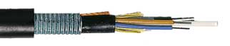
Ducts or conduits

Aerial lashed

Directly buried (armored)

Images from alphawire.com (link Ch 4k)

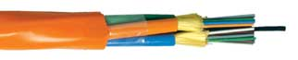
Distribution Cable

Contains tight-buffered fibers in bundles of up to 12 each

Used for Riser and Office Cabling

Must be terminated inside a patch panel or junction box

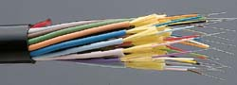
Breakout Cable

Reinforce each tight-buffer fiber with Kevlar and jacket it

Each fiber can be broken out and individually connectorized

Image from arcelect.com (link Ch 4g)

Ribbon cable

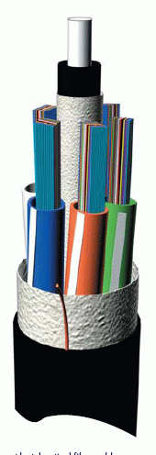
Dozens of fibers packed together

Can be mass fusion spliced or mass terminated

Images from gore.com (link Ch 4b) and alcatel.com (link Ch 4c)

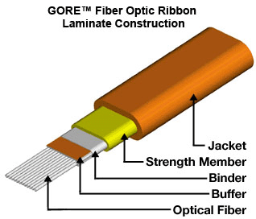

Connectors and Splices

Connectors

Rigid Ferrule Connectors

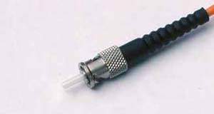
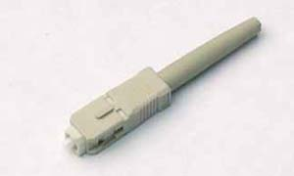
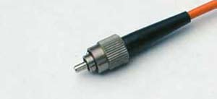
2.5 mm ferrule

ST

SC

FC

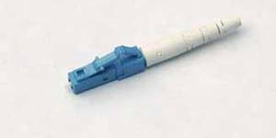
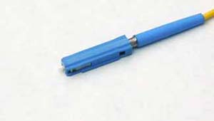
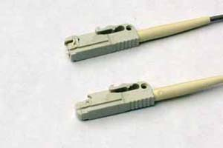
1.25 mm ferrule

Small Form Factor

LC

MU

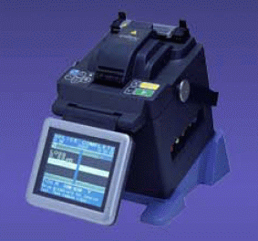

LX-5

Images from thefoa.org (link Ch 6d)

Fusion Splicing

Melts the fibers together to form a continuous fiber

Expensive machine

Strongest and best join for singlemode fiber

May lower bandwidth of multimode fiber

Mass Fusion Splicing

Video from fitel.fiberoptic.com (link Ch 6i)

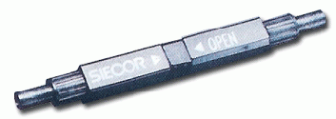
Mechanical Splicing

Mechanically aligns fibers

Contains index-matching gel to transmit light

Equipment cost is low

Per-splice cost is high

Quality of splice varies, but better than connectors

Fiber alignment can be tuned using a Visual Fault Locator
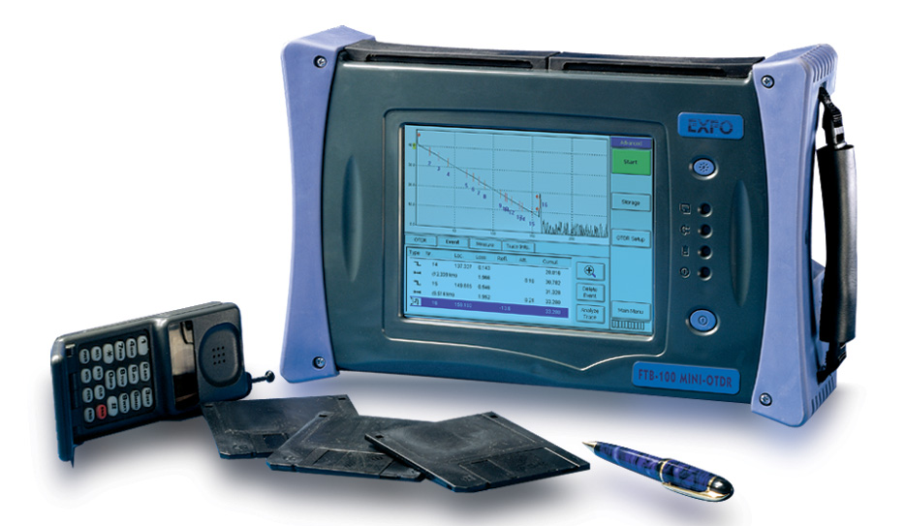
OTDR: Testing Cable Plants

OTDR: Optical Time-Domain Reflectometer

Image from exfo.com

OTDR Uses

Measure loss

Locate breaks, splices, and connectors

Produces graphic display of fiber status

Can be stored for documentation and later reference

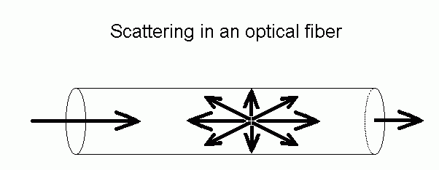
Cable can be measured from one end

Backscatter

A small amount of light is scattered back to the source from the fiber itself

Splices or connector pairs cause a larger reflection of light back to the source

Figure from techoptics.com (link Ch 17a)
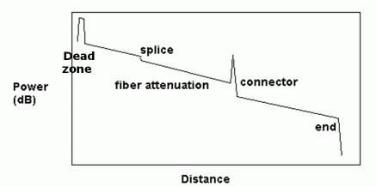

OTDR Display

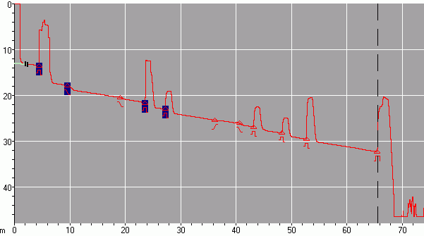
Start of cable
Connection Points
End of cable

OTDR Trace

of CCSF Fiber

Loop

Total length:
66 km

The Future of Fiber Optics: Faster Networks

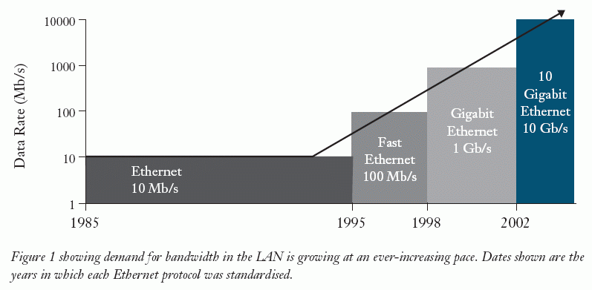
History of Ethernet

From Corning (link Ch 5b)

Bandwidth Comparison

Multimode Fiber is limited to 10 Gbps for reasonable lengths (30 m)

Singlemode Fiber is MUCH faster – its bandwidth is estimated to be 100,000 Gbps (100 Tbps)

But no electronics are available yet to transmit signals that fast

From www.lucent.com/press/0601/010628.bla.html

Singlemode Fiber is NOT Expensive

Price of 500 feet of riser-rated indoor bulk cable, 12-fiber

62.5/125 micron MM $889

50/125 micron MM $889

50/125 micron
laser-optimized MM $1143

8.5/125 micron SM $584

From blackbox.com (link Ch 5c)

Faster Electronics ARE More Expensive

Price of electronic-to-optical media converters

100 Mbps Multimode: $ 229

1 Gbps Multimode: $ 760

1 Gbps Singlemode: $1,180

Prices from L-Com.com (Links Ch 5d & 5e)

Fiber to the Home

One fiber cable can carry voice, data, and video

Already available in many cities

http://www22.verizon.com/FiOSForHome/channels/FiOS/root/about_installation.asp
The Future of Fiber Optics: More Secure Networks

Quantum Encryption

Encryption keys are sent as individual photons

Undetected spying is impossible, because measuring the photons changes them

www.toshiba-europe.com/research/crl/QIG/securityfromeavesdropping.html

Commercial Quantum Key Distribution Devices

MagiQ and Clavis: www.magiqtech.com and www.idquantique.com/products/clavis.htm

Sources

Fiber Optic Technician's Manual, Third Edition by Jim Hayes

City of Light : The Story of Fiber Optics (Sloan Technology Series) by Jeff Hecht

Lennie Lightwave Guide To Fiber Optics www.lennielightwave.com
Last modified 1-10-07

