Optical Time Domain Reflectometer (OTDR)
The OTDR sends a brief pulse of infrared light into the fiber, and measures the back-scattered light that returns from the cable. This gives a graphical display of the fiber length, showing connectors, splices, and the end of the cable. It is especially helpful in locating a break in a long fiber link.
Goal:
The goal is to get a good trace of the CCSF fiber loop, which is about 60 km long.

Starting the EXFO OTDR
- Turn it on with the button on the lower right of the front panel
- The screen dims a lot, just press the button several times to make it brighten again.
- The starting screen shows the module we have installed:

FTB-7300D-23B-EI-EIUL This is the OTDR.

Collecting a Trace
- On the bottom of the screen, there are three buttons:
Advanced OTDR Automatic OTDR Create Ref./Template
- Touch the Automatic OTDR button on the screen with the blue stylus. Don't use the tip of a pen because that will mark up the screen.
- Touch the square Start button in the lower right of the screen.
- An old trace is shown. Ignore it and connect the fiber to the CCSF network at the wall-mounted patch panel.
- In the Wavelength section, notice that both 1310 nm and 1550 nm are selected with X signs. That’s OK – we will use both wavelengths.
- Make sure the three dials: Distance (km), Pulse, and Time (s) are all set to Auto.
- Press the green Start button in the top right. If a box appears saying “Data Unsaved”, click No. While the trace runs. You will see a yellow warning box saying Warning! Laser is ON in the lower right of the screen. It will take 30 seconds for each wavelength.
- When the trace is collected, you will see a trace on the screen. Compare it to the figures on the next page.
- A good trace will show a spike at 0 km and a gradual slope going out to 66 km or so, with spikes in between at each patch panel.
- A bad trace will just fade to noise within 0.5 km, indicating that the launch cable is incorrectly connected.

Last modified 1-10-07
Example OTDR Traces
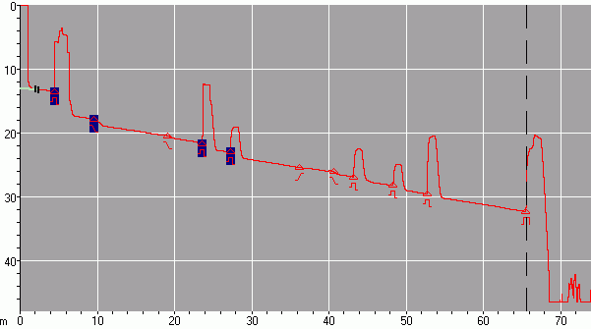
Start of cable
Connection Points
End of cable
Good Trace of
66 km CCSF Loop

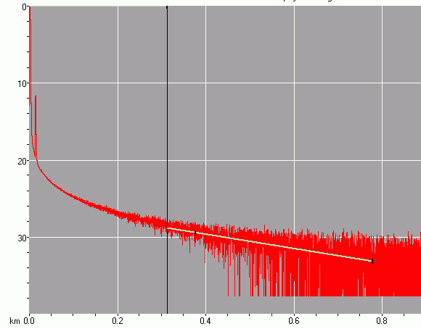
Bad Trace:
Launch Cable Improperly Attached

