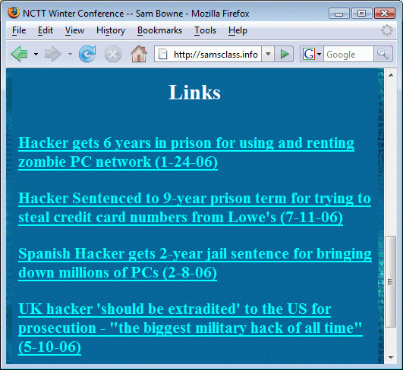
Contact Information

Sam Bowne

Email: sbowne@ccsf.edu

Website: samsclass.info

All materials from this talk are already on that website

Download them and use them freely

Isn’t Hacking a Crime?

Introduction to Ethical Hacking

Ethical hackers

Employed by companies to perform penetration tests

Penetration test

Legal attempt to break into a company’s network to find its weakest link

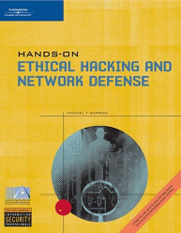
Tester only reports findings, does not harm the company

The Role of Security and Penetration Testers

Hackers

Access computer system or network without authorization

Breaks the law; can go to prison

Crackers

Break into systems to steal or destroy data

U.S. Department of Justice calls both hackers

Ethical hacker

Performs most of the same activities but with owner’s permission

The Role of Security and Penetration Testers (continued)

Script kiddies or packet monkeys

Young inexperienced hackers

Copy codes and techniques from knowledgeable hackers

Experienced penetration testers use Perl, C, Assembler, or other languages to code exploits

Security Credentials

CompTIA offers Security+ certification, a basic familiarity with security concepts and terms

OSSTMM Professional Security Tester (OPST)

Designated by the Institute for Security and Open Methodologies (ISECOM)

Based on the Open Source Security Testing Methodology Manual (OSSTMM)

Written by Peter Herzog

Certified Information Systems Security Professional (CISSP)

Issued by the International Information Systems Security Certifications Consortium (ISC²)

Usually more concerned with policies and procedures than technical details

Web site: www.isc2.org
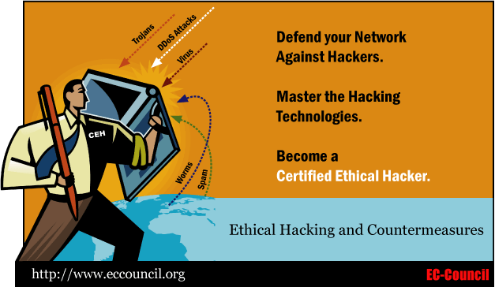

Certified Ethical Hacker (CEH)

But see Run Away From The CEH Certification

Link at samsclass.info

What You Cannot Do Legally

Accessing a computer without permission is illegal

Other illegal actions

Installing worms or viruses

Denial of Service attacks

Denying users access to network resources

Possession of others’ passwords can be a crime

See Password theft

Link at samsclass.info

Get Out of Jail Free Card

When doing a penetration test, have a written contract giving you permission to attack the network

Using a contract is just good business

Contracts may be useful in court

Have an attorney read over your contract before sending or signing it

Projects

Project 1: Using a Keylogger to record keystrokes (including passwords)

Project 2: Using The Metasploit Framework to take over a vulnerable computer remotely

Demonstration: Using Ophcrack to crack Windows passwords with Rainbow tables

CNIT 123: Ethical Hacking and Network Defense

3-unit course

Offered face-to-face next semester

Face-to-face and online sections in Spring 2008

Last modified 6-13-07

