What You Need for This Project

LEGAL WARNING!
Use only machines you own, with passwords you created, or machines with accounts you have permission to hack into. Stealing passwords, or even possession of them without permission from the owners, is a crime! Don’t do it! If you do illegal things, you may be arrested and go to jail, and I will be unable to save you. These instructions are intended to train computer security professionals, not to help criminals.
- A computer running Windows XP (any version). This can be either a real or virtual machine.
- You don’t need administrator privileges—you don’t need any login account at all on the Windows XP machine.
- You need physical access to the Windows XP machine, and the ability to boot from a CD.

Start Your Host Machine
- Power on the machine. Log in with the user name CNIT80 and no password.
Launching VMWare
- Click Start, "All Programs", VMWare, "VMWare Workstation". If you see a “Tip of the day” box, click Close. If you see a “VMware Web Check” box, click Cancel.
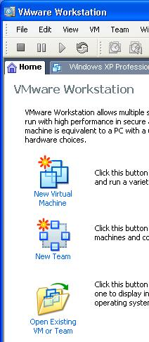
- In the "VMWare Workstation" window, from the menu bar, click View, "Go to Home Tab". You should see a screen with three large icons, as shown to the right on this page. Click the "Open Existing VM or Team" icon.
- In the Open box, click “My Computer”. Double-click the “VMs (V:)” drive to open it. Double-click the "CNIT80 VMs" folder to open it. Double-click the “Win XP Pro for Hacking” folder. Double-click on the “Windows XP Professional.vmx” file. (The .vmx filename extension may not be visible.)
- The "VMWare Workstation" window reappears, with a tab labeled “Windows XP Professional”. In the left pane, click the blue "Start this virtual machine" link.
- If a “Windows XP Professional – Virtual Machine” box opens with a long message about product activation, click OK.
- A “Windows XP Professional – Virtual Machine” box opens asking if it should create a new unique identifier (UUID). Accept the default selection of Create and click OK.
- A “Windows XP Professional – Virtual Machine” box opens warning you that the default sound device cannot be opened. Click OK.
- If a “Windows XP Professional – Virtual Machine” box opens with message about the keyboard timeout hook value, click OK.

- When the virtual PC launches, it automatically logs on with the user name Student and no password. A Windows XP desktop appears within the VMware window. This is your virtual machine (VM). Virtual machines are great for hacking projects because if you mess them up, you can just delete them and replace them easily.

Creating Passwords to Crack
- In your virtual machine, click Start, right-click "My Computer", and click Manage. In "Computer Management", in the left pane, expand the "Local Users and Groups" container.
- In the left pane of "Computer Management", click the Users container. You should see some accounts in the right pane, as shown below on this page.
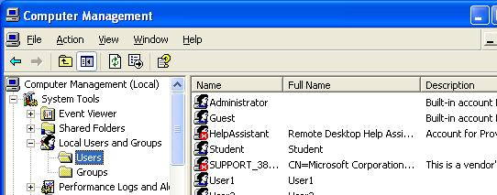

Creating Test Passwords
- Fill in the table below with passwords to test. Don’t just use my examples, which are very weak, scramble the letters and numbers to make passwords that are hard to remember and hard to guess.

Test6 Six letters and numbers like abc123: _______________________________

Test12 Twelve letters and numbers like abcdef123456: _______________________________

Testx A password you think is reasonably secure: _______________________________

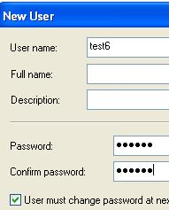

Creating Test Accounts
- In the left pane of Computer Management, right-click Users and click New User.
- In the NewUser box, enter user name of Test6 and the password you wrote down above, as shown to the right on this page. Click Create. The check boxes in the lower section of the New User box don’t matter, because no one will really be using these accounts.
- Repeat the process to create all the accounts in the box above.

Shutting Down Your Machine
- In your virtual machine, click Start, "Turn Off Computer", "Turn Off".

Getting the Ophcrack CD Image
- You need the Ophcrack CD image, or a bootable CD. If you are working in the S214 lab, the image is already there in the V:\Install folder. If you are working at home, you can download it from http://ophcrack.sourceforge.net/

Setting the Virtual CD to Use the Ophcrack CD Image
- Make sure your virtual machine is powered down. You cannot change these settings while it’s on.
- In the VMware Workstation window, from the menu bar, click View, "Go to Home Tab". Click the "Open Existing VM or Team" icon.
- In the Open box, click “My Computer”. Double-click the “VMs (V:)” drive to open it. Double-click the "CNIT80 VMs" folder to open it. Double-click the “Win XP Pro for Hacking” folder. Double-click on the “Windows XP Professional” file. You should see a Windows XP Professional VM in the Powered Off state. Don't start the virtual machine yet!
- From the Menu bar, select VM, Settings.
- In the "Virtual Machine Settings" box, click CD-ROM in the left pane. In the right pane, click Use ISO Image. Click the Browse button.
- In the "Browse for ISO Image" box, on the left side, click the "My Computer" icon. Double-click the “VMs (V:)” drive to open it. Double-click the Install folder to open it. Double-click on the “ophcrack-livecd-1.1.3.iso” file.
- Your screen should now look like the image below on this page. Click OK to close the Virtual Machine Settings box.
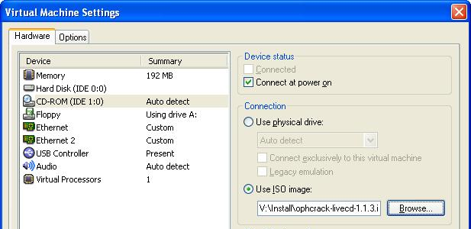

Adjusting the BIOS Boot Order
- This next process is a little tricky. You will probably need to try it a few times to make it work, because you need to click the mouse and then press the correct key on the keyboard within 2 or 3 seconds.
- On the left side of the “Windows XP Professional – Vmware Workstation” window, click the blue "Start this virtual machine" link.
- If a “Windows XP Professional – Virtual Machine” box opens with a long message about product activation, click OK.
- A “Windows XP Professional – Virtual Machine” box opens warning you that the default sound device cannot be opened. Click OK.
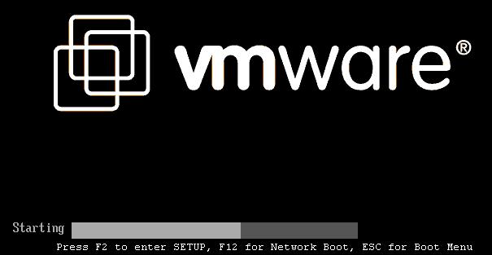
- You will see the screen shown below for just a couple of seconds, with this message at the bottom: "Press F2 to enter SETUP…". Within those few seconds, you must click the left mouse button to make the virtual machine listen to the keyboard, and press the F2 key on the upper left of your keyboard.
- If you don't do it fast enough, Windows XP will start. If that happens, wait till it starts and shows you a list of login names, including Student. Then click "Turn off computer" and click Restart to restart your virtual machine.
- When you succeed, you will see a screen titled "Phoenix BIOS Setup Utility", as shown below. Press the right-arrow key on the keyboard three times to highlight Boot. Then press the down-arrow on the keyboard twice to highlight "CD-ROM Drive". Finally, press the + key on your keyboard twice to move "CD-ROM Drive" to the top of the list, as shown in the image below.
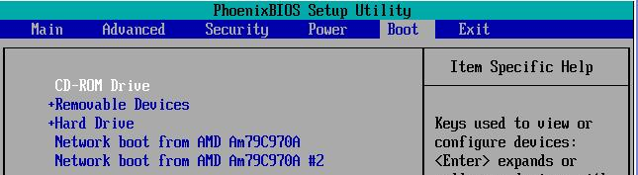

- When your screen looks like the image above, press the F10 key. A "Setup Confirmation" box appears. Press the Enter key.

Booting from the Ophcrack CD Image
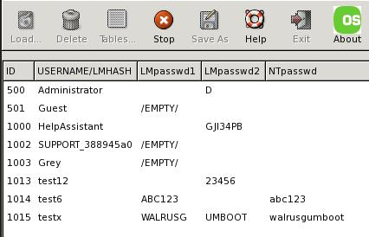
- The virtual machine should boot from the CD image, and show you a list of usernames and passwords like the image to the right on this page.
- Ophcrack loads Slackware Linux and automatically runs the Ophcrack rainbow table cracker. This performs a very fast brute-force password-guessing algorithm, and slowly fills the passwords in as it finds them. It shouldn't take more than 200-400 seconds to find most or all of your passwords. The process is not perfect, but it should find 99% of passwords that use only the characters it searches for, which include uppercase and lowercase letters, numbers, and many punctuation marks. Passwords longer than 14 characters cannot be broken by this program, however. Because Windows does not use LM Hashes for them.

Shutting Down Ophcrack
- Your virtual machine is still running Ophcrack. To stop it, right-click a blank part of the desktop and click Logout.

Disconnecting the Virtual Machine from the Ophcrack ISO Image File
- When your virtual machine has shut down, do these steps to disconnect the virtual CD from the Ophcrack ISO image file:
- From the Menu bar, select VM, Settings.
- In the Virtual Machine Settings box, click CD-ROM in the left pane. In the right pane, click Use physical drive.
- Click OK to close the Virtual Machine Settings box.

Starting Windows XP
- On the left side of the “Windows XP Professional – Vmware Workstation” window, click the blue "Start this virtual machine" link.
- If a “Windows XP Professional – Virtual Machine” box opens with a long message about product activation, click OK.
- If a “Windows XP Professional – Virtual Machine” box opens with a message about "VMware Tools", click OK.
- A “Windows XP Professional – Virtual Machine” box opens warning you that the default sound device cannot be opened. Click OK.
- Log in as Student. There is no password on the Student account.

Learning about LM Hashes
- Windows XP passwords are very insecure! With Ophcrack, anyone could easily crack almost any password. This is because Windows XP uses LM Hashes. To learn about LM Hashes, open a browser and read this brief article: http://en.wikipedia.org/wiki/LM_hash

Setting a Restore Point
- LM hashes are not a bug in Windows XP—they are a deliberate feature. So turning them off is just a matter of adjusting Windows XP with a single Registry key. Before changing the Registry, it is a good practice to create a Restore Point, so you can recover if you make a mistake.
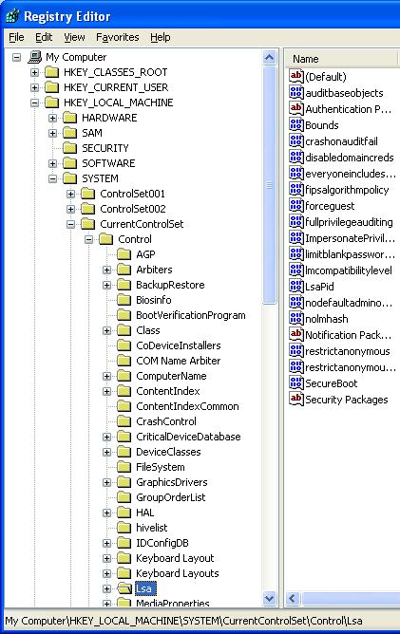
- Click Start, "Help and Support". In "Help and Support Center" window, in the "Pick a Task" section, click "Undo changes to your computer with System Restore". In the next screen, select "Create a Restore Point "and click Next. In the next screen enter a "Restore Point Description" of "Your Name Project 1" and click Create. When you see the "Restore Point Created" message, click the Close button. Close the " Help and Support Center" window.

Hardening Windows XP: Removing LM Hashes
- Click Start, Run. Enter REGEDIT and press the Enter key.
- In the left pane of the "Registry Editor" window, click the + sign to expand the HKEY_LOCAL_MACHINE key. Then expand these keys:
SYSTEM
CurrentControlSet
Control
- Click the Lsa key to select it. Your "Registry Editor" window should look like the example shown to the right on this page.
- In the right pane, double-click nolmhash.
- In the "Edit DWORD Value" box, enter a Value data: of 1, and then click OK.

Changing the Password for the Test6 Account
- Click Start, right-click My Computer, and click Manage. In Computer Management, in the left pane, expand the Local Users and Groups container. Click the Users container to select it.
- Right-click the Test6 account in the right pane and select Set password.
- In the Set password for Test6 box, click Proceed.
- In the Set password for Test6 box, enter a new password of any length in both boxes. Click OK.

Running Ophcrack Again
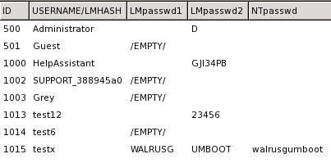
- Repeat the steps you did previously, under the headings “Setting the Virtual CD to Use the Ophcrack CD Image” and “Booting from the Ophcrack CD Image.” You don't need to adjust the BIOS boot order again.
- You should see results as shown to the right on this page–the Test6 account shows /EMPTY/ because there is no LM Hash and Ophcrack cannot crack its password. Notice that the unchanged passwords are still vulnerable, because the previously created LM Hashes are still present.

Last Modified: 6-14-07

