What You Need for This Project

LEGAL WARNING!
Use only machines you own, or machines you have permission to hack into. Hacking into machines without permission is a crime! Don’t do it! If you do illegal things, you may be arrested and go to jail, and I will be unable to save you. These instructions are intended to train computer security professionals, not to help criminals.
- A trusted computer running any version of Windows, with Internet access. You need administrator privileges. This can be either a real or virtual machine.
- A victim computer running Windows 2000 Professional with no Service Packs. This can be either a real or virtual machine.

Start Your Host Machine
- Power on the machine. Log in with the user name CNIT80 and no password.
Launching VMWare
- Click Start, All Programs, VMWare, VMWare Workstation. If you see a “Tip of the day” box, click Close. If you see a “VMware Web Check” box, click Cancel.
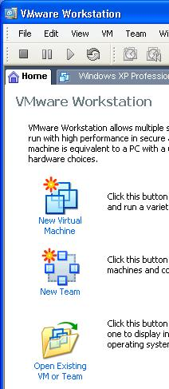
- In the VMWare Workstation window, from the menu bar, click View, “Go to Home Tab. You should see a screen with three large icons, as shown to the right on this page. Click the Open Existing VM or Team icon.
- In the Open box, click “My Computer”. Double-click the “VMs (V:)” drive to open it. Double-click the "CNIT80 VMs" folder to open it. Double-click the “Win 2000 Pro SP2” folder. Double-click on the “Windows 2000 Professional.vmx” file. (The .vmx filename extension may not be visible.)
- The VMWare Workstation window reappears, with a tab labeled “Windows 2000 Pro SP2”. In the left pane, click the blue Start this virtual machine link.
- A “Windows 2000 Professional – Virtual Machine” box opens asking if it should create a new unique identifier (UUID). Accept the default selection of Create and click OK.
- When the virtual PC starts, log in as Administrator with no password. A Windows 2000 desktop appears within the VMware window. This is your Victim Machine.

Getting the Victim Machine's IP Address
- In the Windows 2000 virtual machine, open a Web browser and verify that this machine can reach the Internet. If it cannot, call your instructor over to help solve that problem first.
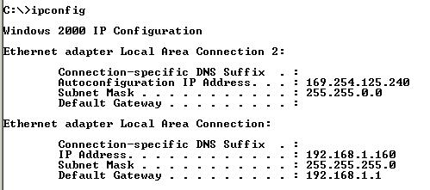
- Click Start, Run. Type in cmd and press the Enter key. In the Command Prompt window, type in IPCONFIG command and press the Enter key. This will show two IP addresses, as shown to the right on this page, because there are two network adapters in the virtual machine.

Victim IP (RHOST): ___________________

- The adapter that is connected has an IP address starting with 192. Find that address and write it in the box to the right on this page.

Starting Your Windows XP Virtual Machine
- Click Start, All Programs, VMWare, VMWare Workstation. If you see a “Tip of the day” box, click Close. If you see a “VMware Web Check” box, click Cancel.
- In the VMWare Workstation window, from the menu bar, click View, “Go to Home Tab. Click the Open Existing VM or Team icon.
- In the Open box, click “My Computer”. Double-click the “VMs (V:)” drive to open it. Double-click the "CNIT80 VMs" folder to open it. Double-click the “Win XP Pro for Hacking” folder. Double-click on the “Windows XP Professional.vmx” file. (The .vmx filename extension may not be visible.)
- The VMWare Workstation window reappears, with a tab labeled “Windows XP Professional”. In the left pane, click the blue Start this virtual machine link.
- If a “Windows XP Professional – Virtual Machine” box opens with a long message about product activation, click OK.
- A “Windows XP Professional – Virtual Machine” box opens asking if it should create a new unique identifier (UUID). Accept the default selection of Create and click OK.
- A “Windows XP Professional – Virtual Machine” box opens warning you that it “could not connect to floppy”. Click OK.
- A “Windows XP Professional – Virtual Machine” box opens warning you that it “virtual device floppy0 will start disconnected”. Click OK.
- If a “Windows XP Professional – Virtual Machine” box opens warning you that the default sound device cannot be opened. Click OK.
- If a “Windows XP Professional – Virtual Machine” box opens with message about the keyboard timeout hook value, click OK.
- When the virtual PC launches, if it doesn't automatically log on, log on as Student with no password. A Windows XP desktop appears within the VMware window.

Getting the Windows XP Machine's IP Address
- In the Windows XP virtual machine, open a Web browser and verify that this machine can reach the Internet. If it cannot, call your instructor over to help solve that problem first.
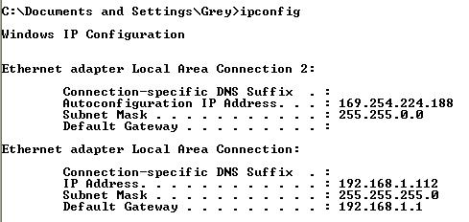
- Click Start, Run. Type in cmd and press the Enter key. In the Command Prompt window, type in IPCONFIG command and press the Enter key. This will show two IP addresses, as shown to the right on this page, because there are two network adapters in the virtual machine.
- The adapter that is connected has an IP address starting with 192. Find that address and write it in the box to the right on this page.

Attacker IP (LHOST): ___________________

Downloading The Metasploit Framework

- In the virtual Windows XP machine, open Firefox and go to metasploit.net
- At the top of the Metasploit page, in the “Framework 2.7” line, click the WIN32 link, as shown to the right on this page.
- In the “Opening famework-2.7.exe” box, click the “Save file” button. The file is saved on your desktop.

Disabling the Antivirus Software

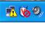
- Some portions of Metasploit use known exploits, and McAfee antivirus will prevent them from installing. So we need to turn off the antivirus scanner before installing Metasploit. Look in the lower right-hand corner of your virtual Windows XP machine's desktop. Find the shield icon with the red V on it, as shown to the right on this page. Right-click the shield icon and click "Disable On-Access Scan".
McAfee Shield Icon
- The shield icon should now show a red circle with a slash through it, as shown to the right on this page.

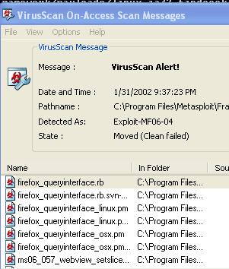
Installing Metasploit
- Minimize all windows. Double-click the framework-2.7.exe file on your desktop and click through the installer, accepting all the default selections.
- A "VirusScan On-Access Scan Messages" box will appear, as shown to the right on this page. This is McAfee getting upset about the hacking tool you are installing, and blocking some portions of it. In the "VirusScan On-Access Scan Messages" box, click the "Close Window" button.
- Close all windows.

Starting MSFWeb
- Click Start, All Programs, Metasploit 2, MSFWeb. A command prompt window opens with a single line of text in it as shown below. Leave this window open – this is a little Web server running on your machine, which enables you to control Metasploit through a Web browser.
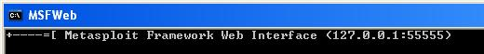
Launching the MS04-011 Exploit
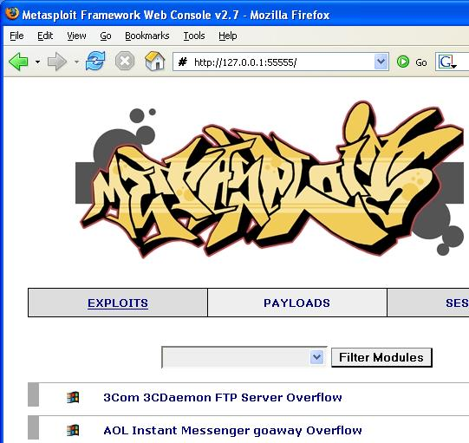
- Open Firefox (IE does not work for this) and type this address into the Address bar:
127.0.0.1:55555
- Press the Enter key. You should see a graffiti-style Metasploit logo, with a long list of exploits, such as the ones shown to the right on this page targeting 3Com, AOL, and many more. Computers running these products can be attacked by Metasploit.

Launching the MS04-011 Exploit
- In the Metasploit page, scroll down to "Microsoft LSASS MSO4-011 Overflow" and click it. This exploit can take over an unpatched Windows system—it does not depend on any additional vulnerable software.
- Scroll down to the "Select Target" section and click the victim operating system –Windows 2000.
- In the "Select Payload" section, click win32_reverse – this is a common payload that opens a Command Prompt on the victim machine, so you can type in commands of your choice to do anything you like on that machine.
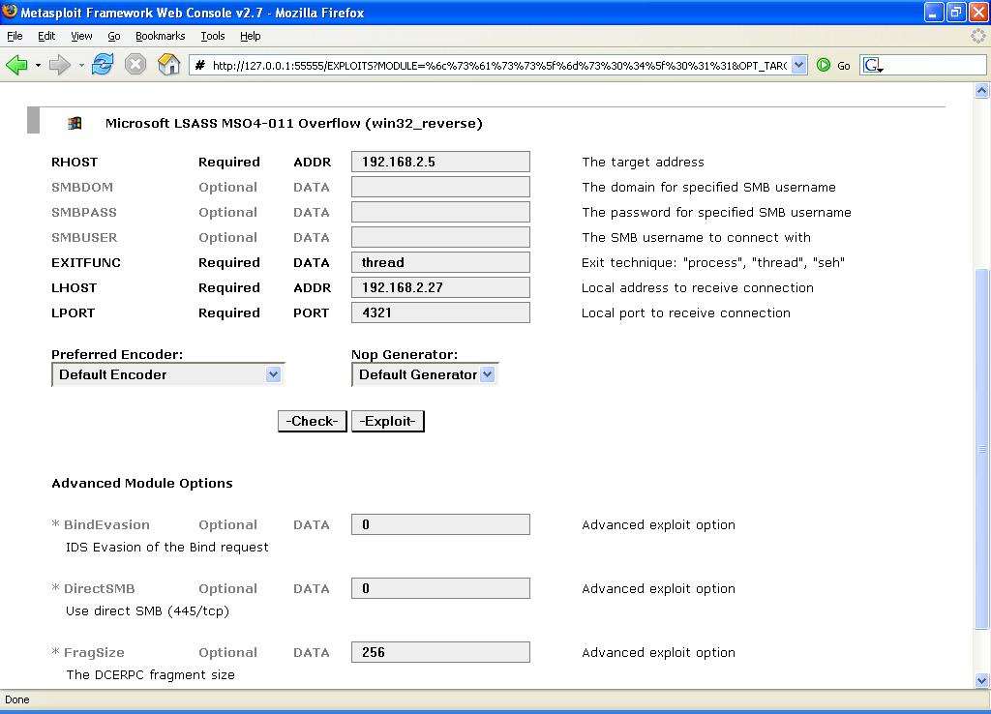
- Get the RHOST and LHOST values you wrote down in the boxes on previous pages. Type them into the RHOST and LHOST boxes in the next screen, as shown to the right on this page. Then click the Exploit button near the bottom of the window.
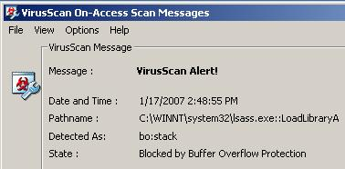
- You should see an Exploit Output that appears only briefly, followed by a page that says The connection was reset. The exploit failed.
- To see why, look at your Windows 2000 machine’s desktop. You should see a McAfee antivirus warning, as shown to the right on this page.
- On the Windows 2000 virtual machine, close all windows.

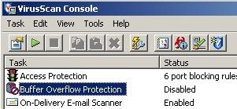
Disabling the Virus Scanner’s Buffer Overflow Protection
- In the Windows 2000 virtual machine, in the lower right corner, right-click the little shield icon and select "VirusScan Console".
- In the "VirusScan Console" window, right-click "Buffer Overflow Protection" and select Disable. The Status line should change to Disabled as shown to the right on this page.

Launching the MS04-011 Exploit Again
- On your Windows XP virtual machine, in the Firefox window, type in the address 127.0.0.1:55555 and press the Enter key.
- Scroll down to "Microsoft LSASS MSO4-011 Overflow" and click it.
- Scroll down to the "Select Target" section and click "Windows 2000".
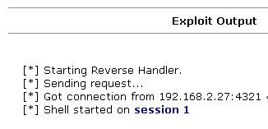
- In the "Select Payload" section, click win32_reverse.
- Enter the RHOST and LHOST values you wrote down in the boxes on previous pages of this project Then click the Exploit button.
- You should see an "Exploit Output" similar to the example to the right on this page, with different IP addresses and ports. If it works, you will see the line "Shell started on session 1" (your session number will be larger). You may have to try the exploit more than once.
- When you get a connection, in the "Shell started on session #" line, click the session link.

Using the Reverse Shell to Tag the Victim’s Desktop
- As shown below on this page, enter two commands to create a file on the victim’s desktop. This is a traditional way childish hackers scare victims, showing that you “own” their box.

cd \documents and settings\administrator\desktop

echo “ha ha” > YOURNAME_owns_your_computer.txt

(Replace YOURNAME with your own name in the second command.)

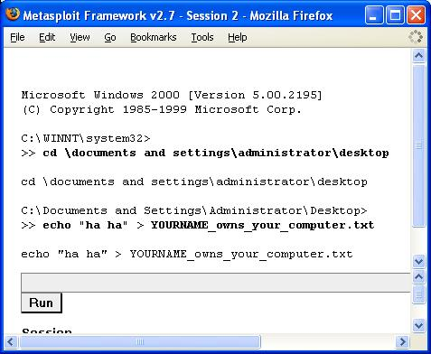

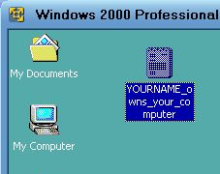
- You should be able to see the new file on the victim’s desktop, as shown to the right on this page. Imagine how you would feel if files started appearing on your computer from nowhere while you were using it!

Hardening the Windows 2000 Machine
- To prevent this exploit, just use Windows Update to put all service packs and updates onto the Windows 2000 machine. That will take a while, and may not be practical in the lab. But if you do, this exploit will stop working.

Last Modified: 6-13-07

