What You Need for This Project

LEGAL WARNING!
Use only machines you own, or machines you have permission to spy on. Using keyloggers to spy on people without permission is a crime! Don’t do it! If you do illegal things, you may be arrested and go to jail, and I will be unable to save you. These instructions are intended to train computer security professionals, not to help criminals.
- A trusted computer running any version of Windows, with Internet access. You need administrator privileges. This can be either a real or virtual machine.

Use Your Trusted Virtual Machine (usually Win XP Pro SP2)
- Start your trusted virtual machine. This is the machine you will be trusting and using to exploit other machines, so you should keep it updated and protected with a virus scanner.

Creating a Restore Point
- Before doing anything risky with your computer, it is a good idea to create a Restore Point so you can undo changes to your system if you need to. Click Start, Help and Support. In Help and Support Center window, in the Pick a Task section, click Undo changes to your computer with System Restore. In the next screen, select Create a Restore Point and click Next. In the next screen enter a Restore Point Description of Your Name Restore Point for Project 1 and click Create.
- When you see the Restore Point Created message, click Close.

Downloading SC KeyLog PRO (Demo version)
- Open a browser (Firefox, preferably) and go to soft-central.net
- In the Products section, under the SC-KeyLog PRO header, click the Read more link.
- On the next page, scroll to the bottom and click the Download demo button. Save the
sc-keylogprodemo.exe file on your desktop.

Installation and Adjusting AntiVirus Settings
- Double-click the keylogprodemo.exe file on your desktop and click through the installer, accepting all the default selections. If your antivirus application blocks some files from installing, you need to exclude the installation folder from virus scanning. Here are the steps to do that with McAfee Antivirus – if you are using a different virus scanner, the steps will be different.
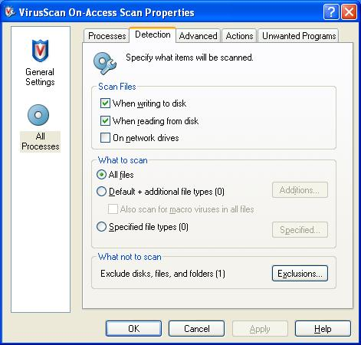
  - Close all windows.
  - Right-click the antivirus icon in the taskbar tray at the lower right of your desktop, and select On-Access Scan Properties.
  - A VirusScan On-Access Scan Properties box opens as shown to the right on this page. In the left pane, click the All Processes icon. In the right pane, click the Detection tab. Click the Exclusions button.

  - In the Set Exclusions box, click the Add button.
  - In the Add Exclusion box, click the Browse button. Browse to the C:\Program Files\SC-KeyLog PRO DEMO folder. Click the OK button.
  - In the Set Exclusions box, click the OK button.
  - In the VirusScan On-Access Scan Properties box, click the OK button.
- Note that this does put your machine at some risk – you have to trust the Keylogger software not to have nasty viruses in it, and you are also more susceptible to viruses in the future if they get into that folder. This is one reason to use a virtual machine, or one you don’t mind wiping clean.
- Double-click the sc-keylogprodemo.exe file on your desktop and run the installer again. Make sure it installs without setting off your virus scanner.

Using SC KeyLog PRO to Make a KeyLog Engine
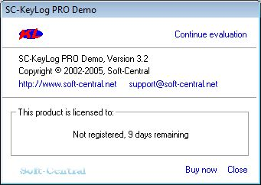
- After installation, the SC-KeyLog PRO Demo should launch, showing a small gray box as shown to the right on this page. If it does not open automatically, click Start, All Programs, SC-KeyLog PRO DEMO, Main.
- In the SC-KeyLog PRO Demo box, click the Continue evaluation link.
- A large window opens titled Sc-KeyLog PRO *** Demo version *** with a smaller box in front of it titled SC-KeyLog Control Panel/
- In the SC-KeyLog Control Panel, click Create SC-KeyLog Engine.
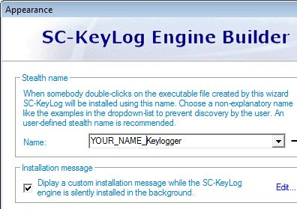
- In the SC-KeyLog Engine Builder box, click Next.
- In the next window, clear the Use email box. Emailed log files are a great feature, but as far as I can tell there is no way to make them work with the demo version. Click Next.
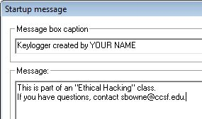
- In the next window, enter a Stealth name of YOUR_NAME_Keylogger as shown to the right on this page. Don’t use the literal words “YOUR_NAME” – use your own name instead. It is possible to choose a sneakier name to conceal the keylogger’s nature, but for this project we are not trying to be sneaky, just to see how it works.
- Check the Installation message box and click the blue Edit… link. Enter the text shown to the right, replacing “YOUR NAME” with your own name. Click OK.
- In the SC-KeyLog Engine Builder window, click Next.
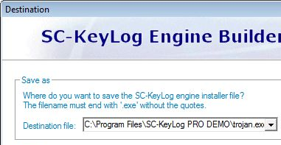
- In the next window, you choose where to save the file. This must be in a folder that your virus scanner is not monitoring, so use the same folder you used to install the software – usually C:\Program Files\SC-KeyLog PRO DEMO
- Give the file a name of Trojan.exe as shown to the right on this page. Once again, we could give it a sneaky name like fun.exe but we are not actually trying to trick people. Click Next,
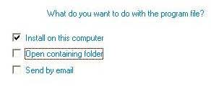
- In the SC-KeyLog Engine Builder window, click Next.
- The next window says Congratulations! As shown to the right on this page. Check the Install on this computer box and make sure the other two boxes are cleared, as shown to the right on this page. Click OK.

Installing the Keylog Engine
- The virus scanner should go off and prevent the Keylogger from installing. To get it to install, we need to turn the virus scanner off. Close the virus warning window. Right-click the antivirus icon in the taskbar tray at the lower right of your desktop, and select Disable On-Access Scan.
- In the SC-KeyLog Control Panel, click Create SC-KeyLog Engine.
- In the SC-KeyLog Engine Builder box, click Next five times, then click OK. The Keylogger should install on the local system.
- A warning box appears as shown below on this page. Click Yes.
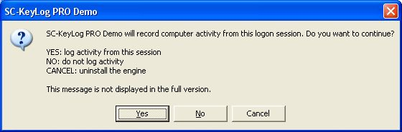

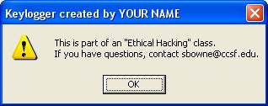
- A message box with your name in the title and my email address in the body should appear, as shown to the right on this page. Click OK.

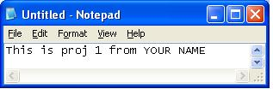
Typing in Plain Text and a Password
- Open Notepad and type in some text, including your name, as shown to the right on this page.
- Go to Yahoo or some other email service, and type in a name and the WRONG PASSWORD. Don’t use your real password, because it will be captured in the Keylogger’s DAT file. Click the Sign in button. You won’t get in, because the password is wrong.

Finding the Log File
- Click Start, My Computer. Double-click C:. Double-click Windows. If necessary, click Show the contents of this folder. Double-click System32. If necessary, click Show the contents of this folder.
- Click View, Details. Click the Date modified header twice to sort by date, with the most recent files on top.
- The Keylogger files are hidden system files. To make them visible, click Tools, Folder Options. Click the View tab. Clear the Hide protected operating system files (Recommended) box. Scroll down and click the Show hidden files and folders radio button. In the Warning box, click Yes. In the Folder Options box, click OK.
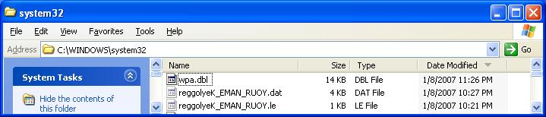
- You should see a file with a name starting reggol (logger backwards), as shown below. The keystrokes will be stored in the file ending in .dat.

Viewing the Captured Keystrokes
- In the SC-KeyLog Control Panel, click View Current Logfile.
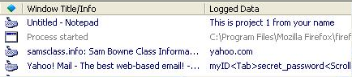
- Look through the Logged Data. You should be able to find the sentence you typed, and the user name and password you typed in, as shown to the right on this page.

Removing the Keylogging Software with System Restore
- Click Start, Help and Support. In Help and Support Center window, in the Pick a Task section, click Undo changes to your computer with System Restore. In the next screen, select Restore my computer to an earlier time and click Next.
- When the Select a Restore Point screen appears, select the restore point labeled Your Name Restore Point for Project 1.
- Click Next. If a window opens warning you that changes made after this point will not be monitored, click OK. Click Next again to perform the System Restore.

Last Modified: 1-9-07 11:30 pm

