What You Need for This Project

LEGAL WARNING!
Use only machines you own, or machines you have permission to hack into. Hacking into machines without permission is a crime! Don’t do it! If you do illegal things, you may be arrested and go to jail, and I will be unable to save you. These instructions are intended to train computer security professionals, not to help criminals.
- A trusted computer running any version of Windows, with Internet access. You need administrator privileges. This can be either a real or virtual machine.
- A victim computer running Windows 2000 Professional with no Service Packs. This can be either a real or virtual machine.

Start Your Victim Machine
- Start your victim machine. It should be running Windows 2000 with no Service Packs. If you are using the virtual machine provided by your instructor, log in as Administrator with the password password
- Open a Web browser and verify that this machine can reach the Internet. If it cannot, call your instructor over to help solve that problem first.

Victim IP: ___________________

- Click Start, Run. Type in cmd and press the Enter key. In the Command Prompt window, type in IPCONFIG command and press the Enter key. This will show your IP address. Write it in the box to the right on this page.

Use Your Trusted Machine (usually Win XP Pro SP2)
- Start your trusted machine. This is the machine you will be trusting and using to exploit other machines, so you should keep it updated and protected with a virus scanner.

Downloading The Metasploit Framework
- Open a browser (Firefox, preferably) and go to metasploit.com
- Click Framework. Click Downloads.
- Scroll down until you see the Windows installer for latest version of Metasploit (Version 2.7 as I write this). Click the Framework for Windows link. Save the file on your desktop.

Installing Metasploit
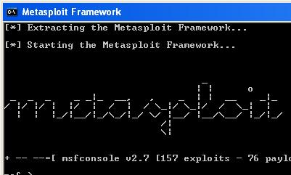
- Double-click the framework-2.7 .exe file on your desktop and click through the installer, accepting all the default selections. When the graphical installer is done, a command prompt window titled Metasploit Framework stays open. Wait until you see metasploit in ASCII art, as shown to the right on this page.
- Metasploit is most powerful when run from this command prompt window. But we are going to use the Web interface, which is much easier to use.
- Click the red X button to close the Metasploit Framework window.

Starting MSFWeb
- Click Start, All Programs, Metasploit 2, MSFWeb. A command prompt window opens with a single line of text in it as shown below. Leave this window open – this is a little Web server running on your machine, which enables you to control Metasploit through a Web browser.

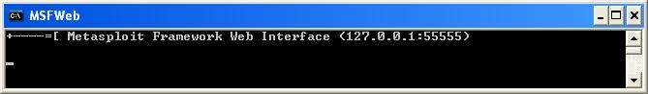

Launching the MS04-011 Exploit
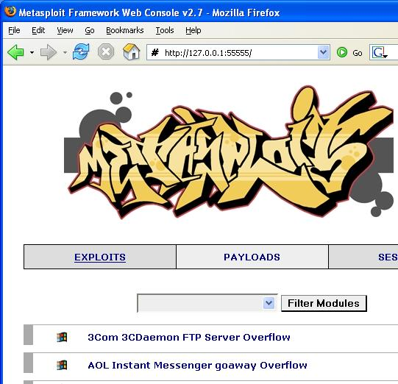
- Open a browser (Firefox, preferably) and go to 127.0.0.1:55555
- If a security alert from your firewall pops up, unblock the program.
- You should see a graffiti-style Metasploit logo, with a long list of exploits, such as the ones shown to the right on this page targeting 3Com, AOL, and many more. Computers running these products can be attacked by Metasploit.
- Scroll down to Microsoft LSASS MSO4-011 Overflow and click it. This exploit can take over an unpatched Windows system—it does not depend on any additional vulnerable software.
- Scroll down to the Select Target section and click the victim operating system – either Windows 2000 or Windows XP.
- In the Select Payload section, click win32_reverse – this is a common payload that opens a Command Prompt on the victim machine, so you can type in commands of your choice to do anything you like on that machine.
- Look at the first page of this project, and find the Victim IP you wrote down. Type that number into the RHOST box in the next screen, as shown below. Don’t use the number 192.168.2.5 – that’s the number from my home network. Use your correct victim IP address instead. Then click the Exploit button near the bottom of the window. (Don’t bother with the Check button – it does not seem to work properly.)

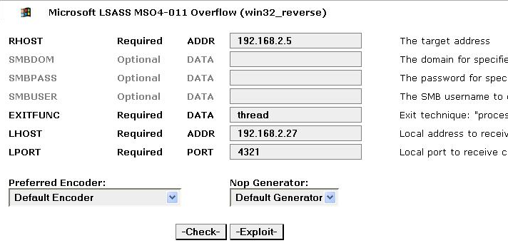
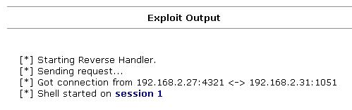
- You should see an Exploit Output similar to the example to the right on this page, with different IP addresses and ports. If it works, you will see the line Shell started on session 1. Click the session 1 link.

Using the Reverse Shell to Tag the Victim’s Desktop
- Enter these two commands to create a file on the victim’s desktop, which is a traditional way to scare people, showing that you “own” their box.
cd \documents and settings\administrator\desktop

echo “ha ha” > YOURNAME_owns_your_computer.txt

(Replace YOURNAME with your own name in the second command.)
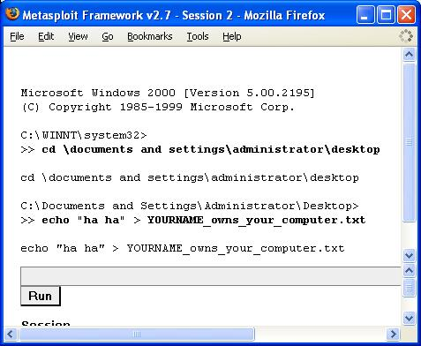

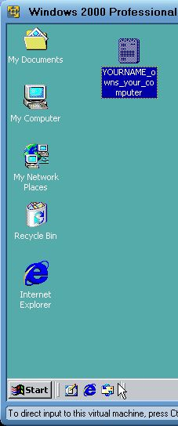
- You should be able to see the new file on the victim’s desktop, as shown to the right on this page. Imagine how you would feel if files started appearing on your computer from nowhere while you were using it!

Last Modified: 1-9-07 10 pm

