Unit Objectives

Explore uses for the Internet

Understand networks

Understand network connectors

Learn the origins of the Internet

Understand the growth of the Internet

Understand how the World Wide Web works

Connect to the Internet

Evaluate Internet service options

Explore Uses for the Internet

The Internet is used for:

Obtaining information

Communicating

Email and IMs

Buying and selling goods and services

Downloading Software

Accessing multimedia

Playing online games

Three types of electronic discussion groups:

Mailing lists

Send email to members

Newsgroups

See Google Groups

Blogs
A client/server LAN

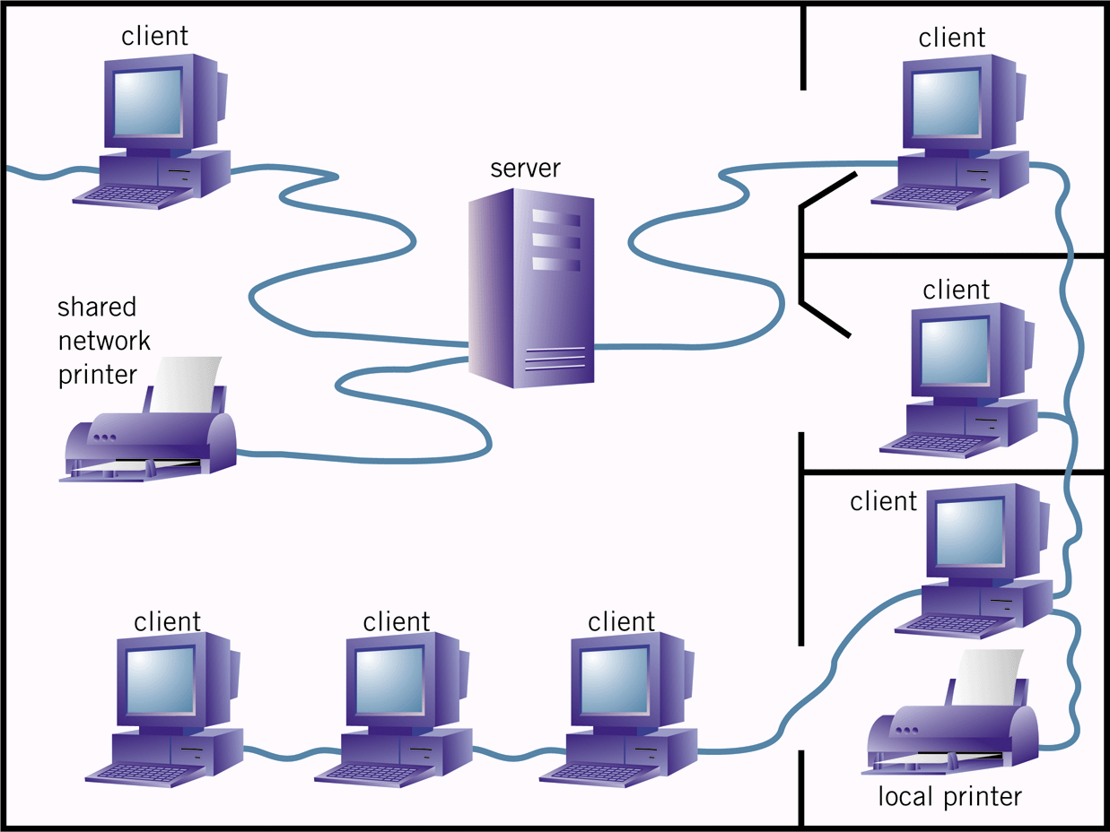See kottke.org and blogger.com

Understand Networks

A network is two or more computers connected to each other.

A computer becomes part of a network by connecting to a nearby computer or to the Internet.

Networks allow computers to share resources.

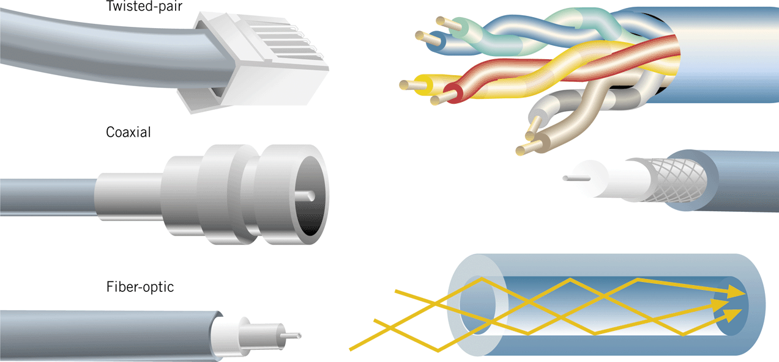Understand Network Connectors

Computers are connected using:

twisted-pair cables

coaxial cables

fiber-optic cables

wireless connections

Learn the Origins of the Internet

1960s

The DOD created DARPA to examine ways to connect its computers to one another and to weapons installations all over the world.

DARPA created the first network, ARPANET, in 1969.

ARPANET was four computers networked together.

Clues to Use

The transfer protocol is the set of rules that computers use to move files from one computer to another on an internet.

HTTP is the most common transfer protocol used on the Internet.

File transfer protocol (FTP) and the Telnet protocol are also still used.

Understand the Growth of the Internet

1980s

Firms used PCs to construct intranets.

Businesses used commercial e-mail services to communicate with firms outside their intranets.

Larger firms built TCP/IP-based WANs and leased telephone lines to connect their intranets.

In 1989, the NSF permitted MCI Mail and CompuServe to allow their subscribers to exchange e-mails with members of the academic and research communities who were connected to the Internet.

1990s

In 1991, the NSF began implementing plans to privatize much of the Internet via Internet hosts.

In 1995, the FNC adopted the formal definition of the Internet

A global network using TCP/IP

Clues to Use

No one knows how many users are on the Internet.

The Internet has no central management or coordination.

Routing computers do not maintain records of the data packets they handle.

It is estimated that:

at least 300 million host computers are connected to the Internet;

and more than 700 million people worldwide use it.

Understand How the World Wide Web Works

“The Web” and “the Internet” are not the same thing.

The Internet is the entire system of networked computers.

The World Wide Web is a method used to access information contained on a subset of those networked computers.

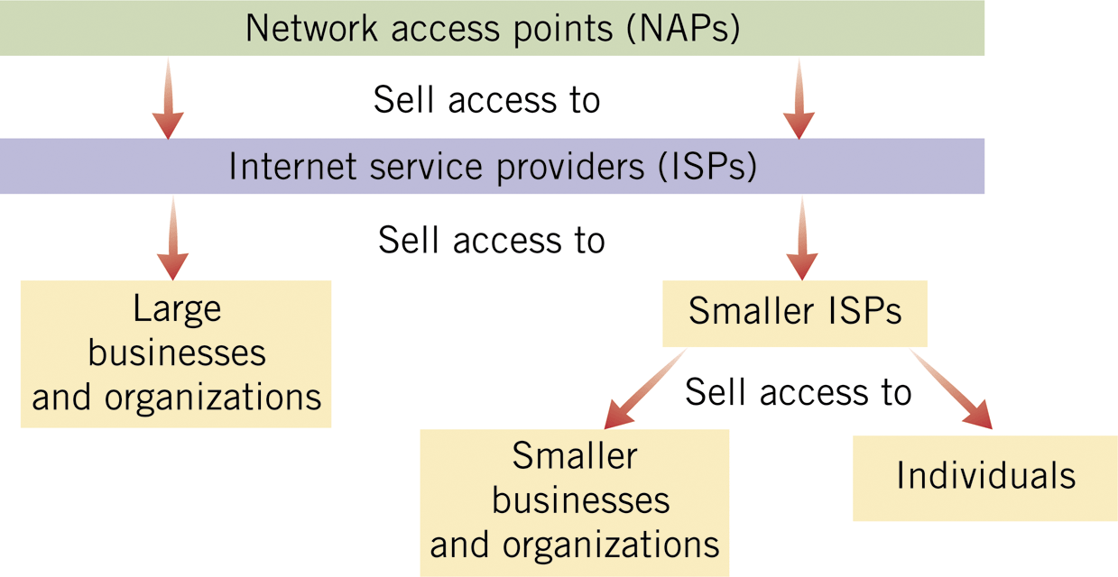You connect to the Internet, and then use the World Wide Web to access information.

Connect to the Internet

To connect to the Internet, individuals and businesses must set up an account with an Internet Service Provider (ISP).

ISPs provide access to a NAP.

Types of connections to the Internet:

telephone service connection (POTS or plain old telephone service)

T1 and T3 line connections

Digital Subscriber Line (DSL)

cable

satellite

wireless

Modem

Short for modulator-demodulator

Converts signals between a computer (uses digital signals) and a twisted-pair or coaxial cable transmission line (uses analog signals)

Modulation—converting a digital signal to an analog signal

Demodulation—converting that analog signal back into digital form

Cable modem

required for a cable connection through a cable television company

DSL modem

required for a DSL connection

To connect a device to the Internet without cables, you need a wireless network interface card (WLAN card) or a Wi-Fi compatible device.

You also must be within range of a wireless access point that is connected to the Internet.

Evaluate Internet Service Options

Ways of connecting to the Internet:

school or employer connection

telephone line connection

cable connection

satellite connection

hot spots

Select an ISP:

What is the monthly base fee and how many hours of Internet service are included?

What is the hourly rate for time used over the monthly base amount?

Is the telephone access number local or long distance?

Which specific Internet services are included?

What software is included?

What user-support services are available?

Internet Basics Include:

Exploring uses for the Internet

Understanding networks

Understanding network connectors

Learning the origins of the Internet

Clues to use: Transfer protocol

Understanding the growth of the Internet

Clues to use: Number of Internet users

Understanding how the
World Wide Web works

Connecting to the Internet

Evaluating Internet service options

Terms to Use

Internet:

a collection of computers all over the world that are connected to one another

World Wide Web:

a subset of the Internet

Web pages:

documents formatted to be viewed on the Web

Web site:

a collection of related Web pages stored on a computer

E-mail:

electronic messages transferred between two or more computers

Instant messages (IM):

messages exchanged over the Internet in real time

Server:

any computer that accepts requests from other computers connected to it and shares its resources with those connected computers

Client:

a computer connected to a server

Client/server network:

a network consisting of one server and multiple clients

LAN (Local Area Network)

a network of computers that are physically close to each other

WAN (Wide Area Network)

a network of LANs

Network operating system:

the software that runs on the server and coordinates the flow of information among its various clients

Network interface card (NIC):

a removable circuit board used to connect a computer to a network by attaching a cable from the NIC to the server or to another client

Packet switching:

a method of sending information that breaks down files and messages into data packets

TCP/IP

Transmission Control Protocol (TCP) includes rules that computers on a network use to establish and break connections

Internet Protocol (IP) includes rules for routing individual data packets

Open architecture philosophy

each network connected to the Internet can use its own protocols and data-transmission methods internally

Network access points (NAPs)

physical locations where networks connect to the Internet

Intranets:

LANs or WANs that use the TCP/IP protocol but do not connect to sites outside the firm

Internet hosts:

computers that connect a LAN or a WAN to the Internet

Hypertext Markup Language (HTML)

a computer language that marks text with a set of tags, or codes, that define the structure and behavior of a Web page

Web server:

a computer that stores files written in HTML and lets other computers connect to it and read those files

Web browser:

software that reads HTML documents and moves from one HTML document to another

Links:

text, graphics, or other Web page elements that connect to additional data on the Web site you are currently exploring or on a Web site halfway around the world

From The Internet–Illustrated Introductory, Fourth Edition, Schneider, Evans, and Pinard

Last modified 6-12-06

