Unit Objectives

Understand Web browsing

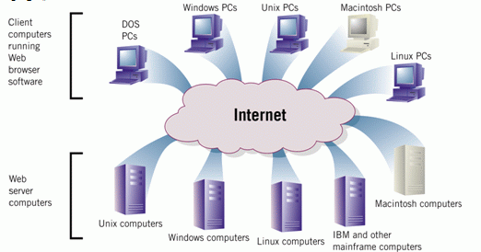
Understand Hypertext Markup Language (HTML)

Understand Web site addresses

Copy text and graphics from a Web page

Understand Web Browsing

When you connect to the Internet, your computer becomes part of a worldwide client/server network.

As a Web client, your computer makes requests of Web servers on the Internet.

Understand Hypertext Markup Language (HTML)

An HTML document is a text file that contains the Web page content and the instructions in HTML tags for formatting that content.

A Web page is the result of a browser reading the tags in an HTML document and displaying the content by evaluating the tags.

An HTML anchor tag links multiple HTML documents together.

Understand Hypertext Markup Language (HTML)

Understand Web Site Addresses

An IP address consists of a four-part number.

Each part is a number ranging from 0 to 255.

A possible IP address is 106.29.242.17.

Most people use a domain name to identify a Web site.

Domain names are words and abbreviations associated with specific IP addresses.

IP addresses can be difficult to remember.

Common Top-Level Domains
Original General TLDs: .com .edu .gov .mil .net .org
Country Codes: .us .au .ca .de
New TLDs: .info .biz .name

A Uniform Resource Locator (URL) tells the Web browser the following information:

the transfer protocol to use when transporting the file (usually HTTP)

the domain name of the computer on which the file resides

the path name of the folder or directory on the computer on which the file resides

the file name
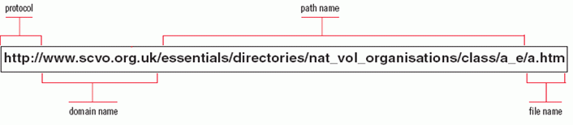

Copy Text and Graphics from a Web Page

To copy text from a Web page:

Drag the mouse pointer over the text you want to copy

Click Edit on the menu bar

Click Copy

To copy graphics from a Web page:

Right-click the image you want to copy

Click Save Picture As or Save Image As on the shortcut menu

Terms to Use

Internet Protocol address (IP address):

the unique number that identifies each computer, like 197.144.51.1

Domain name:

the equivalent of an IP address that uses words and abbreviations, like ccsf.edu

Top-level domain:

the last part of a domain name, like .com
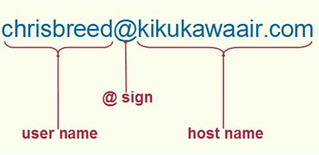

Unit C: Using E-Mail

E-Mail Address

Clues to Use

E-mail messages can have viruses, worms, and Trojan horses in attached files

Don’t open attachments from people you don’t know

If you know the sender, make sure the message makes sense and is specific to you

some worms reproduce by sending themselves out as attachments to everyone in a victim’s Address Book or Contacts list

Install anti-virus software that protects your computer from malicious programs

Hotmail checks for viruses in attachments automatically

Terms to Use

Mail client software:

a program that lets you send and receive e-mail

allows you to store e-mail on your computer

you can read e-mail that you’ve received even after disconnecting from the Internet

Web-based e-mail service (Webmail):

allows you to send and receive e-mail by using a Web browser and the service’s Web site

lets you read your stored e-mail messages from different computers

you can only access your stored e-mail messages when you’re connected to the Internet

User name:

in an e-mail address, the name your ISP uses to identify you

Host name:

in an e-mail address, the computer that stores the e-mail

Last modified 6-19-06

