The Internet–Illustrated Introductory, Fourth Edition

Unit D

Searching the Web

Understand advanced searching techniques

Conduct a search using the Advanced Search page

Conduct a search using Boolean operators

Define Search Engines

Search engine:

a Web site (or part of a Web site) that finds Web pages containing the word or phrase you specify

Google.com is, by far, the most popular search engine

Bots collect information from the Web and catalogue it in a database

Each search engine indexes its database differently

Search engines search only in their own databases

The same search expression in different search engines will get some results that are the same and some that are different

How do you get the best results?

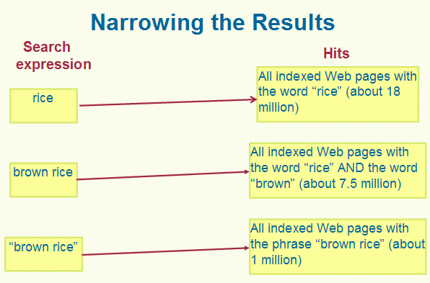
enter keywords that don’t have multiple meanings

enter keywords that are not articles or prepositions

Too many results?

narrow your search results

create a search expression that contains more than one keyword

create a search expression that contains a specific phrase enclosed in quotation marks

Use a Search Engine

Use your browser to go a search engine

Type the search expression in the Search text box

Click Search (or something similar)

Clues to Use

Most major search engines search for variants of keywords automatically

Search for Canada travel guide

Some hits will include

Canadian travel guide, others will include Canada travel guides, etc.

Use a Web Directory

Web directory

a list of links to Web pages organized into hierarchical categories

compiled by human editors instead of bots

Example: Google, More, Directory

Users can browse for information by general categories, rather than by using specific search terms

Many Web directories now include search engines

To access the directory, click a link on the site’s home page

Use a Meta-Search Engine

Meta-search engine

a tool that searches the databases of multiple search engines simultaneously

Example: Dogpile

Most meta-search engines forward queries to major search engines and directories, including:

Google

Lycos

MSN Search

Teoma

Some meta-search engines identify the search engine they retrieve the links from; others do not

Understand Advanced Search Techniques

Advanced Search page

provided by most search engines

provides menus, option buttons, and text boxes to make selections that identify your search criteria

Conduct a Search Usingthe Advanced Search Page

Filter for pages in a specific language

Filter for pages on sites with a specific top-level domain

Use the “All of the words” and “Any of the words” text boxes correctly

Filter for pages that include only the exact phrase

Terms to Use

Search expression or query:

the words or phrases you enter when you conduct a search

Keyword:

each word in a search expression

Bot (Web robot, spider)

a program that automatically searches the Web to find new Web sites and update information about old Web sites already in the search engine database

Results pages

a list of links to Web pages that match the search expression

Hit

a Web page indexed in the search engine’s database that contains text that matches the search expression

The Internet–Illustrated Introductory, Fourth Edition

Unit E

Getting Information from the Web

Get the News

News search engine

use to find current news stories on the Web

searches only online news sites

In some news search engines, you can sort the results by date instead of by relevance

See Google News

Web sites are maintained by all major news sources, including:

ABC

CBS

CNN

Fox

MSNBC

National Public Radio (NPR)

the BBC

The New York Times

The Washington Post

The Times in London

Clues to Use

Really Simple Syndication (RSS)

a file format that shares updates, such as headlines and weather updates, via a newsfeed

usually must be read through an aggregator

Some browsers and some e-mail programs have a built-in aggregator

Most newsfeeds update their content throughout the day

the user can choose how frequently to download stories

Obtain Weather Reports

Weather sites have:

a text box in which to type the city whose weather you want to know labeled:

Forecast

City, State

Links to get extended forecasts

Ex: weather.com and weatherpulse

Obtain Maps and City Guides

Map sites provide:

maps

driving directions

City Guides have travel information, such as:

hotel listings

restaurant listings

sightseeing guides

Information provided by map sites is not perfect

new roads are not included

detours caused by current construction work are not included

Demonstration: maps.google.com

Find Businesses and People

Most sites that offer yellow and white page directories offer both types of directories.

See 411.com

Privacy concerns

Terms to Use

Newsfeed:

a file containing summaries of stories and news from a Web site

Aggregator

a program that lets you receive newsfeed content via an RSS newsfeed

Yellow page directory

search engine that specializes in finding businesses

businesses are grouped by type and location as in the yellow pages phone book

White page directory

search engine that enables you to search for addresses and telephone numbers for individuals

similar to a white pages phone book

Artistic work

the tangible expression of an idea

Public domain

a literary or artistic work that you can freely copy them without requesting permission from or paying the source

Plagiarism

Failure to cite the source of material that you use

Free use

copying a copyrighted work for use in criticism, comment, news reporting, teaching,

scholarship, or research

