Gmail
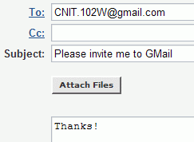
- If you have a GMail account already, skip to the next section: Firefox.
- To get a GMail account, send an email message to CNIT.102W@gmail.com as shown to the right on this page.
- You should get a reply to that message within a day or two. Be sure to check your Bulk Mail folder, or wherever your mail service puts spam. Yahoo mail, and other services too, automatically delete GMail invitations – why should they help the competition?
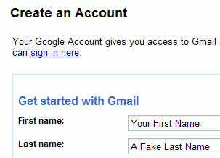
- Open the message with a subject of Your Name, CNIT 102W has invited you to open a Google mail account. Click the blue link in that message.
- A page opens titled Create an Account, as shown to the right on this page. I recommend that you use your real first name but a fake last name, to maintain your privacy. Fill in the whole form and click the I Accept… button at the bottom.
- When your account is created, you will see a page titled Congratulations! Read this page – it points out the main benefits of GMail. Then click the blue http://mail.google.com link at the bottom.
- The GMail inbox screen opens as shown below.
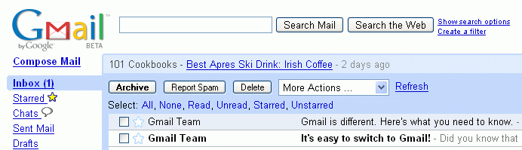

Firefox
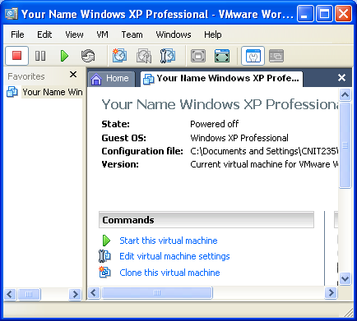
Starting VMWare Workstation
- We will use a program called VMWare Workstation, which simulates a computer on top of the existing Windows XP operating system. That way you can practice installation and other activities without changing (and possibly damaging) the existing operating system.
- Double-click the VMWare Workstation icon on the desktop.
- A VMWare Workstation window opens as shown to the right on this page. Click the blue Start this virtual machine link.
- A couple of VMWare message boxes will open, telling you details about how VMWare works that don’t matter right now. Just click the default selection to get past them.
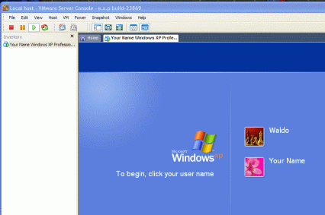
- When your virtual PC starts, you will see a logon screen like the one shown to the right on this page, with Waldo and some other name. Click Waldo. The machine should start with no password.
Downloading and Installing Firefox
- Work in the virtual PC. You will not be able to install Firefox in the host operating system.
- Start Internet Explorer and go to getfirefox.com
- Click the green Download Firefox button.
- In the File Download – Security Warning box, click Run.
- In the Internet Explorer – Security Warning box, click Run.
- A Firefox Setup box opens. Close Internet Explorer.
- When the box with the large heading Welcome to Mozilla Firefox appears, click Next.
- Accept the agreement and click through the installer, accepting all the default selections.
- Firefox should open. If it does not, double-click the Mozilla Firefox icon on the desktop.
- In the Import Wizard box, click Next.
- In the Home Page Selection box, click Next.
- In the Import Complete box, click Finish.
- Firefox opens. In the Default Browser box, click Yes to make Firefox the default browser. It is best to avoid using Internet Explorer as much as you can, because it is constantly attacked by spyware and other dangerous programs. Firefox is far safer to use on the Web.
Using Tabbed Browsing
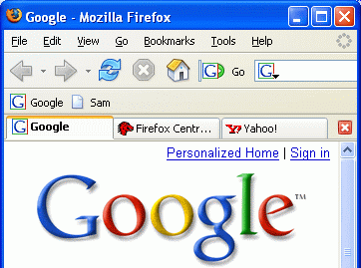
- Firefox can open many Web pages at once, using a technique called Tabbed Browsing.
- With Firefox open, click File, New Tab. A blank Web page opens. Type in yahoo.com and press the Enter key.
- Click File, New Tab, type in google.com and press the Enter key. You now have three Web pages open at once.
- You can control the Tab positions—click the Google tab and drag it to the left so it becomes the first one, as shown to the right on this page.
- Click the lower red X button to close the current tab. Google closes, but the other two tabs are still open.

Finding Extensions
- In Firefox, go to https://addons.mozilla.org
- In the Security Warning box, click OK.
- Click the green We Recommend… link, as shown to the right on this page.
Adding Extensions
- Find Answers in the next page and click the green Install Extension link. A Software Installation box opens. Wait three seconds, and click the Install Now button.
- An Extensions box appears showing that Answers will be installed when Firefox is restarted.
- Click in the Web page showing recommended extensions to make it the active window. Scroll down and find StumbleUpon. Click the green Install Extension link. A Software Installation box opens. Wait four seconds, and click the Install Now button.
- An Extensions box appears showing that Answers and StumbleUpon will be installed when Firefox is restarted.
- Close all open windows, including Firefox. Start Firefox by double-clicking its icon on the desktop.

Using StumbleUpon
- In the upper left of the screen, click the Start Stumbling button.
- In the Welcome to StumbleUpon box, click Create Account. If an Alert box appears, click OK.
- A StumbleUpon web page appears. Fill in the boxes. To add a picture, use any picture you like. If you don’t care, just click the Browse button and open the My Documents folder, open the My Pictures folder, and open the Sample Pictures folder. Double-click a picture in there.
- Look through the boxes at the bottom and select several that interest you. Don’t just pick random ones – choose ones that really interest you if possible. Then scroll to the bottom and click the yellow Create My Account button.
- In the Security Warning box, click Continue.
- There is now a Stumble! Button at the upper left of your browser window. Click it to see a random Website recommended by other browsers. Try several of them and see how it works. StumbleUpon is a good way to find Web sites you would never have noticed otherwise.
Using Answers
- Open a Web page with some text in it. Right-click a word on the page and select Look up on Answers.com. A page opens telling you about the word. This might be useful to explain unfamiliar terms.
- To test it, go to slashdot.org and find an unfamiliar term – there should be plenty of them! Use Answers and see if it can explain the term easily.
Adding Qute and infoRSS
- In Firefox, go to https://addons.mozilla.org
- If a Security Warning box opens, click OK.
- Type Qute in the Search box and click Go. Click the blue Qute 3.1 link.
- Click the green Install Now link. In the Confirm box, click OK.
- In the Themes box, click Qute. Click the Use Theme button. Close the Themes box.
- Scroll back to the top of the Firefox Add-ons page. Type RSS in the search box and click Go. Scroll down to find infoRSS 1.0.2 and click it.
- Scroll down and click the green Install Now link.
- In the Software Installation box, click Install Now.
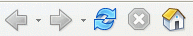
- Close all open windows, including Firefox. Start Firefox by double-clicking its icon on the desktop.
- A Welcome to InfoRSS box appears. Click OK.

Observing the Qute Theme
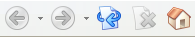
- Look at the toolbar buttons. The original appearance is shown on the top at the right on this page, and the Qute buttons are shown below.

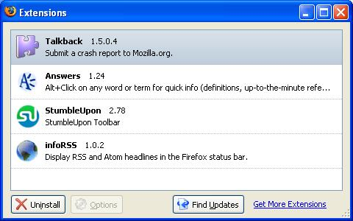
Observing the RSS feed scrollbar
- Look at the lower right portion of the screen. News headlines are scrolling by, on a blue background. Point at a headline and click on it – the news item opens in a new tab.
Opening the Extensions Box
- In the Firefox window, click Tools, Extensions. The Extensions box opens, as shown to the right on this page.

Turning in your Project
- You have now completed Project 1. The only thing that remains is to turn it in. To do that, you need to make a JPEG image of the screen and email it to me, as explained below. Note the hand symbol above -- that indicates the screen image that you must capture and turn in.
- Press the PrintScrn key in the upper-right portion of the keyboard. That will copy the whole desktop to the clipboard. (If you prefer, you can click in the title bar of the Extensions box to make it active and press Alt+PrintScrn to capture only that window, which is neater.)
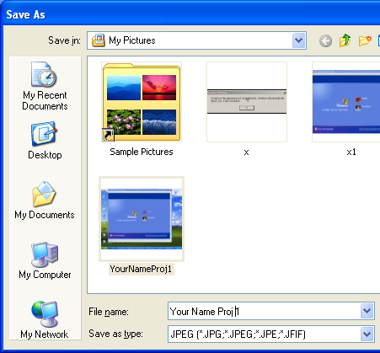
- Click Start, Programs, Accessories, Paint. In the untitled - Paint window, select Edit, Paste from the menu bar. The screen image appears in the Paint window, with only a corner of it visible.
- In the untitled - Paint window, click File, Save. Save the document in the My Pictures folder (or any other place you wish, such as a floppy disk) with the filename Your Name Proj 1. Select a Save as type of JPEG, as shown in the figure to the right on this page.
- Email the JPEG image to me as an attachment. Send it from your GMail account, and send it to: CNIT.102W@gmail.com with a subject line of CNIT 102W Proj 1 From Your Name, replacing Your Name with your own first and last name. Send a Cc to yourself.
Last updated 6-12-06

