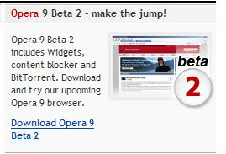
Downloading and Installing Opera 9.0
Warning about Beta Tests: This Opera version is a beta test product, which means it might crash and/or cause problems on your computer. So don’t use it at home unless you are prepared to take some risk. You can use Opera 8 at home more safely, but it doesn’t have as many exciting new features.

- Use your virtual PC. .
- Open Internet Explorer and go to opera.com
- On the right portion of the screen, find the Opera 9 Beta 2 section, as shown to the upper right on this page. Click the Download Opera 9 Beta 2 link.
- In the next screen, verify that the download location is in the US, and click the green DOWNLOAD OPERA button. If an Internet Explorer box opens saying When you send information to the Internet, it might be possible for others so see that information, click Yes. If you get an error message, click the back button in Internet Explorer and try a different download location.
- When you see a the File Download – Security Warning box with the message Do you want to run or save this file?, click Run. Wait while the download proceeds up to 100%.
- In the Internet Explorer – Security Warning box, click Run.
- An Opera 9 installer box opens, with Welcome in large letters at the top. Click Next.
- Accept the agreement and click through the installer, accepting all the default selections.
- Opera should open.

Using Trash
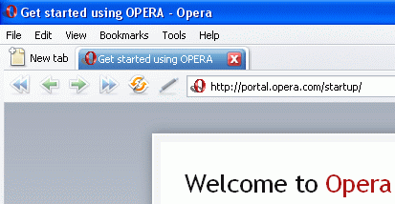
- At the top of the screen there is a blue tab showing the currently open page: Get started using OPERA. Click the X button on the tab.
- The page closes, leaving a blank window. Click the Trash icon in the upper right corner of the Opera window. In the drop-down menu, click Get started using OPERA. The page re-opens.
- Notice that there is now a second tab, named Blank Page. Close the Blank Page tab by clicking on the X.
Using Security Bar – Opera Protects you from Phishing
- Type in the address citibank.com and press the Enter key. In the Citibank page, click the sign on link in the top center.
- This is a secure page, because the URL begins with https. Opera shows you it’s secure by displaying a yellow padlock to the right of the URL, as shown below. But it also shows the name of the owner of the security certificate, Citigroup, so you know who you are communicating with. That’s a good thing, because a lot of people lose money by being tricked by pages that look like bank sites, but aren’t. That particular type of Internet crime is called site spoofing, and the practice of sending emails to people to trick them into visiting the spoofed sites is called phishing.
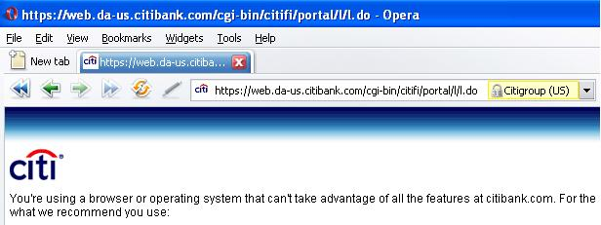

Using Thumbnail Preview
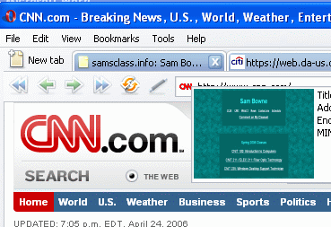
- In the upper left of the window, click the New Tab button. Type in any URL you like, such as samsclass.info and press the Enter key to open the page.
- Click the New Tab button again, and enter another URL such as cnn.com
- Point to one of the tabs and hover there, but don’t click. A tiny version of the Web page appears, as shown to the right on this page. This is useful to find the page you want when many tabs are open.
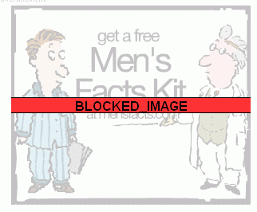

Using Content Blocker
- Suppose there is stuff I don’t want to see on a Web page that is otherwise useful. You can block it!
- Look on the CNN page and find an annoying ad (there should be plenty of ads!). To block it, point to an empty part of the CNN page, such as the right hand margin, and right-click. In the context menu, click Block content….
- A message appears in a yellow bar near the top of the screen saying Click on content you want to block. The text on the page turns gray – you cannot block the gray part. But the ads and images are clear. To block an ad, just left-click on it once. You should see a red BLOCKED IMAGE bar across it, as shown above.
- In the yellow bar, click the gray Done button. CNN reappears, without the ads.

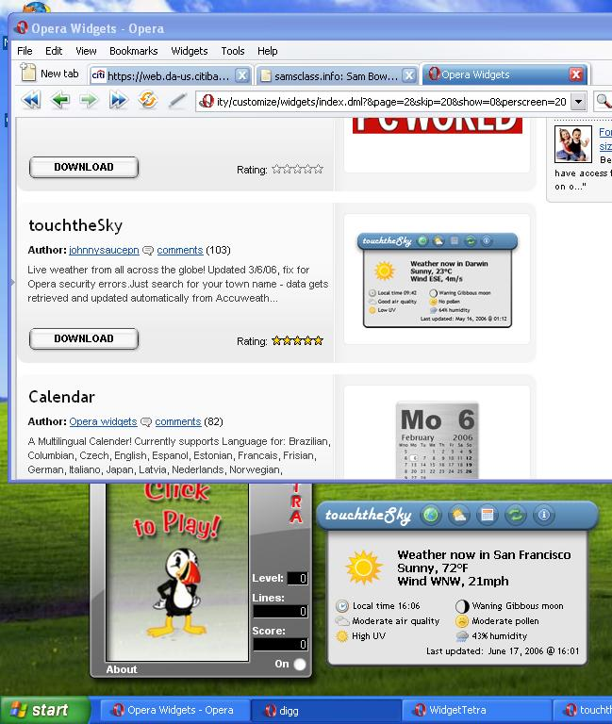
Using Widgets
- Using any tab, type in the URL portal.opera.com/startup and press the Enter key to open the page.
- On the right side, click the blue Opera Widgets link.
- Find a Widget you like, such as WidgetTetra or touchtheSky and download it.

Saving a Screen Image
- Once you have one or more Widgets visible on your desktop, as shown to the right on this page, press the PrintScreen key. That will copy the whole desktop to the clipboard.

- Click Start, Programs, Accessories, Paint. In the untitled - Paint window, select Edit, Paste from the menu bar. The screen image appears in the Paint window.
- In the untitled - Paint window, click File, Save. Save the document in the My Pictures folder (or any other place you wish, such as a floppy disk) with the filename Your Name Proj 1xa. Select a Save as type of JPEG.

Downloading and Installing Internet Explorer 7
- Microsoft has also updated their browser, to compete with Opera and Firefox. But their version is not finished yet, it’s also a Beta Test product. So
- Use your virtual PC.
- Click Start. All Programs, Internet Explorer. Go to www.microsoft.com/windows/ie/downloads
- Click the Internet Explorer 7 Beta 2 for Windows XP Service Pack 2 (SP2) link.
- In the next screen, click the Continue button. This will test your computer to make sure you have a legal copy of Windows XP. The Windows XP installed on the college machines is legal, of course.
- In the next screen, click the Download button.
- When you see a the File Download – Security Warning box with the message Do you want to run or save this file?, click Run. Wait while the download proceeds up to 100%.
- In the Internet Explorer – Security Warning box, click Run.
- An Install Windows Internet Explorer box opens, with Welcome Internet Explorer 7 Beta 2 in large letters at the top. Click Next.
- Accept the agreement and click through the installer, accepting all the default selections. The installation takes a long time, about 10 minutes when I did it.
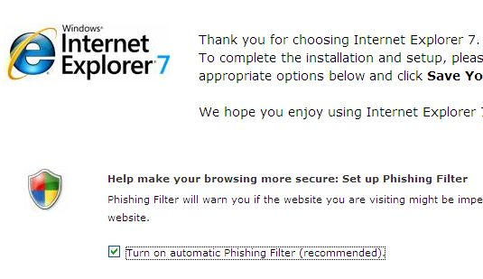
- When you see the message Internet Explorer installed successfully, click the Restart Now (Recommended) button. When your virtual PC restarts, log in as usual.
- Click Start. All Programs, Internet Explorer.
- A Web page opens, showing you options, as shown to the right on this page. Check the Turn on automatic Phishing Filter item.
- Scroll down and check the Participate in the Customer Experience Improvement Program box. Click the Save your settings button.

Using Internet Explorer’s New Security Features
- Type in the address citibank.com and press the Enter key. In the Citibank page, click the sign on link in the top center.
- Internet Explorer 7 shows you this page is secure by displaying a yellow padlock to the right of the URL, as shown below. Click the padlock to see more information about exactly who owns this Web page.
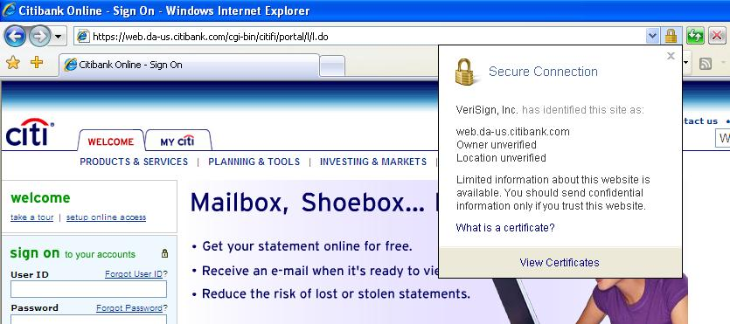

New tab button

- Click Tools, Phishing Filter, Check this website. Read the Phishing Filter box, then click OK. You should see the message This website is not a suspicious or reported phishing website. This does not mean it’s safe, it just means it has not been reported to Microsoft as a phishing site by other users. The phrasing of that message is misleading, and reportedly Microsoft is going to change it in the final version of Internet Explorer 7. Click OK to close the box.

Using Tabbed Browsing
- Click the New tab button as shown in the figure above on this page. A new tab opens, and after a few seconds a message appears saying You’ve opened a new tab. Enter a URL such as google.com
- Open a third tab and go to a different website such as www.ccsf.edu
- Now you have three web pages open in different tabs, as shown below:

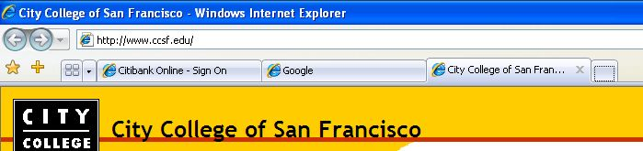
Quick tabs button

- Click the Quick tabs button as indicated above on this page.
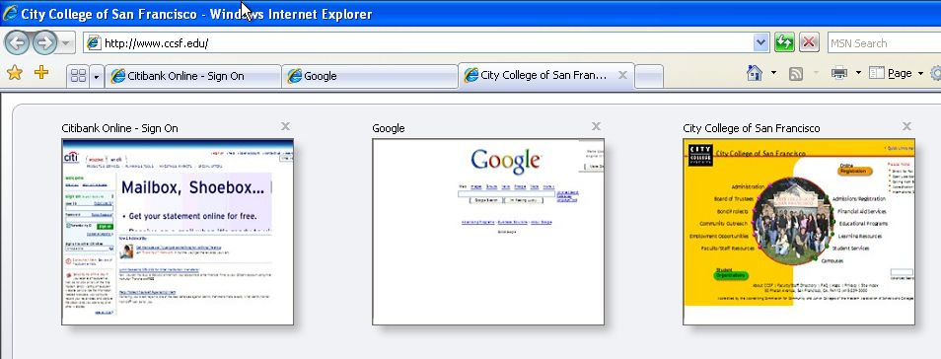
- The Quick Tabs view opens, as shown to the right on this page, with thumbnail views of all the Web pages.

Saving a Screen Image
- Press the PrintScreen key. That will copy the whole desktop to the clipboard.
- Click Start, Programs, Accessories, Paint. In the untitled - Paint window, select Edit, Paste from the menu bar. The screen image appears in the Paint window.
- In the untitled - Paint window, click File, Save. Save the document in the My Pictures folder (or any other place you wish, such as a floppy disk) with the filename Your Name Proj 1xb. Select a Save as type of JPEG.

Opening a Set of Tabs
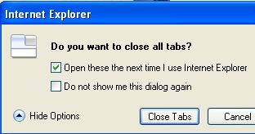
- This next feature sounds handy – remembering a whole group of pages, not just a single Home page. The only problem is that it doesn’t work very well yet.
- Click the red X button at the upper right of the Internet Explorer window.
- When a box pops up saying Do you want to close all tabs?, click the Show Options button, and check the Open these the next time I use Internet Explorer box, as shown to the right on this page.
- Click the Close Tabs button. Internet Explorer closes.
- Click Start. All Programs, Internet Explorer. It should open all three pages again. When I tried it, I got an error message saying Internet Explorer has encountered a problem… and I had to try it again. The next time I tried it, Internet Explorer opened, but the tabs did not. So I repeated the whole process a second time, and it worked the second time.

RSS Feeds
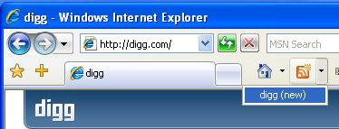
- RSS (Really Simple Syndication) is a popular way to publish rapidly-changing information, like news headlines. You can subscribe to them in Internet Explorer 7 very easily, without even adding an extension the way you did in Firefox.
Feeds
- In Internet Explorer 7, go to digg.com
- Click the drop-down arrow next to the orange Feeds button, as shown to the right on this page, and click dig (new).
- You should see a page with news stories, and a yellow box at the top saying You are viewing a feed… as shown in the lower right of this page.

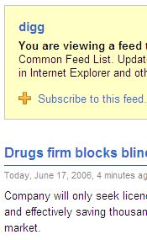
Turning in your Project
- Email the JPEG images to me as attachments to a single email message. Send it from your any account you like, and send it to: CNIT.102W@gmail.com with a subject line of CNIT 102W Proj 1x From Your Name, replacing Your Name with your own first and last name. Send a Cc to yourself.

Last modified 6-17-06

