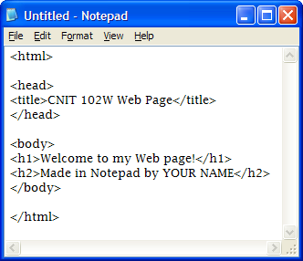
Writing HTML with Notepad
Do not use the virtual computers for this project.
Making a Web Page with Notepad
- Click Start, All Programs, Accessories, Notepad.
- Type in the text you see to the right on this page. Save the file with the name YourNamepage1.html in the My Documents folder. Make sure you use the .html extension! It your file has a .txt extension it will not work!
- Don’t close Notepad, but resize it so that it uses no more than half the screen.

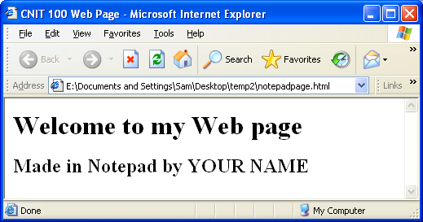
Viewing your Web Page Locally
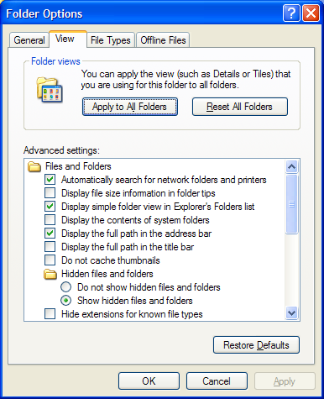
- Click Start, My Documents. Find the YourNamepage1.html icon and double-click it. It will open in a Web browser, as shown to the right on this page. If it opens in Notepad, you have a .txt file extension on your file, and you need to do these steps to rename it:
  - In the My Documents window, click Tools, Folder Options.
  - In the Folder Options box, click the View tab.
  - Make sure the Hide extensions for known file types box is not checked, as shown to the right on this page.
  - In the Folder Options box, click the OK button.
  - Find the YourNamepage1.html.txt file and right-click it. In the context menu, click Rename.
  - Remove the .txt at the end of the file name and press the Enter key.
  - In the Rename box, click the Yes button.
  - Double-click the YourNamepage1.html.txt icon to open it in a Web browser.

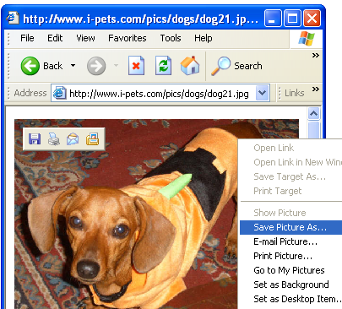
Saving an Image File
- Open a new browser window and go to Google.com. Click the Images tab. Do a search for anything you like, such as dogs, and find a picture you like.
- You need to save this picture on your hard disk, and you need to make sure you know its exact file name, including the file extension.
- Right-click on the picture you like best and select Save Picture As…, as shown to the right on this page. If you are using Firefox, click Save Image As….

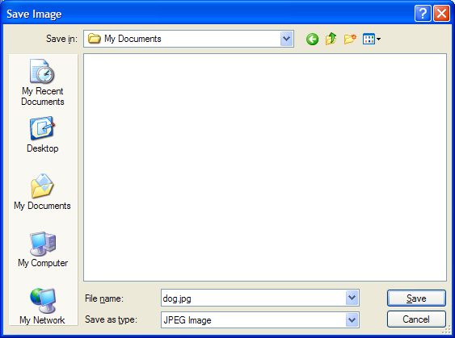
- The Save Picture dialog box opens, as shown to the right on this page. In the left section of the Save Picture dialog box, click the My Documents folder.
- In the File name: box, type in a short, simple name you can remember, like dog. Notice the file extension in the Save as type: box—it should be either gif or jpg. Write down the complete file name below. In my example, the file name is dog.jpg but your name may be different.

Image File Name: __________________________

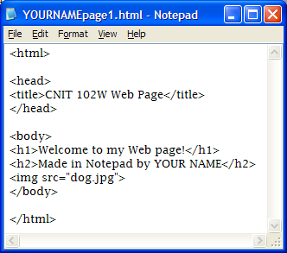
Adding the Image to the Web Page
- Add this line to the Notepad file, after the line including YOUR NAME, as shown to the right on this page:
<img src=”dog.jpg”>
- Click File, Save to save the file. In the browser window, click View, Refresh. The image should appear, as shown to the right on this page.

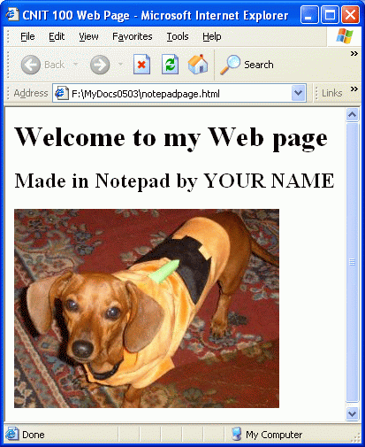

- In the browser, click View, Refresh. The image should appear, as shown to the right on this page.
- Your Web page is now complete, but no one can see it but you. That’s because it’s stored on your computer. To make it visible to everyone, you need to copy the page to a Web server.

HP-UNIX User Name and Passwords
- CCSF uses a Hewlett-Packard UNIX machine as its Web server, and each CNIT student has an account on it, with your own User Name and Password.
User Name:
Password:
- User ID: First write down your HP-UNIX User Name in the box to the right. There is a list of the User Names on the wall of the classroom. Your initial User Name is the first letter of your first name, then the first 5 letters of your last name, and then a 2-digit number. Usually the number is 01. For example, if your name is Sally Smith your User Name is probably ssmith01
- Password: Your Password is your birthdate, using 3 letters for the month, 2 digits for the day, and 2 digits for the year. So if you were born on June 14, 1978, your Password is jun1478
- If you were born near the start of a month, use a 0 as the first digit of the date, like this: A person born on August 4, 1967 would have a Password of aug0467
- Write your Password in the box above.

Opening SSH Secure Shell
- This Web page consists of two files in your my Documents folder: YourNamepage1.html and dog.jpg. But no one can see the files on your computer – to make them available to other people, you have to move the files up to a Web server.
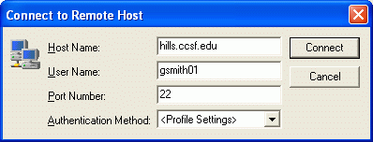
- Click Start, All Programs, SSH Secure Shell, Secure File Transfer Client. When the SSH Secure File Transfer window opens, press the Enter key.
- In the Connect to Remote Host window, enter a Host Name of hills.ccsf.edu and the User Name you wrote in the box above on this page. Press the Enter key.
- One or two more boxes appear. Press Enter to close them. When you see the Enter Password box, enter the Password you wrote in the box above on this page. Press the Enter key.

Creating the public_html Folder on the Web Server
- SSH Secure File Transfer opens as shown below. The left pane shows files on your machine, and the right pane shows files on the Web server. Right-click in the right pane and click New Folder. Type this name for the new folder:
public_html
- Press the Enter key to finish naming the folder. Your Web pages need to be in a folder with this precise name or they will not be visible. That’s the way the Apache Web Server software is configured on the HP-UNIX server.
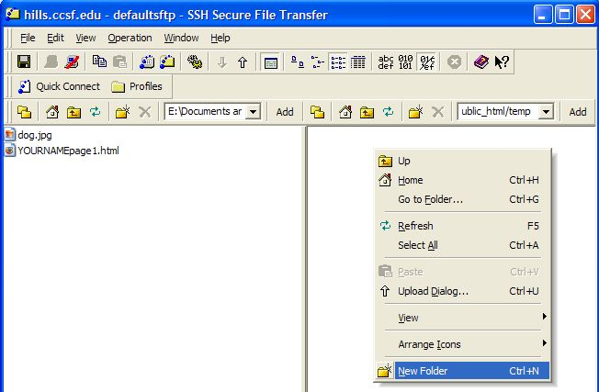

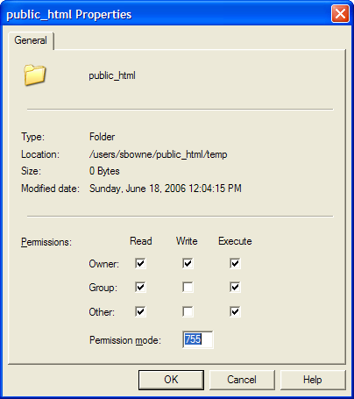
- Right-click the public_html folder and click Properties. You will see a Permissions list, as shown to the right on this page. Make sure the Read and Execute boxes in the Other line are checked, as shown to the right on this page. If those boxes are not checked, your Web page will not be visible in a browser. Click OK.

Copying your Files to the Web Server
- Double-click the public_html folder in the right pane to open it, and navigate to My Documents folder in the left pane. You should see the two files YourNamepage1.html and dog.jpg in the left pane, as shown on the previous page.
- Drag the two files from the left pane to the right pane and drop them. This copies your files to the server.
- Open a browser and type in this URL to see your page:
hills.ccsf.edu/~gsmith01/ YourNamepage1.html
Replace gsmith01 with your HP-UNIX ID.
- When your page is visible, click View, Source to see the HTML code you typed in. The Web page is nothing more than a file of HTML code, which may also refer to images and other files inside it. Your Web browser renders the Web page, drawing it on your screen as specified by the HTML tags.

Turning in your Project
- Open a new browser window and compose an e-mail message to CNIT.102W@gmail.com with a subject line of CNIT 102W Proj 2 From Your Name, replacing Your Name with your own first and last name. Send a Cc to yourself.
- Resize the e-mail and the browser showing your page so they both fit on the screen at once, as shown below. Then grab the icon to the left of the Web address in the browser and drag it into the email message, and drop it there, as indicated by the arrow in the diagram below. This is a very useful technique, far more reliable than typing Web addresses.

Last modified 6-18-06

