Requirements
- You will need a headset with a microphone. If you are working in S214, your instructor has some headsets. Use your virtual PC.
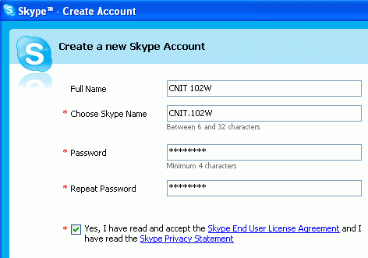
- If you are working in the ACRC (301 Batmale), ask for a headset and microphone at the front desk,. Plug them in to the computer in the color-coded ports, which are on the front of the computer. Sometimes the ports on the back work better.

Installing Skype
- Open a browser and go to skype.com (I did it with Internet Explorer. With other browsers the steps may be slightly different.)
- Click the Download Now button. On the next screen, click the Download button. On the next screen, click the Download button.
- In the File Download – Security Warning box, click Run.
- In the Internet Explorer – Security Warning box, click Run.
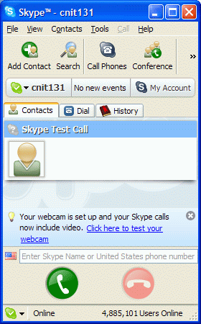
- A blue box appears with a header of Hello! Thank you for downloading Skype. Check the Yes, I accept the EULA box and click Install.

Creating a Skype Account
- A Create a new Skype Account box opens, as shown above and to the right on this page. Make up a Skype Name and password, and click the Yes, I have read and I accept the Skype end user license agreement box. Click Next.
- In the Help your friends find you window, enter your name, city, and e-mail address and click Sign in.

Testing Your Sound Settings
- A Skype window opens showing that you have only one Contact -- Skype Test Call. Click the Skype Test Call to make it larger, as shown to the right on this page, and click the round green Call button at the bottom of the window.
- You should hear a voice guiding you through a test of your speakers and headphones. Repeat this test until you get your sound system working correctly. You may need help from your instructor.

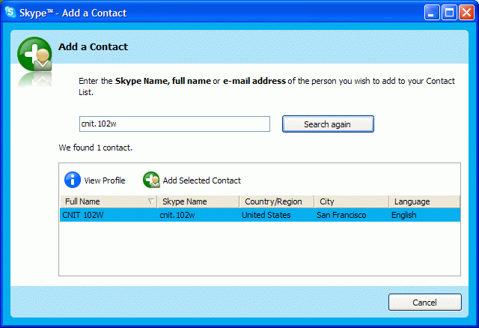
Adding CNIT.102W as a Contact
- At the upper left of the Skype window, click the the Add Contact button. In the Add a Contact box, enter cnit.102w as shown to the right on this page. Click the Search button. When you see CNIT 102W appear in the lower part of the window, as shown to the right on this page, click the Stop Search button.
- Click the Add Selected Contact button.
- In the Say Hello! to CNIT 102W box, click OK.

Calling CNIT 102W – No Answer
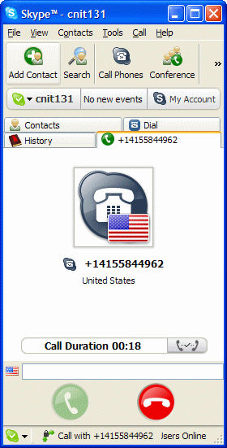
- In the Skype window, on the Contacts tab, there is now a CNIT 102W entry, as shown to the right on this page. Double-click CNIT 102W.
- You should hear a telephonic ringing sound, but there is no answer. That’s because I am not logged in to answer, and I did not pay for Skype voicemail.

Calling a Normal Telephone
- In the Skype window, click the Dial tab. Enter any US phone number, including the area code. For example, if you are in Science 214, there is a phone in the room with this phone number: 415-452-5081. Press the Enter key to dial.
- Answer the phone when it rings, or get someone else to answer it.

Saving a Screen Image
- Once you have started a call session, you should see a screen with a Call Duration value, as shown to the right on this screen. Press the PrintScreen key.
- Click Start, Programs, Accessories, Paint. In the untitled - Paint window, select Edit, Paste from the menu bar.
- In the untitled - Paint window, click File, Save. Save the document in the My Pictures folder (or any other place you wish, such as a floppy disk) with the filename Your Name Proj 3a. Select a Save as type of JPEG.

Turning in your Project
- Email the JPEG image to me as an email attachment. Send it to: CNIT.102W@gmail.com with a subject line of CNIT 102W Proj 3 From Your Name. Send a Cc to yourself.
Last modified 6-25-06

