Starting Your Computer
- Start your computer with the appropriate L removable hard drive in it. Use your virtual PC.

Adding PC Pitstop to the Trusted Sites Zone

Open Internet Explorer 7. If you are using IE 6, the steps are slightly different – ask your instructor. Click Tools, Internet Options. Click the Security tab. Click the Trusted sites icon.

Click the Sites button. In the top text box, enter http://www.pcpitstop.com

Clear the Require server verification… check box, as shown to the right on this page. Click the Add button. Click Close.

Click OK to close the Internet Options box.

, click in the Address bar near the top of the window, and type in

www.pcpitstop.com

Then press the Enter key open the PC Pitstop page, as shown to the right on this page


Testing Your Computer with PC Pitstop

Open Internet Explorer, click in the Address bar near the top of the window, and type in

www.pcpitstop.com

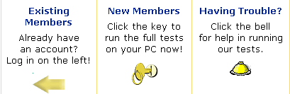
Then press the Enter key open the PC Pitstop page, as shown to the right on this page

Click on Full Tests in the upper left part of the window. The PC Pitstop Full Tests page opens, showing three boxes with gold icons in them as shown to the right on this page.

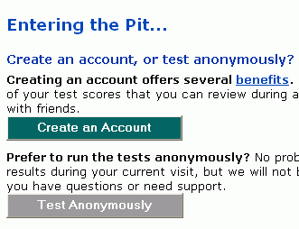
Click the key under the words New Members. If security boxes pop up, allow PC Pitstop software to install and run.

When you see the Entering the Pit… screen, as shown to the right on this page, click Test Anonymously.

In the next screen, click Let’s go!

When a PC Pitstop Utility box opens, as shown below, click OK. This may happen twice.
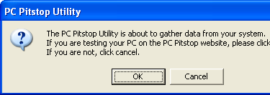

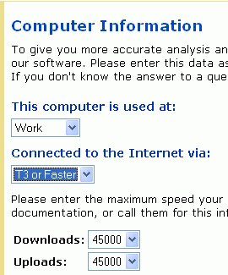
Wait while the PC Pitstop software runs – it takes a few minutes, and the screen will show large test patterns during the video card test.

If a Windows Firewall box opens, click Unblock.

When a Computer Information box opens, as shown to the right on this page, select Work and T3 or Faster. The Downloads and Uploads should both automatically set to 45000, the speed of a T3 connection. After answering the questions, and click the Go button.

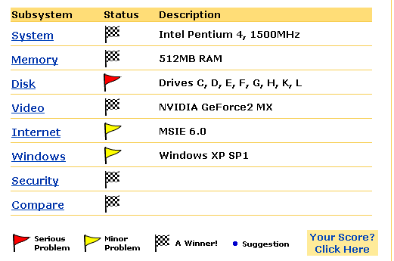
When a Test Results Summary window opens, scroll down and find the summary of your computer system with colored flags, as shown to the right on this page.

Saving a Screen Image
- Press the PrintScreen key.
- Click Start, Programs, Accessories, Paint. In the untitled - Paint window, select Edit, Paste from the menu bar.
- In the untitled - Paint window, click File, Save. Save the document in the My Pictures folder (or any other place you wish, such as a floppy disk) with the filename Your Name Proj 5x. Select a Save as type of JPEG.

Turning in your Project
- Email the JPEG image to me as an email attachment. Send it to: CNIT.102W@gmail.com with a subject line of CNIT 102W Proj 5x From Your Name. Send a Cc to yourself.

If you do this at home, and you see red or yellow flags, click on them to find out what problems there are with your computer, and how to fix them.

Last Updated: 6-26-06

