Starting Your Computer
- Start your computer with the appropriate L removable hard drive in it. Use your virtual machine.

Setting a Restore Point in the Virtual Machine
- Before doing anything risky with your computer, it is a good idea to create a Restore Point so you can undo changes to your system if you need to. In the Virtual PC, click Start, Help and Support.
- In Help and Support Center window, in the Pick a Task section, click Undo changes to your computer with System Restore.
- In the next screen, select Create a Restore Point as shown below on this page, and click Next..
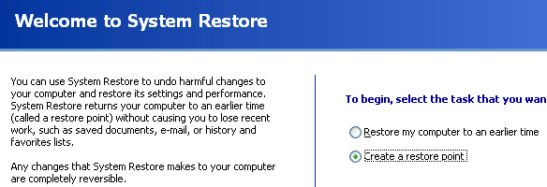

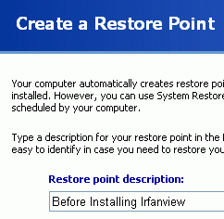
- In the next screen enter a Restore Point Description of Before Installing Irfanview, as shown to the right on this page, and click Create.
- When you see the Restore Point Created message, click Close.
Downloading and Installing IRFANVIEW
- Open Internet Explorer. Go to irfanview.com. Click the download link.
- In the next screen, click the Tucows Worldwide Network - Download IrfanView link.
- A new window opens with a tucows banner. Click the DOWNLOAD NOW link.
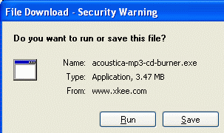
- The next page asks you to choose a download location. Scroll down to find USA and click on it. Click on any location in the list that appears – use one in California if possible. When downloading files, it’s faster, more reliable, and cheaper for the server operators if you use a nearby location.
- A File Download – Security Warning box opens, as shown to the right on this page. Click Run.
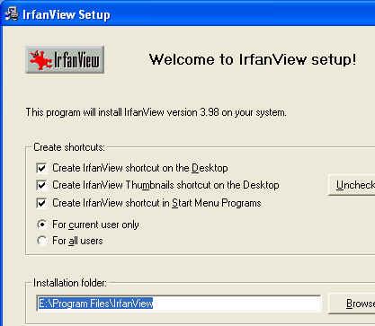
- In the Internet Explorer – Security Warning box, click Run.
- .An Irfanview Setup box opens, as shown to the right on this page. Click Next.
- Click Next through the next two windows.
- When you see a window titled Free! Google Desktop Search, click the Don’t install Google Desktop Search radio button and click Next.
- In the Ready to Install box, click Next.
- In the Installation Successful box, click Done.
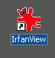
- Your virtual PC desktop should now have an IrfanView shortcut, as shown to the right on this page.

Using System Restore
- Imagine that you didn’t like IrfanView, but you couldn’t uninstall it. Normally you can uninstall software, but sometimes there are errors that prevent it, and some nasty software is deliberately written so you cannot easily remove it. In cases like that, you can use System Restore to remove the software, as long as you have a Restore Point available that was created before you installed the software.
- In the virtual machine, click Start, Help and Support. In Help and Support Center window, in the Pick a Task section, click Undo changes to your computer with System Restore. In the next screen, select Restore my computer to an earlier time and click Next.
- When the Select a Restore Point screen appears, select the Before Installing Irfanview restore point, as shown below on this page.
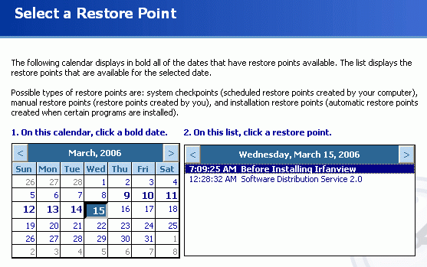

Saving a Screen Image
- Press the PrintScreen key.
- Click Start, Programs, Accessories, Paint. In the untitled - Paint window, select Edit, Paste from the menu bar.
- In the untitled - Paint window, click File, Save. Save the document in the My Pictures folder (or any other place you wish, such as a floppy disk) with the filename Your Name Proj 6x. Select a Save as type of JPEG.

Restoring Your System
- Click Next. Click Next again to perform the System Restore. When you are prompted to restart your virtual machine, do so.
- After the Restoration is complete, the Irfanview shortcut should vanish. Irfanview won’t run anymore.
- Click Start, My Computer. Double-click drive C:. Click Show the contents of this folder.
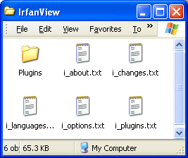
- Double-click Program Files. Click Show the contents of this folder.
- If Irfanview had been uninstalled, the entire Irfanview folder would have been removed. But as you can see, the folder is still there.
- Double-click Irfanview. As you can see, several text files were left behind by System Restore. System restore is not perfect – it leaves some junk behind on your computer when you use it.

Turning in your Project
- Email the JPEG image to me as an email attachment. Send it to: CNIT.102W@gmail.com with a subject line of CNIT 102W Proj 6x From Your Name. Send a Cc to yourself.

