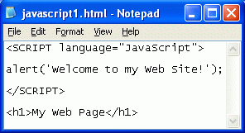
Creating a Javascript Page With an Alert Box
- Click Start, All Programs, Accessories, Notepad.
- Type in the four lines as shown to the right on this page. Save the file on the desktop with the name javascript1.html – be sure to get the filename extension correct.
Running a Javascript Program
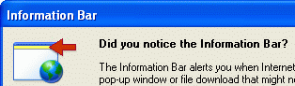
- Minimize all windows, if necessary, and find the javascript1.html icon on the desktop. Double-click that icon to run the Javascript in Internet Explorer.
- If an Information Bar box pops up, as shown to the right on this page, do these three things:
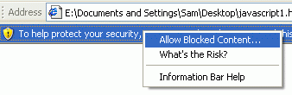
  - Click OK to close the Information Bar box.
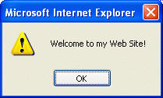
  - Find the yellow bar near the top of the window, saying To help protect your security …. Click on the yellow bar and then click Allow Blocked Content, as shown to the right on this page.
  - In the Security Warning box, click Yes.
- A box opens containing the text Welcome to my Web Site! as shown to the right on this page. This is the output of the Javascript program. Click OK to close the window.
Creating a Javascript Program with Two Alert Boxes
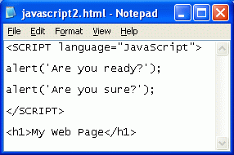
- Click Start, All Programs, Accessories, Notepad.
- Type in the text as shown to the right on this page. Save the file on the desktop with the name javascript2.html.
- Double-click the javascript2.html icon on the desktop. If an Information Bar box pops up, do the same three things you did previously to allow the script to run.
- When a box opens containing the text “Are you Ready?”, click OK to close it.
- When another box opens containing the text Are you sure?, click OK to close it.
Understanding Javascript
- Javascript lives inside Web pages, and it is used to make things happen on the Web page. So far we have only used one Javascript command: alert. The alert command opens a box, and then waits for the viewer to click on the OK button before continuing.
- The only other Javascript command you need today is the document.bgColor command – this changes the background color of the Web page.
Creating a Javascript Program to Change Background Color
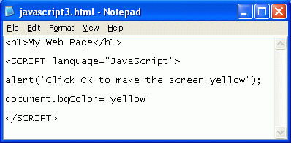
- Click Start, All Programs, Accessories, Notepad.
- Type in the text as shown to the right on this page. Save the file on the desktop with the name javascript3.html.
- Double-click the javascript3.html icon on the desktop. If an Information Bar box pops up, do the same three things you did previously to allow the script to run.
- A box opens containing the text Click OK to make the screen yellow. Click OK to close
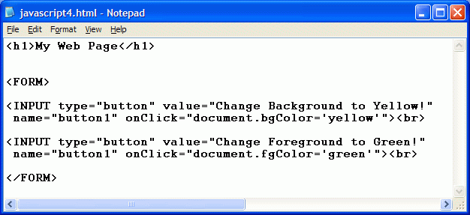
Creating a Javascript Program With Buttons
- Click Start, All Programs, Accessories, Notepad.
- Type in the text as shown below. Save the file on the desktop with the name javascript4.html

- Double-click the javascript4.html icon on the desktop. If an Information Bar box pops up, do the same three things you did previously to allow the script to run.
- Click the buttons and see what they do.
Creating Your Own Javascript Program
- Make your own Javascript program that will do these things:
- Open an Alert box introducing the page, with this message in it: A Javascript program written by YOUR NAME (replace YOUR NAME with your own name)
- Open a box announcing the color change you are about to do, with a message like this Click OK to make the screen aqua.
- After the user clicks OK, the screen should change color to aqua.
- There should be one or more buttons on the page that change the background page color
- There should be one or more buttons on the page that change the foreground page color
Copying your Files to the Web Server
- Upload your files to the Geocities server.
Turning in your Project
- Send an e-mail message to CNIT.102W@gmail.com with a subject line of CNIT 102W Proj 7x From Your Name, replacing Your Name with your own first and last name. Send a Cc to yourself. Drag the address of your page into the email message.
Learning More About Javascript
- If you want to learn more about Javascript, there is a nice tutorial here:
http://www.pageresource.com/jscript/jbasics.htm
Last modified 6-28-06

