Malware

Malicious software

Causes symptoms like:

New things appear on your screen

New toolbars appear in your browser

Your machine runs slowly, or crashes

Your home page resets

It can also make your machine a Zombie, controlled by criminals and used for crimes

Spyware

Gathers information about you

Targeted advertising

Collecting passwords

Installed on your machine by

Clicking on links

Opening attachments to e-mail or Instant Messages

Just by opening Web pages (drive-by download)

Cookies

Cookies mark your machine so a Web server knows who you are


Usually useful and safe, used by online e-mail and shopping sites

Easily controlled by antispyware software like Windows Defender, Spybot, or AdAware

Not a major threat

Extra Web Pages

Pop-ups and pop-unders

Little ads that appear on top of, or under, other Web pages

One-pixel Web pages

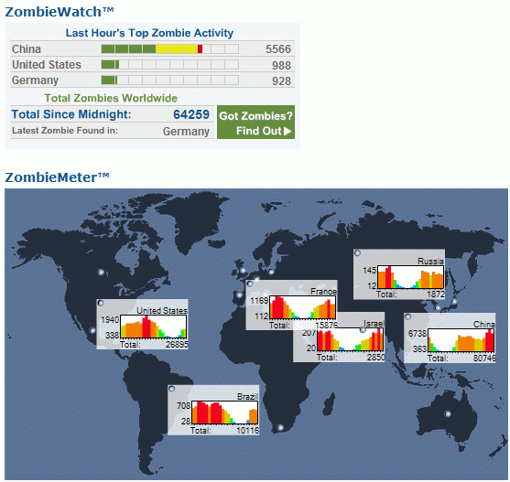
Show up on toolbar but nowhere else

Used as a gateway to install other nasty things on your machine

Toolbars

Sometimes useful, but use up screen space and may be accompanied by other malware

Zombies

Machines controlled by criminals

Used to send spam, or perform attacks on Web sites

See links CNIT 30 1c – 1f on my Web page: samsclass.info
Spam

Unsolicited email

Scams -- get-rich offers, messages from banks, etc.

Click on links or opening attachments, malware gets on your computer

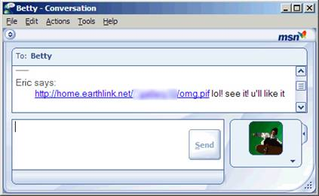

Spim

Instant message spam

See links CNIT 30 1g & 1h

Image from microsoft.com

Viruses

Viruses reproduce and spread from one computer to another

If you get infected, your machine can harm other machines

ALWAYS RUN ANTIVIRUS SOFTWARE

McAfee is free to CCSF students (Link 1i & j)

AVG is free to everyone (Link 1k)

Norton is popular (Link 1l)

Panda is reportedly the best (Link 1m)

Worms v. Viruses

Viruses are attached to files, or in a boot sector on a hard disk

Worms travel through a network, often by email

They both spread and are very dangerous

Trojan Horses or Trojans

A file that claims to do one thing, but actually does something else

Keystroke logger -- collects passwords and other personal data

Remote-controls your computer, making it a Zombie

Blended Threats

Combine many forms of attack

Very dangerous, and common

