Malware

Fighting Spyware, Viruses, and Malware

Ch 4

How the Pros Do It

Test machines

Easily replaced test OS images

Software to detect exactly what damage an infection has caused

We now have all these things for free with virtual PCs and HijackThis

Anatomy of an Infection

File system

Add, delete, or modify files

Spyware doesn’t usually modify or delete files, or make many copies of itself; that’s what viruses do

Windows Registry

All software installation modifies the Registry

Avoid editing the Registry manually; if you must, set a Restore Point first (demonstration)

Internet Explorer and other Applications

Change IE home page and security settings

Prevents updates or online virus scans

Especially common with Browser Hijackers

To remove browser hijackers, go to a clean machine and download Stinger from McAfee

Link CNIT 30 Ch 4a, or /vil.nai.com/vil/stinger/

Infect Outlook, send emails to people in your Address book

Windows System

May block Windows Update, or even show you a fake Windows Update Screen

Some malware kicks out previous infections to steal zombies from other botmasters

System Restore

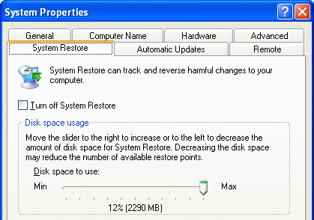
Enables Windows XP machines to return the system files to the way they were on a previous date

Fixes many problems, but not viruses or worms

Infections can hide in the Restore Points, so that later Restores re-infect a cleaned system

Delete the Restore points before running Stinger, and most other malware removal tools too

Disabling System Restore

System Properties

Turning it off deletes all the Restore points

Don’t do it casually, only when you know you are infected

Safe Mode

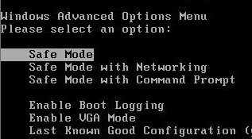
Press F8 during startup

Startup items, like spyware, don’t run

But neither do antivirus and antispyware programs

Avoid “Safe Mode with Networking” for that reason

Registry Editing

The Registry stores thousands of system settings

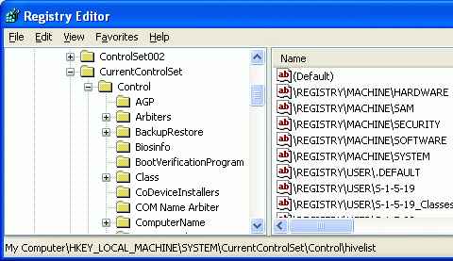
Control Panel is the best way to modify the Registry for normal activities

To manually change the Registry, use

Start, Run, Regedit

You may need to remove items spyware puts into the Registry manually

You can wreck your machine with a wrong registry edit

Set a Restore Point first

Project 3x guides you through a few fun Registry hacks

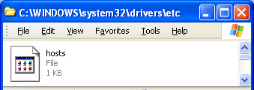
CoolWebSearch

This is an example of very nasty malware

Makes pop-ups

Blocks antispyware scans

Adds favorites to Internet Explorer

Hijacks the home page and other pages via the Hosts file

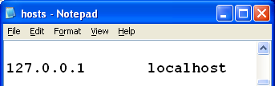
Some variants are very difficult to remove

See links CNIT 30 Ch 4d, 4e

Hosts File

C:\WINDOWS\system32\drivers\etc\Hosts

Can be used to make networking faster and more reliable

Can also be used to redirect traffic to spoofed sites

“Pharming”
Last modified 6-27-06

