Ground Rules
Use a Virtual Machine – Don’t Even THINK of Doing this to a Machine You Love!
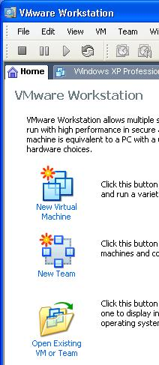
- This project will break your machine. You may very well never be able to fix it again, without reformatting the hard disk and reinstalling Windows. So use a virtual PC – that’s what they are for! Whatever you do, do NOT try this on someone else’s computer, or on a computer with valuable or private information, emails, etc. Remember what side of the fence we are on: Our ultimate goal is to FIX broken machines, not to take machines people love and ruin them.
Copying the Good Windows Pro Virtual PC
- Start your computer in S214 with the L drive, and log in as CNIT30. There is no password.
- Click Start, My Documents, My Virtual Machines. You should find a folder named Original Windows XP Professional. Right-click, hold the right mouse button down, drag the folder down ½ inch, and drop it. Select Copy Here from the context menu. Wait until the copy finishes – it will take about 5 minutes.
- Right-click on the Copy of Original Windows XP Professional folder and select Rename from the context menu. Give it a new name of Your Name Wrecked Win XP Pro.
Launching VMWare
- Click Start, All Programs, VMWare, VMWare Workstation.
- In the VMWare Workstation window, click the Home tab, as shown to the right on this page. Click the Open Existing VM or Team icon.
- In the Open box, open the My Documents folder, and open the My Virtual Machines folder. Open the Your Name Wrecked Win XP Pro folder. Double-click on the Windows XP Professional.vmx file.
- The VMWare Workstation window reappears, with a tab labeled Your Name Wrecked Win XP Pro. In the left pane, click the blue Start this virtual machine link.
- When the virtual PC launches, click Waldo to log in. There is no password. Waldo has Administrative privileges over the virtual PC.
Make Sure you Have Antivirus Software Running
- If you do the following steps on a machine without antivirus, you will mess up not only your computer, but other computers! It’s generally considered safe to allow a virtual PC to get spyware, but it is NOT safe to allow a virtual PC to get viruses, because the viruses can spread to you host system and to other computers on your network.
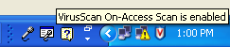
- Look at the Notification Area on the lower right of your desktop, next to the clock. You should see a shield icon with a red V on it. Hover the mouse over that icon and wait a few seconds. You should see the message “VirusScan On-Access Scan is enabled”, as shown to the right on this page. That shows that McAfee Antivirus is running. If you are using some other antivirus product, such as Norton or AVG, you should see some icon there indicating that it is protecting you.
- If you don’t have any antivirus software running, STOP HERE and install it. You can get a free copy of McAfee Antivirus from your instructor, and you can also get AVG AntiVirus free at this website:
http://free.grisoft.com/doc/2/lng/us/tpl/v5
Testing Your Antivirus Software
- Open a Web browser and go to eicar.com
- On the left of the page, click the “The AntiVirus testfile eicar.com” link.
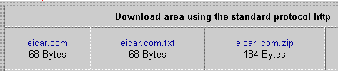
- The next page explains what the antivirus test file is – glance through it. It’s a harmless program that is used to test virus scanners. It is not a real virus, but it will set off virus scanners.
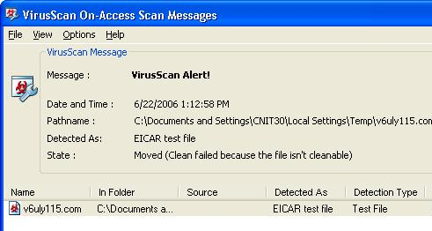
- Scroll to the bottom of this page and click the eicar.com link, in the top left of the gray box, as shown to the right on this page.
- You should see a VirusScan Alert appear, as shown to the right on this page. If you are not using McAfee, the alert box will look different, but it should still say EICAR somewhere on it.

Capturing a Screen Image
- You need to turn in an image of this screen to get full credit for this portion of the project. Note the hand symbol on the previous page—that indicates screen images that you must capture and turn in.
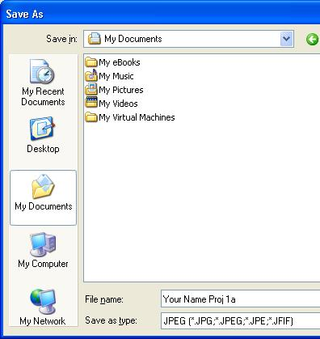
- Press Ctrl+ Alt on the keyboard to release the cursor from within the Virtual Machine window. Move the mouse pointer out of the VMWare Workstation window.
- Press the PrintScrn key in the upper-right portion of the keyboard. That will copy the whole desktop to the clipboard.
- Click Start, Programs, Accessories, Paint. In the untitled - Paint window, select Edit, Paste from the menu bar. The desktop appears in the Paint window, with only a corner of it visible.
- In the untitled - Paint window, click File, Save. Save the document in the My Pictures folder (or any other place you wish, such as a floppy disk) with the filename Your Name Proj 1a. Select a Save as type of JPEG, as shown in the figure to the right on this page.

Installing HijackThis!
- HiJack This is a wonderful program that can be used to diagnose Spyware infections. It’s best to install it before you get infected. HiJack This is NOT antispyware – it does not protect your machine. It just makes it easier to fix problems when they do occur.
- If you are in Science 214, use the procedure below to get HiJack This from the server in that room. If you are working at home, download it from:
http://majorgeeks.com/download3155.html
- Click Start, Run. Enter \\192.168.3.1 and click OK. If you are prompted for a name and password, put in Administrator and P@ssw0rd

- An Instructor1 Machine in Sci214 window opens. Double-click the CNIT 30 folder. Drag the hijackthis Zip archive to your desktop.
- Double-click the hijackthis Zip archive. In the hijackthis.zip window, drag the HijackThis executable file to your desktop, as shown to the right on this page.
- MajorGeeks recommend putting HiJack This into a folder named C:\Program Files\HJT, instead of your desktop. You can do that, or leave it on the desktop for this project.

Scanning a Clean Machine with HijackThis!
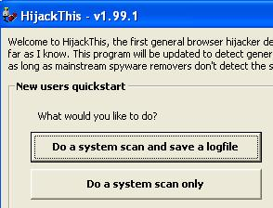
- Double-click the HijackThis executable file. A HijackThis warning box opens. Read it and click OK.
- A Hijack This window opens, as shown to the right on this page. Click the Do a system scan and save a logfile button.
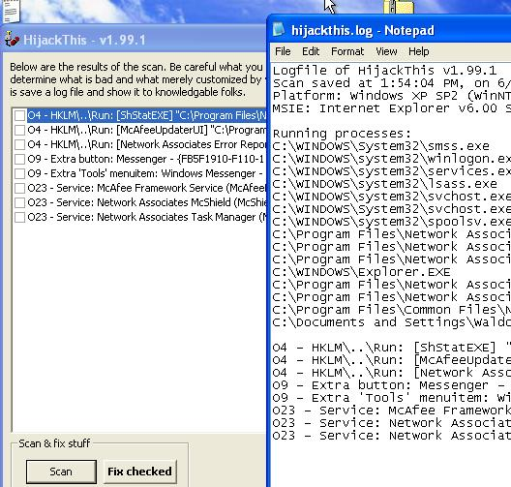
- Two windows appear, as shown to the right on this page. The two windows show the same information – processes, registry keys, toolbars, and services that look suspicious to Hijack This. The text file is more complete, but harder to read. This is what a clean machine looks like – there are only a few entries.
- Close both of the HijackThis windows.
Foolishly Installing Horrible Junk
- Click Start, All Programs, VMWare, VMWare Workstation.
- Pick some awful stuff to install. If there are known sites or programs you have had problems with in the past, use them! Make this class as relevant to your real-world problems as you can. My only requirement is that you get some junk on the machine that appears in a spyware scan later; I recommend that you get it wrecked so that Internet Explorer doesn’t work anymore. That’s usually the point at which people call Tech Support.
- If you don’t know of any horrible junk yourself, read this Web page that lists the ten worst sites to download stuff from, according to McAfee: http://tinyurl.com/ls7k5 (link CNIT 30 1a on my Web page, samsclass.info).
- Keep notes of what junk you install, so you can repeat the same process later on other machines. For example, here’s what I did to mess up my virtual PC:

  - Open Internet Explorer and go to RatLoaf.com
  - Download and install Tropical Aquarium Screensaver (No apparent spyware)
  - Scroll to the bottom of the page. Under the Windows header, click the blue letter D. Scroll down to Dog Days Screensaver. Click it.
  - Install everything it tells you to; at least 10 or 15 clicks worth of stuff, including many warnings that what you are doing is a bad idea
  - (TONS of Spyware)

Scanning an Infected Machine with HijackThis!
- Double-click the HijackThis executable file. In the Hijack This window, click the Do a system scan and save a logfile button.
- A hijackthis – Notepad window appears with a lot of information in it, but it’s not easy to tell what it means. Luckily, there is a free online analysis tool to help.
- Click anywhere in the hijackthis – Notepad window to make it active. Press Ctrl+A to select everything, and then press Ctrl+C to copy it to the clipboard.
- Open a browser and go to hijackthis.de
- Press Ctrl+V to paste the logfile into the box. Scroll to the bottom of the window and click the Analyze button.
- You should see the items rated as Safe or Nasty as shown below. Scroll down and find something nasty, as shown below:
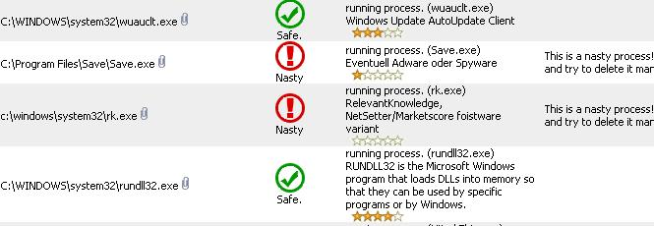

Capturing a Screen Image
- Press Ctrl+ Alt on the keyboard to release the cursor from within the Virtual Machine window. Move the mouse pointer out of the VMWare Workstation window.
- Press the PrintScrn key in the upper-right portion of the keyboard. That will copy the whole desktop to the clipboard.
- Click Start, Programs, Accessories, Paint. In the untitled - Paint window, select Edit, Paste from the menu bar. The desktop appears in the Paint window, with only a corner of it visible.
- In the untitled - Paint window, click File, Save. Save the document in the My Pictures folder (or any other place you wish, such as a floppy disk) with the filename Your Name Proj 1b. Select a Save as type of JPEG.

Turning in your Project
- Email the JPEG images to me as attachments to a single Email message. Send it to: cnit.030@gmail.com with a subject line of Proj 1 From Your Name, replacing Your Name with your own first and last name. Send a Cc to yourself.

Last Modified: 6-22-06

