Starting Your Wrecked Virtual PC
- Start your computer in S214 with the L drive, and log in as CNIT30. There is no password.
- Click Start, All Programs, VMWare, VMWare Workstation.
- In the VMWare Workstation window, click the Home tab, as shown to the right on this page. Click the Open Existing VM or Team icon.
- In the Open box, open the My Documents folder, and open the My Virtual Machines folder. Open the Your Name Wrecked Win XP Pro folder. Double-click on the Windows XP Professional.vmx file.
- The VMWare Workstation window reappears, with a tab labeled Your Name Wrecked Win XP Pro. In the left pane, click the blue Start this virtual machine link.
- When the virtual PC launches, click Waldo to log in. There is no password. Waldo has Administrative privileges over the virtual PC.

Installing VMWare Tools (Optional)
- VMWare Tools make your virtual PC easier to use. With VMWare Tools, you no longer have to press Ctrl+Alt to get the mouse pointer out of the virtual machine, and you can drag-and-drop files from the host system to the virtual system. But it’s not really necessary, and if you have wrecked this machine so badly that it is difficult or impossible to install things now, you can skip this step.
- Press Ctrl+Alt to release the mouse pointer from the virtual PC. On the VMWare Workstation menu bar, click VM, Install VMWare Tools. A VMWare Tools box opens in the virtual machine. Follow the instructions on your screen to install the tools, accepting the default options. Restart your virtual PC when you are prompted to. When your machine restarts, you may see messages about readjusting your screen resolution – that is normal. Let VMWare Tools adjust your screen automatically.

Saving a HijackThis! Short Analysis Before Cleaning
- Double-click the HijackThis executable file on the virtual desktop.
- In the Hijack This window, click the Do a system scan and save a logfile button.
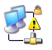
- Click anywhere in the hijackthis – Notepad window to make it active. Press Ctrl+A to select everything, and then press Ctrl+C to copy it to the clipboard.
- Open a browser and go to hijackthis.de Note: If you cannot connect to the Internet from the virtual PC, it’s because the spyware is making your network connection unreliable, as if often does. Do these steps to repair the connection:
  - Click Start, My Computer.
  - In the left pane of the My Computer window, click My Network Places.
  - In the left pane of the My Network Places window, click View Network Connections.
  - If you see a little yellow triangle with an exclamation point on it, as shown above and to the right on this page, right-click it and select Repair.

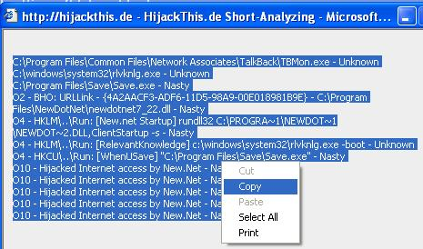
- Press Ctrl+V to paste the logfile into the box. Scroll to the bottom of the window and click the Analyze button.
- The next screen shows the items rated as Safe, Nasty, or Unknown as you saw in project 1. Scroll to the bottom of this page and click the Short Analysis link.
- Use the mouse to highlight the information in the Short Analysis, right-click the highlighted area, and click Copy as shown to the right on this page.
- Click Start, Programs, Accessories, Notepad. From the Notepad menu, click Edit, Paste. Save this file in the My Documents folder with the name Your Name Before Cleaning.

Installing Windows Defender
- Windows Defender is Microsoft’s antispyware tool, and it is widely considered to be a good product.
- If you are in Science 214, use the procedure below to get Windows Defender from the server in that room. If you are working at home, you can download it from tinyurl.com/c9p2f
- Click Start, Run. Enter \\192.168.3.1 and click OK.
- An Instructor1 Machine in Sci214 window opens. Double-click the CNIT 30 folder. Drag the Windows Defender installer file to your desktop.
- If your desktop is cluttered with advertisements from the spyware, try to close them to get them out of the way.
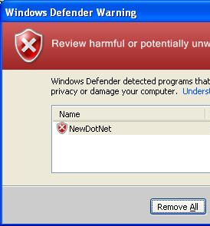
- Double-click the Windows Defender icon on your desktop. Run the installer. Accept the agreement. Use the recommended or default settings. When you see the message Windows Defender Installation Complete, leave the Check for updated definitions and run a quick scan now box checked and click Finish.
- It may be hard to see the Windows Defender window because of all the spyware boxes cluttering your desktop. Look for Windows Defender on the taskbar.
- When you see a Windows Defender Warning boxes, like the example shown to the right on this page, press the PrintScrn key.

Saving a Screen Image
- Click Start, Programs, Accessories, Paint. In the untitled - Paint window, select Edit, Paste from the menu bar. The desktop appears in the Paint window, with only a corner of it visible.
- In the untitled - Paint window, click File, Save. Save the document in the My Pictures folder (or any other place you wish, such as a floppy disk) with the filename Your Name Proj 2. Select a Save as type of JPEG.

Removing Spyware with Windows Defender
- In the Windows Defender Warning box, click Remove All. If you get more boxes like that, click Remove All. If Windows Defender wants to restart your system, agree to that.

Saving a HijackThis! Short Analysis After Cleaning with Windows Defender
- Double-click the HijackThis executable file on the virtual desktop.
- In the Hijack This window, click the Do a system scan and save a logfile button.
- Click anywhere in the hijackthis – Notepad window to make it active. Press Ctrl+A to select everything, and then press Ctrl+C to copy it to the clipboard.
  - Open a browser and go to hijackthis.de
- Press Ctrl+V to paste the logfile into the box. Scroll to the bottom of the window and click the Analyze button. Scroll to the bottom of the next screen and click the Short Analysis link.
- Use the mouse to highlight the information in the Short Analysis, right-click the highlighted area, and click Copy.
- Click Start, Programs, Accessories, Notepad. From the Notepad menu, click Edit, Paste. Save this file in the My Documents folder with the name Your Name After Cleaning With Defender.

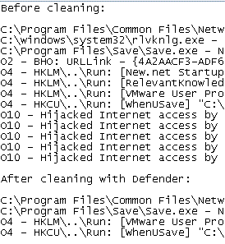
Turning in your Project
- Compose an email message to: cnit.030@gmail.com with a subject line of Proj 2 From Your Name, replacing Your Name with your own first and last name. Send a Cc to yourself.
- Type in the words Before Cleaning, and paste the short scan results from the Your Name Before Cleaning file into the message.
- Type in the words After Cleaning with Defender, and paste the short scan results from the Your Name After Cleaning With Defender file into the message.
- The body of your final email should look similar to the example to the right on this page (of course, your spyware items might be different). Attach the JPEG image and send the message.
Last Modified: 6-23-06

