For extra credit, you can just repeat the entire process with a different antispyware tool. So you would have to do these steps:
Remove Windows Defender From Your Virtual PC
- It’s OK to run multiple AntiSpyware programs on a computer to keep it clean. – in fact it’s often recommended. But since we want to infect the machine with Spyware again, we need to remove Windows Defender to let the nasty stuff on.
- Open Add or Remove Programs in Control Panel and uninstall Windows Defender.
Put Spyware on Your Virtual PC (Not a real PC, of course!)
- Repeat the process you used in project 1 to infect a PC. There is no need to start from a clean copy of the Original PC – just go download and install the same horrible stuff you used last time. If you forgot what you did last time, just find some new stuff to download. It’s not important that you duplicate your previous infection state exactly. All you need is a machine with enough spyware to see the tool do its job.

Save a HijackThis! Short Analysis Before Cleaning
- Do this the same way you did in Project 2.

Installing a Different AntiSpyware Tool
- Choose any anti-spyware tool you want. Here are a few I recommend, and that I have placed in the CNIT 30 folder on the server in room S214.
- Ad-Aware from www.lavasoft.com
- Spybot from www.safer-networking.org/en/download/
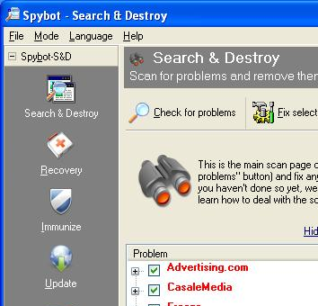
- Ewido (30 day trial) from www.ewido.net/en/download/

Clean your Virtual PC with the AntiSpyware Tool
- The exact steps differ for each tool. Just run whatever scan and clean procedure it recommends.
- Capture a screen image of your tool cleaning your system, as shown to the right on this page. The exact image varies with the tool.

Save a HijackThis! Short Analysis After Cleaning
- Do this the same way you did in Project 2.

Turning in your Project to Get 5 Points Extra Credit
- Send the message to me just as you did in Project 2, with the scans before and after cleaning. Attach the JPEG image of your cleaning tool. Use a subject of Project 2x from YOUR NAME.

Repeat it with a Third AntiSpyware Tool to Get 5 More Points Extra Credit
- Choose a new tool, different from the other two, and do it all again.
- You can’t get more than 10 points total extra credit for this Project 2x.
Last Modified: 6-23-06

