Starting a Clean PC
- Start your computer in S214 with the L drive, and log in as CNIT30. There is no password.
- Click Start, All Programs, VMWare, VMWare Workstation.
- In the VMWare Workstation window, click the Home tab. Click the Open Existing VM or Team icon.
- In the Open box, open the My Documents folder, and open the My Virtual Machines folder. Open the Original Windows XP Professional folder. Double-click on the Windows XP Professional.vmx file.
- The VMWare Workstation window reappears. In the left pane, click the blue Start this virtual machine link.
- When the virtual PC launches, click Waldo to log in. There is no password. Waldo has Administrative privileges over the virtual PC.
- Don’t install junk on the clean virtual machine! Keep it clean! If you accidentally corrupt the clean virtual machine, ask your instructor how to download a fresh copy of a clean one from the server.

Installing VMWare Tools (Optional)
- VMWare Tools make your virtual PC easier to use. With VMWare Tools, you no longer have to press Ctrl+Alt to get the mouse pointer out of the virtual machine, and you can drag-and-drop files from the host system to the virtual system. But it’s not really necessary, and if you have wrecked this machine so badly that it is difficult or impossible to install things now, you can skip this step.
- Press Ctrl+Alt to release the mouse pointer from the virtual PC. On the VMWare Workstation menu bar, click VM, Install VMWare Tools. A VMWare Tools box opens in the virtual machine. Follow the instructions on your screen to install the tools, accepting the default options. Restart your virtual PC when you are prompted to. When your machine restarts, you may see messages about readjusting your screen resolution – that is normal. Let VMWare Tools adjust your screen automatically.
Using NETSTAT With No Web Pages Open
- Click Start, Run. Type in CMD and press the Enter key.
- A Command Prompt window opens. Type in this command:
netstat –n
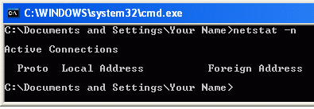
and then press the Enter key. The netstat command shows all active network connections on your machine. If you have not been using the Internet, you will see a result like the figure to the right on this page, with no values, just column headings.
Using NETSTAT With the CCSF Web Pages Open
- Leave the Command Prompt window open. Open a Web browser and go to www.ccsf.edu. When the Web page has loaded, click in the Command Prompt window and enter the netstat –n command again, followed by the Enter key. (Every command entered into a Command Prompt widow must be followed by the Enter key, so I won’t continue to mention it. Just press Enter after each command.)
- Now you should see several network connections, including ones to the CCSF Web server, as shown below on this page. The number on the left, starting 192.168, is your IP Address. The value after the colon, which should be larger than 1024, is the Local Port Number. The value on the right, 147.144.1.212, is the CCSF Web Server’s IP Address. The Web server’s Port number is 80, because it is sending out normal HTTP Web pages.
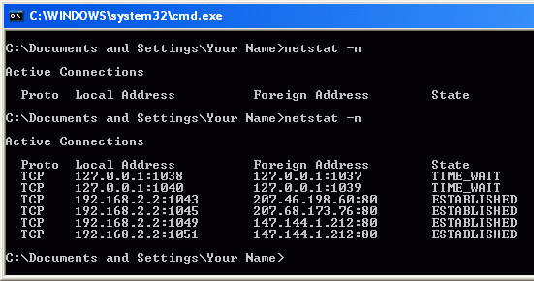

Using NETSTAT With a Secure Web Pages Open
- Leave the Command Prompt window and the CCSF Web page open. Open another Web browser and go to yahoo.com. At the top of the Yahoo! page, just to the right of the red YAHOO!, click the Mail icon.
- Notice that this address starts https://, and that there is a padlock icon visible on the right side of your browser (the exact location varies with the browser). This is a secure page—you can be confident that you are really communicating with Yahoo,and that no one else can read the name and password you enter.
- Click in the Command Prompt window and enter the netstat –n command again. You should see connections from your machine to 208.59.201.17:443, as shown on the next page. This is Yahoo’s server, port 443, which is the port used by HTTPS.
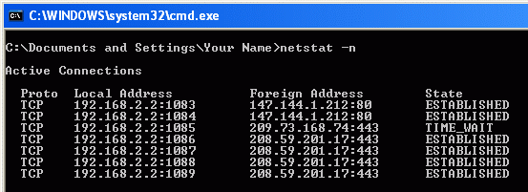

Saving a Screen Image
- Press the PrintScrn key.
- Click Start, Programs, Accessories, Paint. In the untitled - Paint window, select Edit, Paste from the menu bar. The desktop appears in the Paint window, with only a corner of it visible.
- In the untitled - Paint window, click File, Save. Save the document in the My Pictures folder (or any other place you wish, such as a floppy disk) with the filename Your Name Proj 3a. Select a Save as type of JPEG.
Using the Network Setup Wizard to Share Files
- Your machine is not a Web server, but it can act as a file server if you share a folder. Here’s the recommended way to do that with Windows XP.
- Click Start, My Computer. In the left pane of the My Computer window, click My Network Places.
- In the left pane of the My Network Places window, click the Set up a home or small office network link.
- At the Welcome to the Network Setup Wizard screen, click Next.
- At the Before you continue… screen, click Next.
- At the Select a connection method screen, accept the default selection of This computer connects to the Internet through a residential gateway or through another computer on my network and click Next.
- At the Give this computer a description and a name screen, click Next.
- At the Name your network screen, enter a Workgroup name of Sci214and click Next.
- If a File and printer sharing screen appears, accept the default selection of Turn on file and printer sharing and click Next.
- At the Ready to apply network settings screen, click Next.
- At the Please wait screen, wait for the animation to end. It might take a minute or longer.
- At the You’re almost done screen, click Just finish the wizard. I don’t need to run the wizard on other computers and click Next.
- At the Completing the Network Setup Wizard screen, click Finish.
Sharing a Folder
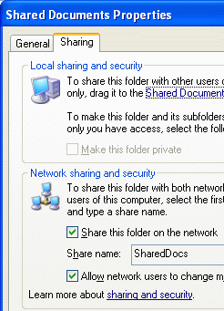
- Click Start, My Computer. Right-click the Shared Documents folder and select Sharing and Security.
- In the Shared Documents Properties box, on the Sharing tab, select Share this folder on the network, as shown to the right on this page. Check the Allow network users to change my files box. Click OK.
Finding Your IP Address
- Click in the Command Prompt window and enter this command:
IPCONFIG
- You should see several lines of information, including your IP Address, as shown below on this page. Write down your IP Address.
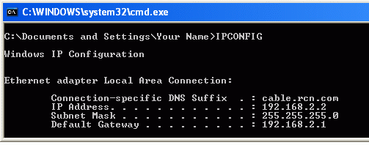

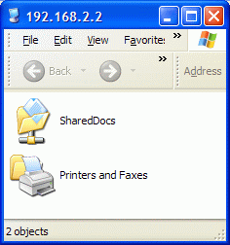
Opening the Shared Folder from the Host Operating System
- In the host operating system (NOT the virtual PC), click Start, Run. Type this line into the Run box, replacing 192.168.2.2 with the IP address you wrote down in the previous step:
\\192.168.2.2
- Press the Enter key. You should see a window open showing the shared folder on your virtual PC, as shown to the right on this page. This means that a network connection is open between the host PC and the virtual PC, and the virtual PC is acting as the Server.
Using NETSTAT With a Shared Folder Open
- In the virtual PC, click in the Command Prompt window and enter the netstat –n command again. You should see a connection with a Foreign Address ending in a port number of 139, as shown below. Port 139 is used by NetBIOS, which is the Windows file sharing system.
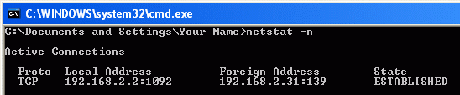

Saving a Screen Image
- Press the PrintScrn key.
- Click Start, Programs, Accessories, Paint. In the untitled - Paint window, select Edit, Paste from the menu bar. The desktop appears in the Paint window, with only a corner of it visible.
- In the untitled - Paint window, click File, Save. Save the document in the My Pictures folder (or any other place you wish, such as a floppy disk) with the filename Your Name Proj 3b. Select a Save as type of JPEG.

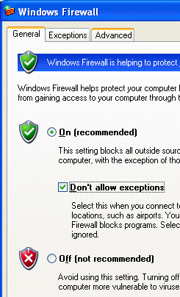
Blocking File Sharing With Windows Firewall
- In the virtual PC, click Start, Control Panel. If you see a heading of Pick a category in the right pane, click the Switch to Classic View link in the left pane.
- Double-click Windows Firewall. In the Windows Firewall box, on the General tab, check the Don’t allow exceptions box, as shown to the right on this page. Click the OK button.
Attempting to Open the Shared Folder from the Host Operating System
- In the host operating system (NOT the virtual PC), click Start, Run. Type this line into the Run box, replacing 192.168.2.2 with the IP address you wrote down in the previous step:
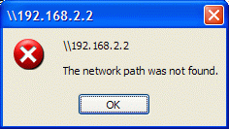
\\192.168.2.2
- Press the Enter key. Wait for about 45 seconds. After your computer times out, an error message appears, saying The network path was not found, as shown to the right on this page. You cannot connect to the shared folder because the firewall is stopping you.

Saving a Screen Image
- Press the PrintScrn key.
- Click Start, Programs, Accessories, Paint. In the untitled - Paint window, select Edit, Paste from the menu bar. The desktop appears in the Paint window, with only a corner of it visible.
- In the untitled - Paint window, click File, Save. Save the document in the My Pictures folder (or any other place you wish, such as a floppy disk) with the filename Your Name Proj 3c.

Turning in your Project
- You should have three JPEG images, as indicated by the pointing hand symbol above. Some of the images are probably saved in the virtual PC, and some on the host system. Before you turn in your project, you must gather all the images onto the same system. If you have installed VMWare Extensions, you can just drag-and-drop files from the host operating system to the virtual system, and vice versa. If you don’t want to use VMWare extensions, you can save the files on a floppy, or on a network share, or email them from one machine to the other.
- After you have gathered all three images together, send them all as attachments in a single message addressed to: cnit.030@gmail.com with a subject line of Proj 3 From Your Name, replacing Your Name with your own first and last name. Send a Cc to yourself.
Last Modified: 6-28-06

