Linux – the Safest OS
- Linux is an alternative to Microsoft Windows. If you are using Linux, your computer is almost immune from viruses, spyware, worms, and the like. You will be as safe as Macintosh users. There is on complete safety in computers, and there are ways to attack and exploit Linux systems, but it is very rare. Probably the main reason Linux is safe is that there are so many different types of Linux, and that it is so unpopular (1% or less of desktop computers).
Starting a Clean Virtual Machine
- Start VMWare Workstation.
- In the VMWare Workstation window, click the Home tab. Click the Open Existing VM or Team icon.
- In the Open box, open the My Documents folder, and open the My Virtual Machines folder. Open the Original Windows XP Professional folder. Double-click on the Windows XP Professional.vmx file.
- The VMWare Workstation window reappears. In the left pane, click the blue Start this virtual machine link.
- When the virtual PC launches, click Waldo to log in. There is no password. Waldo has Administrative privileges over the virtual PC.
Installing digestIT
- Whenever you download a program, or even copy it from a local server, there is a chance that the program you get is not in its original form, either because of an error, or the action of a virus. It is a good habit to check every downloaded file before using it. In order to verify a file, a hash function is used – a function that combines all the bytes in the file in a mathematical way to create a hash value that you can compare to the hash value of the original file. The most common type of hash used is a MD5 Hash.
- Unfortunately, Windows doesn’t include an MD5 hash calculator. But you can get one easily on the Internet. Here’s the one I use:
- Click Start, Run and type in
\\192.168.1.3
- Click OK to open the shared folder. Drag the MD5Win32.zip file to the desktop of your virtual PC. If you are working from home, you can download the Browser Appliance from this Web address:
http://digestit.kennethballard.com/download.html
- Double-click the MD5Win32.zip file. Drag the MD5Win32.msi installer file to the desktop of your virtual PC. Double-click the installer and install the software with the default options, selecting a typical install.
Checking the MD5 Hash of the digestIT Zip File
- Normally you check the MD5 hash before installing software, but you can’t do that until you have a hash program. So, just this once, we’ll check it after the fact.
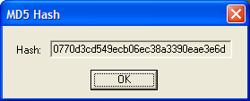
- Right-click the MD5Win32.zip file and select Hash File. A box should pop up with the MD5 Hash value, as shown to the right on this page. The value should be:
0770d3cd549ecb06ec38a3390eae3e6d

Saving a Screen Image
- Press the PrintScrn key.
- Click Start, Programs, Accessories, Paint. In the untitled - Paint window, select Edit, Paste from the menu bar. The desktop appears in the Paint window, with only a corner of it visible.
- In the untitled - Paint window, click File, Save. Save the document in the My Pictures folder (or any other place you wish, such as a floppy disk) with the filename Your Name Proj 4a. Select a Save as type of JPEG.
- Whenever you download a program, or even copy it from a local server, there is a chance that the program you get is not in its original form, either because of an error, or the action of a virus. It is a good habit to check every downloaded file before using it. In order to verify a file, a hash function is used – a function that combines all the bytes in the file in a mathematical way to create a hash value that you can compare to the hash value of the original file. The most common type of hash used is a MD5 Hash.
Downloading a Virtual Machine Containing Ubuntu Linux
- Ubuntu is currently the most popular type of Linux used on home machines. As you will see, it is very easy to install and use. And to make it even easier, VMWare has a pre-installed Ubuntu Linux virtual machine available for use, called a Browser Appliance.
- Start your computer in S214 with the L drive, and log in as CNIT30. There is no password.
- Click Start, Run and type in
\\192.168.1.3
- Click OK to open the shared folder. Drag the Browser-Appliance-1.0.0.zip file to your desktop. It will probably take about 5 minutes to copy to your computer. If you are working from home, you can download the Browser Appliance from this Web address:
http://www.vmware.com/vmtn/appliances/directory/browserapp.html
Checking the MD5 Hash Value
- Right-click the Browser-Appliance-1.0.0.zip file and select Hash File. The calculation will take about 30 seconds, showing a progress bar. When the calculation is done, you should see this hash value:
b8797f94a67ae8550e5b589904dcf8bd

Moving the Browser Appliance to the Host Operating System
- Right now the browser appliance is inside a virtual PC, but we want it stored in the host system. If you have installed VMWare tools, you should be able to drag the Browser-Appliance-1.0.0.zip file from the virtual desktop to the host operating system’s desktop. If you can’t do that, you can just download it from the server again, but that is not the best procedure because you won’t be able to check the MD5 hash.
- After the file has completed copying, minimize the virtual PC window.
- Click Start, My Documents to open the My Documents window. You should see a folder inside it named My Virtual Machines.
- Double-click the Browser-Appliance-1.0.0.zip file on the host operating system’s desktop. Inside you will find a Browser-Appliance folder. Drag the Browser-Appliance folder into the My Virtual Machines folder.
- Restore the virtual PC window, and shut down the Windows XP virtual PC.
Starting Ubuntu Linux
- In the VMWare Workstation window, click the Home tab. Click the Open Existing VM or Team icon.
- In the Open box, open the My Documents folder, and open the My Virtual Machines folder. Open the Browser-Appliance folder. Double-click on the Browser-Appliance.vmx file.
- The VMWare Workstation window reappears. In the left pane, click the blue Start this virtual machine link.
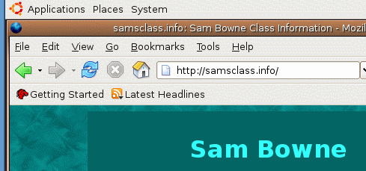
- While Ubuntu Linux starts, you will see some text messages, and a graphical ubuntu logo. After Ubuntu starts up, you will see Firefox open with a page titled Browser Appliance as shown to the right on this page.
- Click in the Address bar and enter some Web address such as samsclass.info to verify that you are connected to the Internet. this URL: The Web page should open as shown to the right on this page.

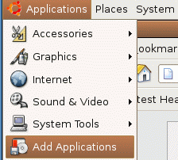
Adding Software to your Ubuntu PC
- In the upper left of the screen, there are three drop-down menus labeled Applications, Places, and System. These can be used to control your Ubuntu PC. Click Applications, Add Applications¸ as shown to the right on this page.
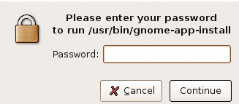
- A box pops up asking for your password¸ as shown to the right on this page. This is one of the reasons Linux is so safe – you are not running with administrative privileges. In order to install software, you must provide the administrator password. That means that spyware, viruses, and other malware can’t install without the password either. This is such a good idea that Microsoft has built it into Windows Vista, which will replace Windows XP. Type in the password of vmware and click Continue.
- In the Add Applications window, look through the available applications. Select any that you like, but be sure to expand the Office category and check OpenOffice.org2 Writer, as shown below. Click the Apply button. In the Changes Pending box, click Apply.
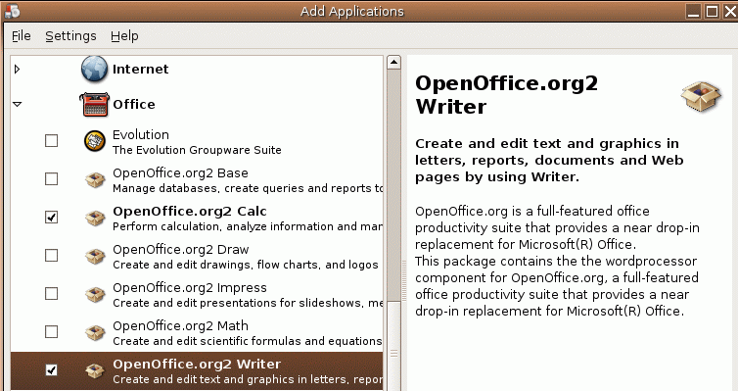

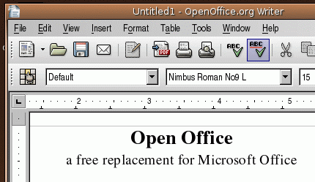
- When the new programs are loaded, try them out.
- To launch Writer, click Applications, Office, OpenOffice.org2 Writer. Type in some text into the Writer window and use some of the formatting tools to see how it works—this is a simpler word processor than Microsoft Word, but adequate for most purposes. And the price is right – free.

Saving a Screen Image
- Make sure the OpenOffice.org Writer window is visible, with some text typed into it. Click outside the VMWare Workstation window, so its title bar dims. Press the PrintScrn key.
- In the host operating system (Windows XP), click Start, Programs, Accessories, Paint. In the untitled - Paint window, select Edit, Paste from the menu bar. The desktop appears in the Paint window, with only a corner of it visible.
- In the untitled - Paint window, click File, Save. Save the document in the My Pictures folder (or any other place you wish, such as a floppy disk) with the filename Your Name Proj 4b.

Turning in your Project
- Send the images as attachments in a single message addressed to: cnit.030@gmail.com with a subject line of Proj 4 From Your Name, replacing Your Name with your own first and last name. Send a Cc to yourself.
Last Modified: 7-6-06

