Starting a Clean PC
Warning! Unexpected port scans are rude, and possibly even illegal! Port scans can set off intrusion detection systems and get us all into trouble. Don’t scan other people’s servers, just scan machines you have permission to scan. The only machine you should scan in this project is a virtual machine in S214.
- Start your computer in S214 with the L drive, and log in as CNIT30. There is no password.
- Click Start, All Programs, VMWare, VMWare Workstation.
- In the VMWare Workstation window, click the Home tab. Click the Open Existing VM or Team icon.
- In the Open box, open the My Documents folder, and open the My Virtual Machines folder. Open the Original Windows XP Professional folder. Double-click on the Windows XP Professional.vmx file.
- The VMWare Workstation window reappears. In the left pane, click the blue Start this virtual machine link.
- When the virtual PC launches, click Waldo to log in. There is no password. Waldo has Administrative privileges over the virtual PC.
- Don’t install junk on the clean virtual machine! Keep it clean! If you accidentally corrupt the clean virtual machine, ask your instructor how to download a fresh copy of a clean one from the server.
Installing the NMAP Port Scanner
- NMAPis a powerful free Linux utility that has been converted into a PC tool. It can be used for many purposes, both good and evil. We’ll use it to test firewalls, to see what they stop and what they allow.
- In the virtual PC, click Start, Run. Enter \\192.168.3.1 and click OK.
- An Instructor1 Machine in Sci214 window opens. Double-click the CNIT 30 folder. Drag the nmap-4.11-setup file to your desktop. If you are working at home, you can download NMAP from insecure.org/nmap
- On your desktop, double-click the nmap-4.11-setup icon. Agree to the agreement, and click through the installer, accepting the defaults. You also have to agree to install another program called winpcap, which is a utility used by NMAP and other good programs. These are good programs you can trust. They are not spyware.
Find a Partner
- You need to work with another student, or at least with a second computer. You can’t scan yourself easily with NMAP, so you will have to scan a different virtual PC. Go to your partner’s machine and perform these steps:

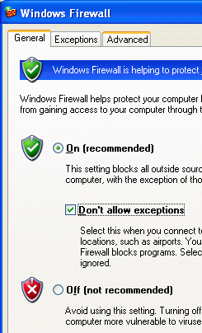
Setting Your Partner’s Firewall to No Exceptions
- In your partner’s virtual PC, click Start, Control Panel. If you see a heading of Pick a category in the right pane, click the Switch to Classic View link in the left pane.
- Double-click Windows Firewall. In the Windows Firewall box, on the General tab, check the Don’t allow exceptions box, as shown to the right on this page. Click the OK button.

Finding Your Partner’s IP Address
- In your partner’s virtual PC, click Start, Run. Type in CMD and press the Enter key.
- In the Command Prompt window, enter the IPCONFIG command. Find the IP Address and write it down.

Scanning Your Partner’s Machine with NMAP
- Return to your own virtual PC. Click Start, Run. Type in CMD and press the Enter key. Then enter these two commands, replacing 192.168.2.2 in the second command with the IP address you wrote down in the previous step:
CD \Program Files\NMAP
NMAP 192.168.2.2
- Wait while the NMAP port scan finishes – it should take one or two minutes. NMAP is sending a lot of packets to your partner’s virtual PC, and waiting to see what responses come back. When the scan is completed, you should see the message shown below: All 1680 scanned ports on 192.168.2.2 are filtered. That’s what a powerful firewall does – no matter what type of requests are sent in, they get no answer at all. This is safe, but it limits the ways you can use the computer – with this setting you cannot share your folders or printers.

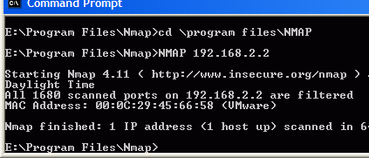
Saving a Screen Image
- Press the PrintScrn key. Click Start, Programs, Accessories, Paint. In the untitled - Paint window, select Edit, Paste.

- In the untitled - Paint window, click File, Save. Save the document in the My Pictures folder (or any other place you wish, such as a floppy disk) with the filename Your Name Proj 4xa. Select a Save as type of JPEG.

Turning Your Partner’s Firewall to Off
- In your partner’s virtual PC, click Start, Control Panel. Double-click Windows Firewall. In the Windows Firewall box, on the General tab, click Off (not recommended). Click the OK button.

Scanning Your Partner’s Machine with NMAP
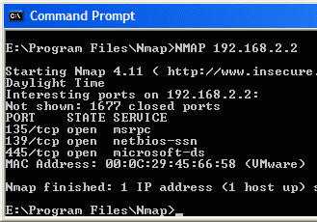
- Return to your own virtual PC. In the Command Prompt window, enter this command, replacing 192.168.2.2 with your partner’s IP address: NMAP 192.168.2.2
- When the scan is completed, you should see some ports open now, as shown to the right on this page. The exact ports open might be different, especially if you are doing this project at home, but some ports should be open.

Saving a Screen Image
- Press the PrintScrn key. Click Start, Programs, Accessories, Paint. In the untitled - Paint window, select Edit, Paste.
- In the untitled - Paint window, click File, Save. Save the document in the My Pictures folder (or any other place you wish, such as a floppy disk) with the filename Your Name Proj 4xb. Select a Save as type of JPEG.

Turning Your Partner’s Firewall to On
- In your partner’s virtual PC, click Start, Control Panel. Double-click Windows Firewall. In the Windows Firewall box, on the General tab, click On. Clear the Don’t allow exceptions box. Click the OK button.

Scanning Your Partner’s Machine with NMAP
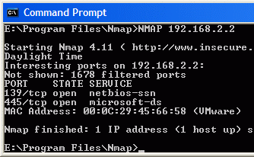
- Return to your own virtual PC. In the Command Prompt window, enter this command, replacing 192.168.2.2 with your partner’s IP address: NMAP 192.168.2.2
- You should see some ports open, as shown to the right on this page, but fewer than you saw with the firewall turned off.

Saving a Screen Image
- Press the PrintScrn key. Click Start, Programs, Accessories, Paint. In the untitled - Paint window, select Edit, Paste.

- In the untitled - Paint window, click File, Save. Save the document in the My Pictures folder (or any other place you wish, such as a floppy disk) with the filename Your Name Proj 4xb. Select a Save as type of JPEG.

Turning in your Project
- Email the images as attachments in a single message addressed to: cnit.030@gmail.com with a subject line of Proj 4x From Your Name, replacing Your Name with your own first and last name. Send a Cc to yourself.
Last Modified: 6-28-06

