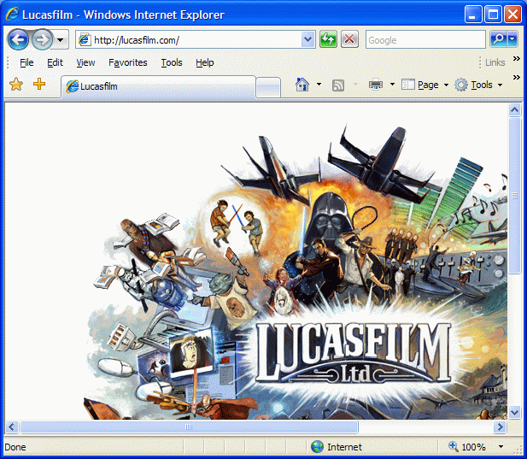
The Joy of Windows
- Use the host operating system at first, do not start VMWare Workstation.
- Click Start, All Programs, Internet Explorer.
- Go to lucasfilm.com
- You should see an animated logo that moves when you mouse over it, as shown to the right on this page. This is a Flash animation. Many websites use Flash. If you see a box telling you to install a player, follow the steps and see if you can do it.
- Go to apple.com/trailers and try to watch a movie trailer. You may have to install some software, like QuickTime or iTunes. Can you do it? Are the messages on the screen clear? Notice how easy (or hard) this is.
Starting Ubuntu Linux
- In the VMWare Workstation window, click the Home tab. Click the Open Existing VM or Team icon.
- In the Open box, open the My Documents folder, and open the My Virtual Machines folder. Open the Browser-Appliance folder. Double-click on the Browser-Appliance.vmx file.
- The VMWare Workstation window reappears. In the left pane, click the blue Start this virtual machine link.

Installing the Flash Player for Linux: Unpacking the Archive
- Click Applications, Internet, Firefox to open Firefox
- Go to lucasfilm.com
- You don't see a pretty animation--instead you see a message saying “Click here to get the latest flash player”. Click there.
- Click the "Download Now" button. A dialog box will appear titled Opening install_flash_player_7_linux.tar.gz.
- Accept the default selection of Open with Archive Manager and click the OK button.
- A window appears titled install_flash_player_7_linux.tar.gz. Click the Extract button.
- An Extract box appears, showing a selection of Extract in folder tmp. Click the Extract button.
- Close all windows.

Installing the Flash Player for Linux: Using Terminal and the Command Line
- From the menu bar, click Applications, Accessories, Terminal.
- In the Terminal window, type this command:
cd /tmp/install_flash_player_7_linux
- Press the Enter key.
- In the Terminal window, type this command:
/flashplayer-installer
- Press the Enter key.
- Your screen should look like the figure below. To start the installation, press the Enter key.
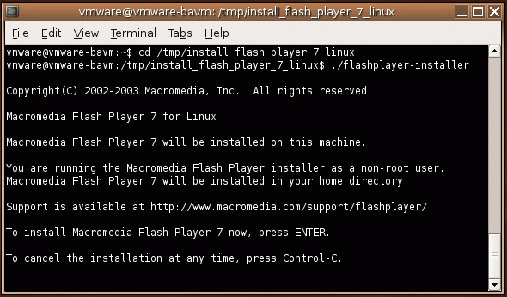

- Follow the instructions on the screen to install the player. You will have to press Enter, Enter, y, Enter.
- At the Perform another installation? (y/n): question, press n, Enter.
- From the System menu, click Log Out. In the Are you sure you want to log out? box, select Restart the computer and click OK.

Using the Flash Player
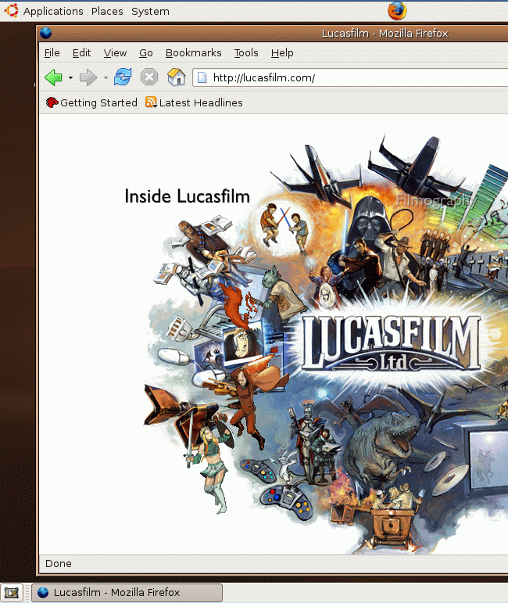
- Click Applications, Internet, Firefox to open Firefox
- Go to lucasfilm.com
- You should see the animation in the Firefox window, as shown to the right on this page.

Saving a Screen Image
- Click outside the VMWare Workstation window, so its title bar dims. Press the PrintScrn key.
- In the host operating system (Windows XP), click Start, Programs, Accessories, Paint. In the untitled - Paint window, select Edit, Paste from the menu bar. The desktop appears in the Paint window, with only a corner of it visible.
- In the untitled - Paint window, click File, Save. Save the document in the My Pictures folder (or any other place you wish, such as a floppy disk) with the filename Your Name Proj 5x.

Turning in your Project
- Send the image as an attachment to a message addressed to: cnit.030@gmail.com with a subject line of Proj 5x From Your Name, replacing Your Name with your own first and last name. Send a Cc to yourself.
Last Modified: 7-6-06

