Removing the Old WinPcap Version
- If you did the Port Scanning project on this machine, it will have an old version of WinPCap installed, which must be removed. If WinPcap is not already on your machine, skip to the next section “Installing WinPcap 4.0 alpha 1”.
- Click Start, Control Panel. If you see Pick a category in large letters, click the Switch to Classic View link in the upper left.
- In Control Panel, double-click Add or Remove Programs. Wait while the program list populates.
- Look for WinPcap in the list. If it is version 3.1, or any version prior to 4.0, click it. Click the Remove button.
- An Uninstall Confirmation box appears. Click Uninstall. When the uninstallation is done, click Close.

Installing WinPcap 4.0 alpha 1
- If you are in room S214, start your virtual PC and open the shared folder by clicking Start, Run and entering \\192.168.1.3 (If you are asked for a name and password, use Administrator and P@ssw0rd.)
- Open the CNIT30 folder, and drag the WinPcap_4_0_alpha1.exe file to the desktop of your virtual PC. If you are working at home, you can download WinPcap from www.winpcap.org/install
- Double-click the WinPcap_4_0_alpha1installer and install the software, accepting the default choices.
Note: This is alpha software, even less reliable than beta software. But you need it – the earlier version I tried does not work with VMWare. Besides, the standards are different – Open Source alpha software is about as reliable as Microsoft Beta software. Anyway, don’t be surprised if you find bugs in the software.

Installing the Wireshark Protocol Analyzer (aka Packet Sniffer)
- If you are in room S214, start your virtual PC and open the shared folder by clicking Start, Run and entering \\192.168.1.3
- Open the CNIT30 folder, and drag the wireshark-setup-0.99.2pre1.exe file to the desktop of your virtual PC. If you are working at home, you can download Wireshark from wireshark.org
- Double-click the Wireshark installer and install the software, accepting the default choices. It should not install WinPCap, because it should recognize that the version you installed above is more recent than the version 3.1 included in the Wireshark installer.

Using the Wireshark Protocol Analyzer to View a Web Page Request:
- Open a Web browser and navigate to www.ccsf.edu. Minimize the browser, but don’t close it.
- Click Start, All Programs, Wireshark, Wireshark
- In the The Wireshark Network Analyzer window, click Capture, Interfaces. In the Wireshark: Capture Interfaces window opens, as shown below on this page, find the line that says Microsoft’s Packet Scheduler. Click the Capture button on that line.

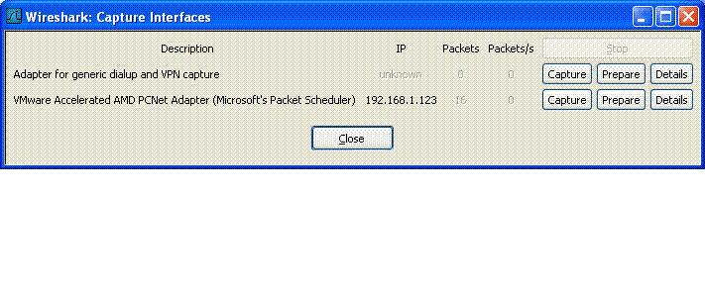
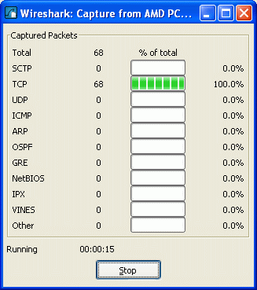
- Restore the Web browser window and click the Refresh button to make sure the page reloads from the Internet.
- After the page has loaded, you should see some packets captured in the Wireshark: Capture window, as shown to the right on this page. The exact number of packets may vary. Click the Stop button at the bottom of the Wireshark: Capture window.
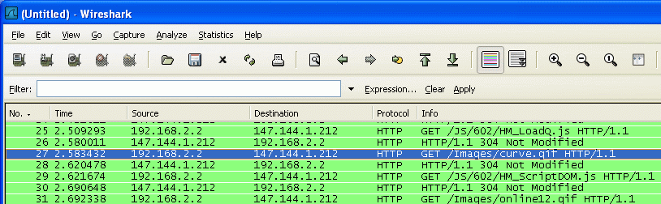
- The upper part of the Wireshark window shows the packets. Look at the rightmost two columns first: Protocol and Info. Scroll down, if necessary, to find the green HTTP GET lines. These are the requests for portions of the CCSF Web page, which contains many image files. The one highlighted below is the GET that requested the curve.gif image. You should be able to find similar packets in your capture.

Testing the Security of the CCSF Web Mail Client
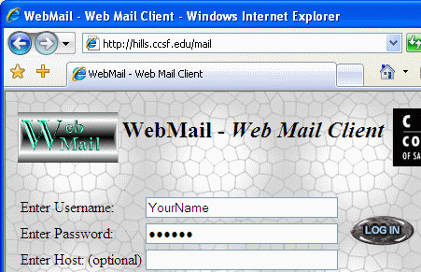
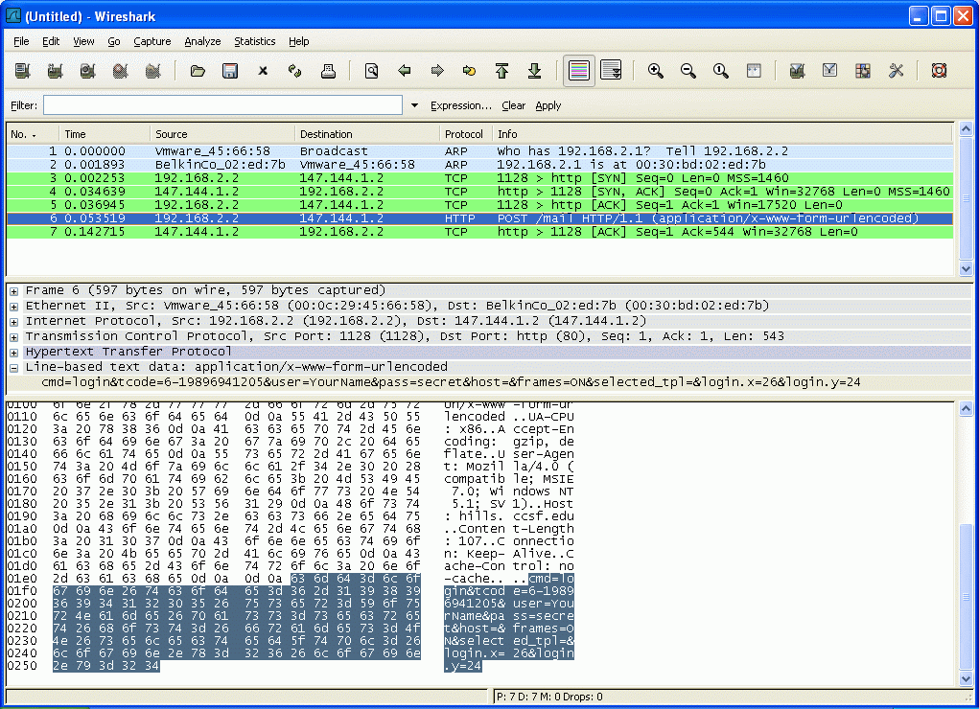
- In the Web browser, go to hills.ccsf.edu/mail
- Enter your name in the Username box, and secret in the Password box. Don’t use your real password, for reasons you will see below. Don’t click the LOG IN button yet.
- In the Wireshark window, click Capture, Interfaces. In the Wireshark: Capture Interfaces window opens, find the line that says Microsoft’s Packet Scheduler. Click the Capture button on that line. If a box appears saying Save capture file before starting a new capture? Click Continue without saving.
- In the Web Mail Client window, click the LOG IN button. That sends your user name and password to the CCSF server.
- You should see some packets captured in the Wireshark: Capture window. I caught 7 packets; you may catch a different number. Click the Stop button at the bottom of the Wireshark: Capture window.
- Look for a HTTP POST packet, as shown to the right on this page. Click it in the upper pane, and look in the lower pane, where the bytes in the packet are shown one-by-one. Near the end you should see your username and password transmitted in an easily read form.

Saving a Screen Image
- Press the PrintScrn key. Click Start, Programs, Accessories, Paint. In the untitled - Paint window, select Edit, Paste.
- In the untitled - Paint window, click File, Save. Save the document in the My Pictures folder (or any other place you wish, such as a floppy disk) with the filename Your Name Proj 6xa. Select a Save as type of JPEG.

Testing Security of Yahoo E-Mail:
- In the Web browser, go to yahoo.com. Click the Mail icon.
- Enter your name in the Yahoo! ID box, and secret in the Password box. Don’t use your real password. Don’t click the Sign In button yet.
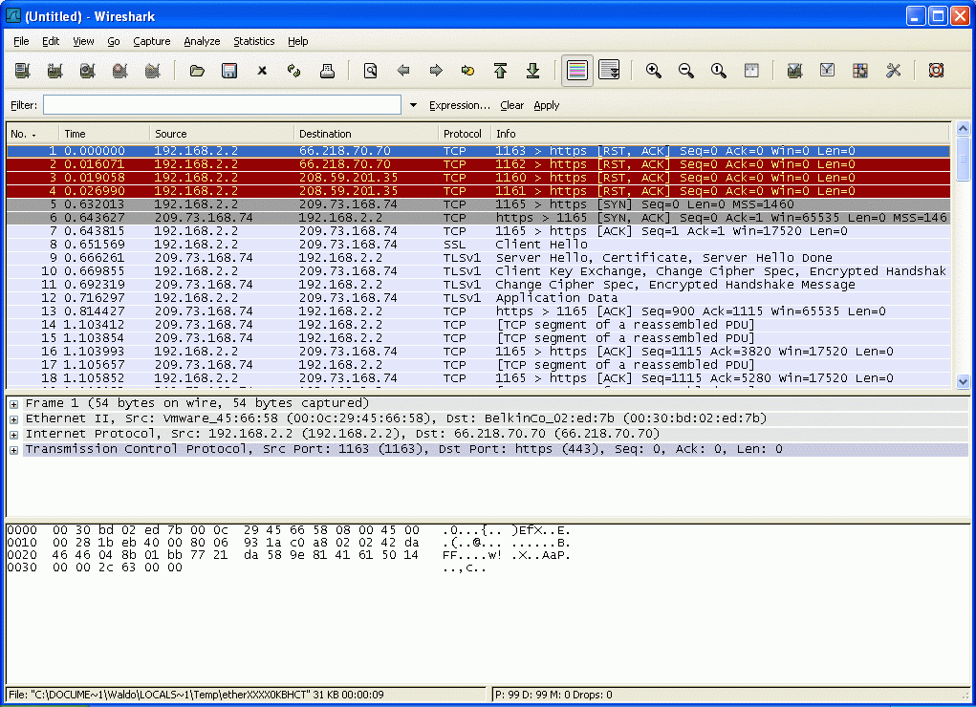
- In the The Wireshark Network Analyzer window, click Capture, Interfaces. In the Wireshark: Capture Interfaces window opens, find the line that says Microsoft’s Packet Scheduler. Click the Capture button on that line. If a box appears saying Save capture file before starting a new capture? Click Continue without saving.
- In the Yahoo window, click the Sign In button.
- When you see some packets (at least 70) captured in the Wireshark: Capture window, click the Stop button.
- Look for a Client Key Exchange packet, as shown to the right on this page. This packet is part of the Secure Sockets Layer handshake Yahoo uses to encrypt your user name and password. After the key is exchanged, the remaining packets are garbled and unreadable, and show up as TCP segment of a reassembled PDU. You can look in them for your name and password, but you won’t find them.

Saving a Screen Image
- Press the PrintScrn key. Click Start, Programs, Accessories, Paint. In the untitled - Paint window, select Edit, Paste.
- In the untitled - Paint window, click File, Save. Save the document in the My Pictures folder (or any other place you wish, such as a floppy disk) with the filename Your Name Proj 6xb. Select a Save as type of JPEG.

Turning in your Project
- Email the images as attachments in a single message addressed to: cnit.030@gmail.com with a subject line of Proj 6x From Your Name, replacing Your Name with your own first and last name. Send a Cc to yourself.
Last Modified: 7-11-06 4 pm

