System Requirements
- You must have Windows XP or Windows 2003 Server, at least 512 MB RAM, and several GB of free space on a hard drive. It’s a LOT better if you have 1 GB or more of RAM.
- You will need a broadband connection. These downloads are too big to download with a modem in any reasonable time period.
Installing VMWare Server
- Open a browser and go to vmware.com
- Point to PRODUCTS and click FREE Virtualization.
- Click the blue VMWare Server link
- On the page with the heading VMWare Server Beta, scroll down and click the Download VMware Server link.
- Under the “First Time Users” heading, click the Download Now button.
- On the next page, at the right side, click the Register button.
- Fill out the form and click Continue.
- Click the Download button labeled VMware Server Beta (for Windows).
- Scroll down and click Yes to agree to the EULA.
- Find this label: “VMware Server for Windows Operating Systems. A master installer file containing all Windows components of VMware Server.” Click the blue Binary (.exe) link to the right of that label.
- Wait for the download – it is 144 MB.
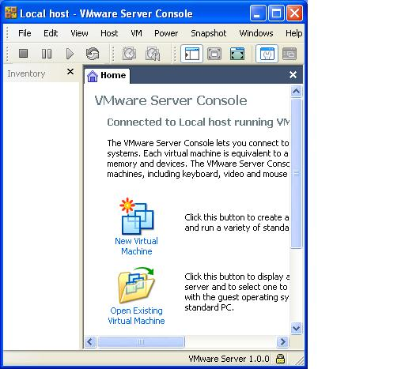
- Run the installer. Click through it, accepting the default choices. If you get a long error message telling you that IIS is not installed, don’t worry about it—IIS is only used for remote administration of the virtual server, and we don’t need that feature.
- You will need a serial number – it’s in your email, in a message with the subject VMWare Server Beta Invitation.
Creating a Virtual PC with VMWare Server
- Open a VMWare Server Console from the desktop shortcut.
- In the VMWare Server Console – Connect to Host box, accept the default selection of Local host and click OK.
- VMWare Server Console opens as shown to the right on this page. Click the New Virtual Machine icon.

- In the Welcome to the New Virtual Machine Wizard box, click Next.
- In the Select the Appropriate Configuration box, accept the default selection of Typical and click Next.
- In the Select a Guest Operating System box, select Microsoft Windows XP Professional and click Next.
- In the Name the Virtual Machine Wizard box, click Next.
- In the Network Type box, accept the default selection of Use bridged networking and click Next.
- In the Specify Disk Capacity box, accept the default selection of 8 GB, but uncheck the Allocate all disk space now box, unless you have a lot of hard disk space available. Click Finish.
- In the VMWare Server Console window, on the Windows XP Professional tab, click Start this virtual machine.
- The machine starts, but cannot find an operating system. Insert a Windows XP Installation CD into the CD drive, and click Power, Reset from the VMWare Server Console menu bar.
- The virtual machine should boot from the CD. If it does not, try pressing F2 and adjusting the virtual BIOS settings.
- Install Windows XP, following the instructions on the screen. You will need to enter the Product Key you got from Microsoft Academic Alliance.
Installing VMWare Player -- Optional
- If VMWare Server runs well on your computer, keep it and don’t get VMWare Player. You cannot have both VMWare Server and VMWare Player installed at the same time. However, if you find that VMWare Server runs slowly, use it to create your virtual machine, and then uninstall VMWare Server, and install VMWare Player instead to run it. VMWare Player is MUCH faster. You can get VMWare Player from vmware.com in the FREE Virtualization section.

